RB Beta4 PCB ADC/FPGA FPGA 37pin
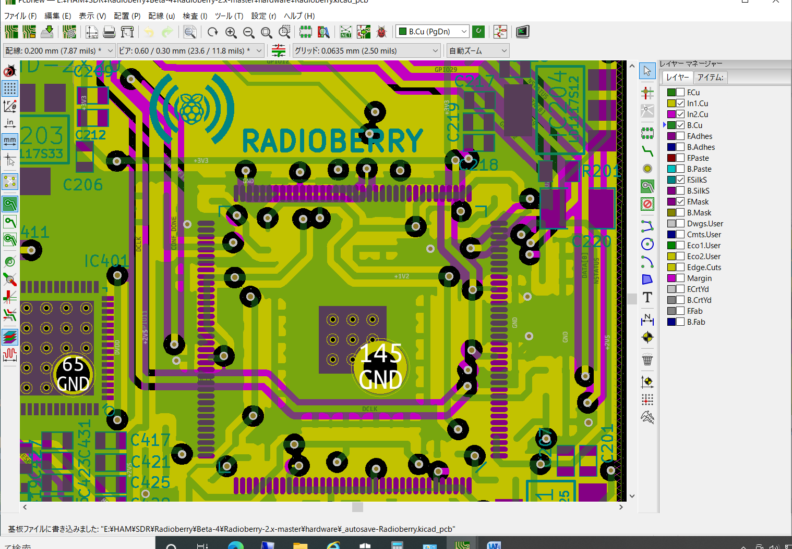
ADC FPGA 1pin
69pin VIA 69-53pinconnection line(yellow)/Cu1 53pin VIA

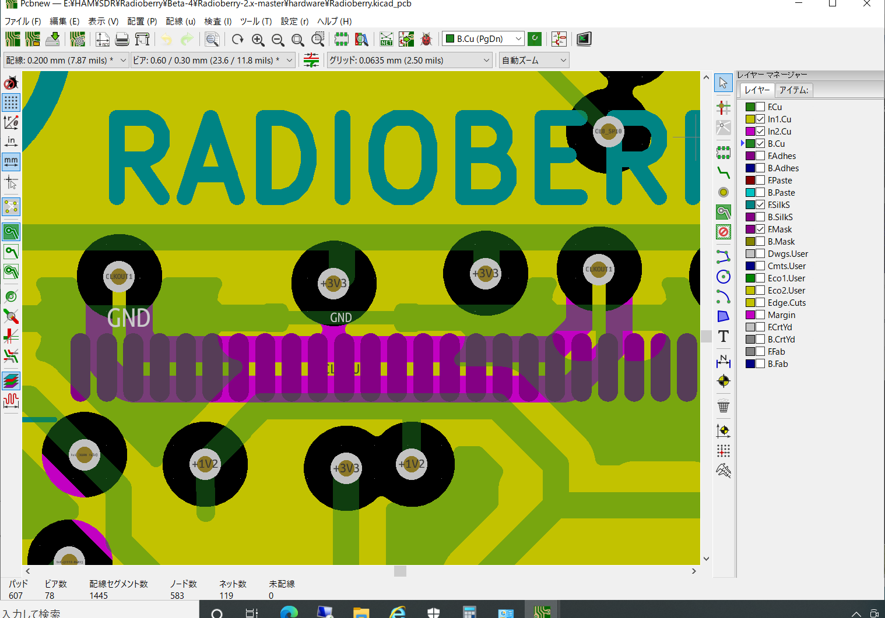

53pin/Clockout1 VIA ”3.3V line” spacing is about 2.5mil(=63.5μm)

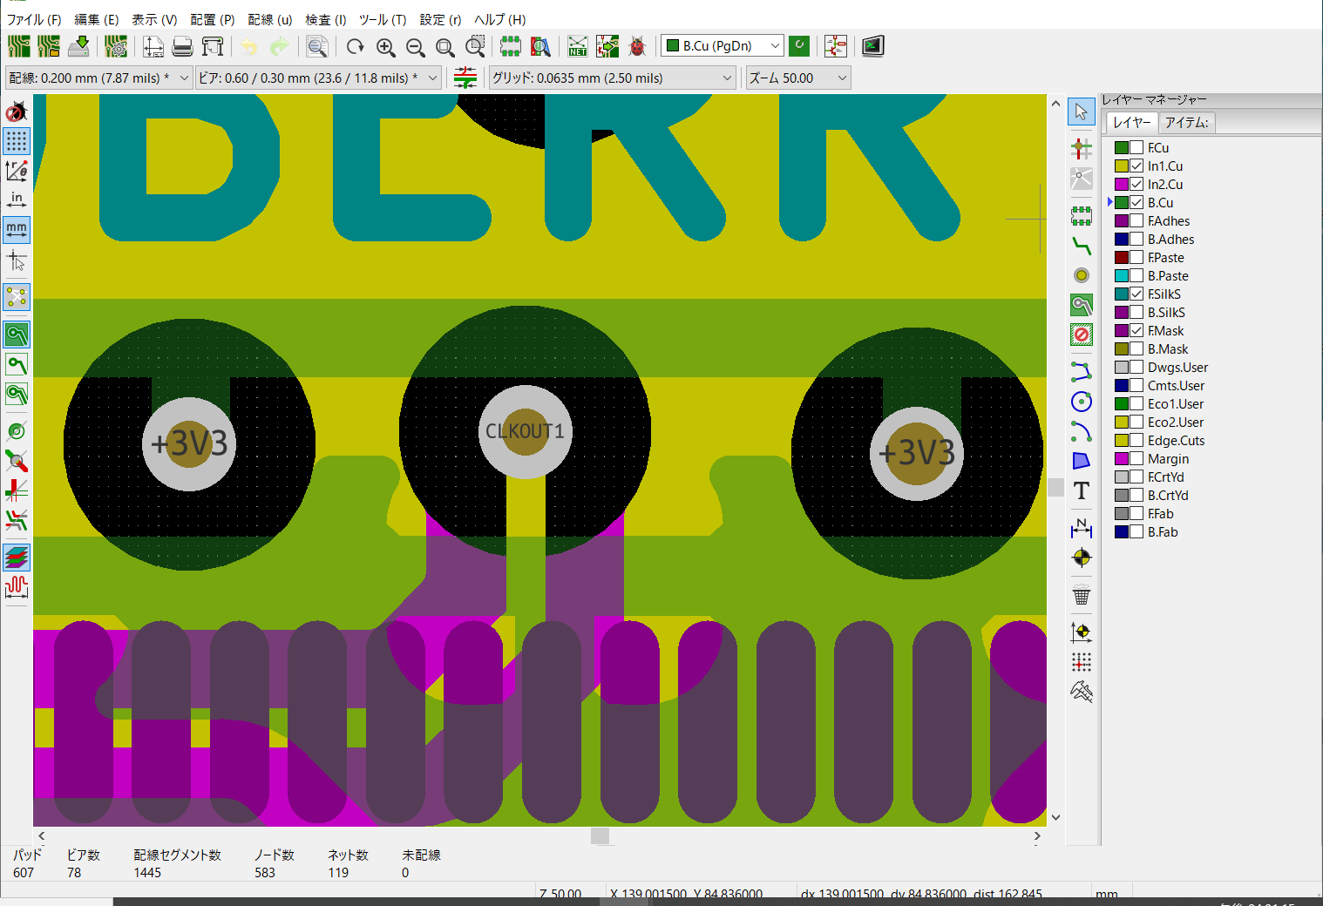

How to repair
- Cut the lines between ADC Clock- Pin69 VIA, 69pin pad-pin69 VIA,
pin53 pad-pin53 VIA
- wire ADC clock-69pin pad, 69pin pad-53pin pad
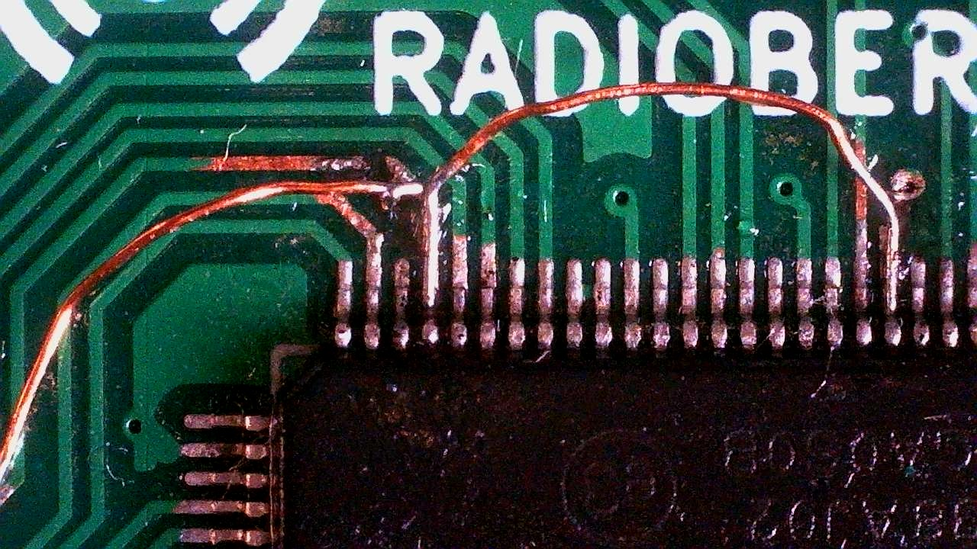
repaired

