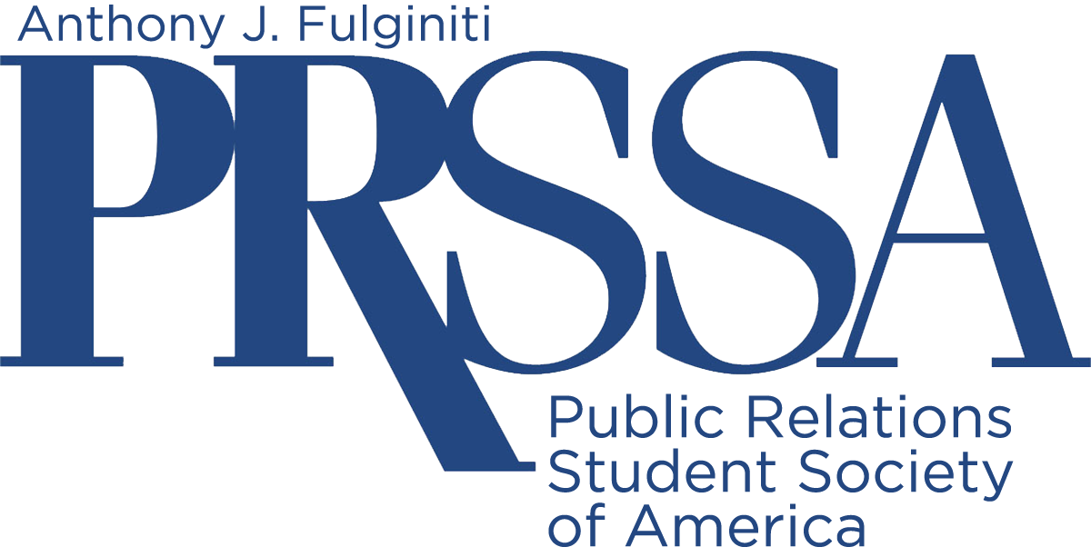

2021 Rowan PRSSA National Cystic Fibrosis Awareness Competition Package

Included Information

- Letter to Chapter ……………………………………………………………2
- Goals and Objectives ……………………………………...……………….3
- Competition Guidelines …………………………………………………….4
- Details and Deadlines ………………………………………………………5
- Judging Form ……………………………………………………………......6
- Entry Form ……………………………………………………………………7
- Fact Sheet …………………………………………………………………….8
- Event Ideas …………………………………………………………………...9-10
- Sample News Coverage …………………………………………………….10-12

Letter to PRSSA Chapter Leaders

October 8, 2021

Dear PRSSA Chapter Leader,

The Public Relations Student Society of America (PRSSA) prides itself on philanthropic activities that promote the well-being of our communities. To continue this tradition, the Anthony J. Fulginiti Chapter of PRSSA (AJF-PRSSA) at Rowan University invites you to participate in our National Cystic Fibrosis Awareness Competition.

Cystic fibrosis is a progressive, genetic disease that attacks young people, contributing to lung infections and limiting the ability to breathe. This competition asks PRSSA chapters to use their public relations skills while helping to enhance and extend life for those living with cystic fibrosis.

Through this competition, PRSSA chapters will create a campaign and host an activity, either online or in person, in November or December 2021 focused on cystic fibrosis awareness and research. The top four chapters will receive a cash prize at the National PRSSA Conference in the fall of 2022.

Awareness of, and support for, cystic fibrosis research is deeply meaningful to Rowan’s AJF-PRSSA chapter. We held our first event for CF in 2013 after the passing in 2012 of Colette W. Bleistine, a former Rowan student and PRSSA leader. Each year, our chapter holds an event or activities to help raise money and awareness in the Rowan community. Colette’s parents formed the Colette W. Bleistine Paying It Forward Foundation, which has donated more than $50,000 in past years to scholarships, students in need and cystic fibrosis research.

We encourage you to compete in the National Cystic Fibrosis Awareness Competition. Together, we can make a difference. Just imagine the impact your chapter can have. If you plan to take part, let us know as soon as possible, and start planning. Please contact gloriabarone@mail.com with any questions.

Sincerely,

Gloria Barone Rosanio, AJF-PRSSA Professional Advisor
Adjunct Professor, Ric Edelman College of Communication and Creative Arts
Rowan University
301 High St., Glassboro, N.J. 08028

PRSSA National Cystic Fibrosis Awareness Competition Goals and Objectives

Competition Goal:
Raise national visibility for cystic fibrosis through PRSSA chapters across the country.

Competition Objectives:
- Increase awareness of cystic fibrosis and the struggles patients face.
- Promote strong public relations and leadership skills, and commitment to community service, among PRSSA chapters nationwide.
- Raise money for CF research with as many students as possible taking part in the competition.

2021 National Cystic Fibrosis Awareness Competition Guidelines

***Please send all submissions digitally to gloriabarone@mail.com. This will allow us to evaluate and provide feedback promptly.

- Chapters must conduct an activity between November 1 and December 15, 2021. This can be online or in person. The target audience should include (but not limited to) local community members, students, faculty and staff.

- The campaign goal is to spread awareness of cystic fibrosis and its effects as well as fundraise for CF research.

- Award packages must include:
- A three-page (maximum) summary (typed, double-paced, one-inch margins)
- Primary and secondary research
- Summary of activities
- Evidence of cystic fibrosis promotion
- Campaign evaluation
- Supplemental information: (15-page limit)
  - Invitations
  - News Releases
  - Advertising (i.e. Flyers, publicity)
  - Photographs
  - Media kit
  - Screenshots from social media promotions
  - Budget
  - Any other materials that provide value to your campaign

- Please submit your package (18-page maximum) as a single PDF file by December 31, 2021 to gloriabarone@mail.com. You will receive a confirmation email within 48 hours of submission.

- First, second, third place and honorable mention winners will receive recognition and awards at the prestigious 2022 PRSSA National Conference, the largest gathering of PRSSA chapters around the country.

- Packages will be judged according to extent of influence, creativity, execution, publicity/promotion, research, professionalism, supporting materials.

Details and Deadlines at-a-Glance
PRSSA National Cystic Fibrosis Awareness Campaign

- The Cystic Fibrosis national competition will take place in the fall semester of 2021.
- Registrations for PRSSA chapters who want to compete are due November 15, 2021.
- Chapters must hold their activities or campaigns in November or December 2021 and must confirm their participation with Gloria Barone Rosanio at gloriabarone@mail.com
- Completed competition packages must be submitted by December 31, 2021.
- PRSSA chapters must submit portfolios including all elements of research, planning, communication, and evaluation phases of their awareness campaigns. A panel of Rowan students, faculty, and professionals will evaluate the portfolios and select first, second, third and honorable mention recipients.

AJF-PRSSA’s Tips for Success

DO | DON’T
Plan ahead | Wait until the last minute
Ask questions | Send packages late
Proofread your package multiple times | Have numerous spelling/grammatical errors
Be creative. Make your activity individual to your school, not cookie cutter. | Simply follow other PRSSA chapters
Have fun | Lose sight of the overall cause

National Cystic Fibrosis Awareness Competition Judging Form

Extent of influence: 1-20 points

Creativity: 1-20 points

Execution: 1-15 points

Publicity/promotion: 1-15 points

Research: 1-10 points

Professionalism: 1-10 points

Supporting material: 1-10 points

National Cystic Fibrosis Awareness Competition Entry Form

If you plan to enter the competition, please submit this form on email to gloriabarone@mail.com

You can use Venmo to send your entry fee of $25, or mail your check for $25 to AJF-PRSSA by November 15, 2021 to:

AJF-PRSSA
Attention: Gloria Barone Rosanio
c/o Ric Edelman College of Communication and Creative Arts
Rowan University
301 High Street
Glassboro, NJ 08028

Include:

Name of PRSSA Chapter: ______________________________________________
University/ College: ____________________________________________________
Mailing Address: _______________________________________________________
Department Telephone Number: __________________________________________
Student Contact: ______________________________________________________
Student Contact’s Email address: ___________________________________________
Student Contact’s Telephone Number________________________________________
Advisor Contact: _______________________________________________________
Adviser Contact’s Email Address: __________________________________________
Adviser Contact’s Telephone Number: ______________________________________

Please make checks in the amount of $25 payable to “AJF-PRSSA.”
We also accept Venmo.
Email gloriabarone@mail.com with questions and to notify us that you are providing payment and entering the competition.

Registration must be submitted by November 15, 2021
Completed package must be submitted by December 31, 2021

Facts about Cystic Fibrosis and Rowan’s History of Support for CF

Cystic fibrosis, a rare genetic disorder, affects children in the United States. The majority of diagnoses occur before the age of two. National awareness helps to fund medical research for this incurable disease and empower those affected by it. Rowan’s AJF-PRSSA chapter held its first event to support awareness of CF in 2013 after the passing of a Rowan student from the disease in 2012.

Each year, our chapter holds an activity or event to help raise money and awareness in the local community. Colette’s parents formed the Colette W. Bleistine Paying It Forward Foundation, which has donated over $50,000 in the past years to scholarships, students-in-need and cystic fibrosis research.

Founded in 1955, the Cystic Fibrosis Foundation leads the world in awareness of the disease, research for the cure and financial support to make CF drugs widely available. The Foundation raises hundreds of millions of dollars for research and works to increase life expectancy in sufferers by decades.

Cystic Fibrosis Facts:
- More than 30,000 people in the U.S. currently live with the disease.
- Doctors diagnose about 1,000 new cases each year.
- The majority of people, about 75 percent, receive their diagnosis by age two.
- The complicated disease can produce a variety of symptoms, and no two cases are the same.
- In the year of the Foundation’s creation, a CF patient could expect to live a median of ten years.
- In 1955, no treatment for CF existed.
- In 2018, a CF patient could expect to live an average of 37 years, with death most often occurring from lung complications.
- With increased research and awareness, gene therapy appears to be a promising treatment and possible cure for the future.
- New drugs and antibiotics help patients manage their symptoms and increase life expectancy.
- In 2010, the Foundation raised $175 million - a goal thought to be impossible for a healthcare nonprofit.
- Although donations and research funds remain in the millions, public awareness of the disease and its sufferers remains quite low.

Additional information regarding cystic fibrosis can be found at https://www.cff.org/.

Cystic Fibrosis Event and Fundraising Ideas
We want your chapter to be as involved as possible in creating a special cystic fibrosis event or activity while raising money for CF research. We understand that it may not be possible to hold an actual event in light of COVID-19, but feel free to adapt any idea below and make it a virtual one, or create a social media awareness or cause marketing campaign. The following are a few ideas your chapter can run with, or that might spark another idea all your own. These fundraisers can be held online, in your campus gym facilities or outside on your campus, with entry or sponsorship fees that will benefit CF. These suggestions are not your only options. We encourage you to be creative and design a unique event. Some ideas:
- “Band Together Against CF” with a Battle of the Bands Rock-a-Thon
- Dance-a-Thon
- Triath-a-Thon
- Jog-A-Thon
- Walk-a-Thon
- Wheel-a-Thon (take part by bikes, rollerskates, skateboards, scooters, anything on wheels)
- Volleyball or basketball tournament
- Karaoke, amateur talent show, or fashion show
- A Jeopardy-like game or trivia night
- Dine-out for Cystic Fibrosis
- Social media campaign
- Cause marketing campaign
- Text message campaign
- Zoom competition or talent show
At the same time, you may want to contact local businesses to donate gift baskets and prize packs to be raffled off, including, for example:
- Food prizes/gift certificates from restaurants
- Gift certificates and merchandise from retail stores
- Haircuts or makeovers from local barbershops and beauty salons
- Free fitness sessions at the local gym
- Free car wash
Again, we want you to be creative and do what works for your chapter and community and ensures the health and safety of all students. Develop the best fundraiser for your campus and chapter and raise as much awareness and money as you can to support cystic fibrosis.

Example of Campus Media Coverage of Cystic Fibrosis Event at Rowan University
The Whit – Rowan University Student Newspaper
“Dance Away Cystic Fibrosis” teaches people about dancing and disease
By
Jesse Mounce
December 6, 2017

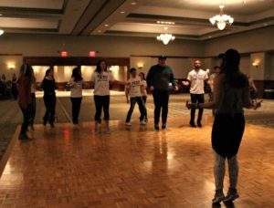
Left, right, back, right.
Students tried to mimic the dance instructor among tables covered in purple tablecloths and violet balloons anchored down by mason jars filled with lavender flowers.
Hosted in the Eynon Ballroom of the Chamberlain Student Center on Thursday night, Dance Away Cystic Fibrosis toted a purple color scheme. Purple occupies a special meaning for the event’s host, Rowan’s Public Relations Student Society of America (PRSSA). Purple represents Cystic Fibrosis.
According to the Cystic Fibrosis Foundation, the disease is “a progressive, genetic disease that causes persistent lung infections and limits the ability to breathe over time.” More than 70,000 people suffer from this disease worldwide.
This year’s Dance Away Cystic Fibrosis was the fourth annual event held in the honor of Colette Bleistine. Bleistine was a student at Rowan, where she was the vice president of Special Events for PRSSA. She died in 2012 after being placed on a double lung transplant waiting list in March of that year.
“We hold this in honor of her every year to raise money and to remember that she was someone who was here. She was a student. She was a part of our organization and she dedicated a lot of time to our work,” said Colleen Scott, senior public relations major and president of PRSSA.
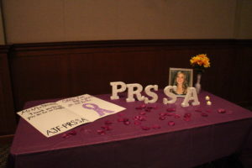
From tables selling hot chocolate or raffle tickets to a Dine and Donate night at Chickie and Pete’s, PRSSA held four fundraisers over the last month leading up to Dance Away Cystic Fibrosis.
Melissa Livingstone, the Dance Away Cystic Fibrosis Chair for PRSSA, said she started planning the event over the summer. Once she knew more about Colette’s story, Livingstone spent the next three months developing the event and fundraisers that would help the club reach their goals. In addition to continuing to honor the legacy of Bleistine, PRSSA set a goal to donate $500 to the Cystic Fibrosis Foundation.
Bleistine’s parents attended the event, as they have for the last three years. After they received flowers and a card, Colette’s mother, Nancee Bleistine spoke to the attendees about her daughter. She informed students about the Colette W. Bleistine Paying it Forward Foundation, which donates money to victims of catastrophic events and scholarships to students who have a passion for community service, just as their daughter did.
“She was very inspirational. People today still tell me about how when they are going through something they think about Colette and all that she endured, because she never complained,” Nancee Bleistine said. “In the midst of it, she still cared about people.”
After Nancee Bleistine’s speech, the dance instructor, Kelsey Martino of Kelstar Kardio, brought students back onto the dance floor to perform a zumba style exercise.
The gathering attracted 40 people, creating a personal and meaningful environment.
“This is my first time at this event, but I love the energy here. I can tell the people who organized it were very passionate about the cause,” said Mavish Khan, senior journalism major. “I love seeing students come together in honor of a Rowan student.”
As the night came to an end, the club called raffle tickets and five lucky winners were awarded with prizes. The students and club members finally found out if they broke their donation goal.
PRSSA shared Colette Bleistine’s story and personality during their fundraisers. As of Thursday night, they raised $534 for the Cystic Fibrosis Foundation—not accounting for the Chickie and Pete’s Dine and Donate.
“Two of her favorite quotes were ‘Life is too short to be anything but happy,’” Nancee Bleistine said. “And the other quote, which I think really suited her so well was, ‘Your problems are never bigger than your purpose.’”
For comments/questions about this story, email features@thewhitonline.com or tweet @TheWhitOnline.

