I'll briefly go through the build process. It won't be very different from Chrono::GPU. After you git clone this repo, remember to

git submodule init
git submodule update

in it (it needs NVIDIA/jitify to do runtime compilation). Then, one typical choice is to make a build directory in it. And in the build directory, make sure CUDA is installed or loaded, then call ccmake to configure the compilation. Something like this...

mkdir build
cd build
ccmake -G Ninja ..

In the ccmake GUI, you mostly like do not have to change anything, but you can change the build type to Release so it compiles with all optimizations. You may also set the installation path prefix to an empty install folder of your choice as shown, but we will worry about installing and using it as a library a bit later.
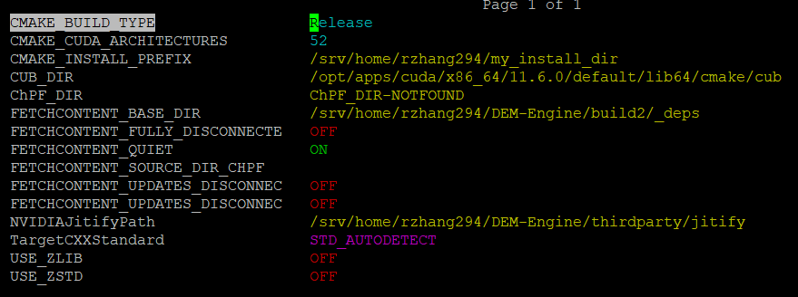

After that, you can start generating and then compiling.

ninja -j 40

If it compiles just fine, then that's already a success. It is completely operable on its own, so to test it out, you could try to run the rotating drum demo

./src/demo/DEMdemo_RotatingDrum

Be sure to request 2 GPUs if you run it on a cluster. It performs much better on 2 GPUs.

This package is still under active development. The functionalities that you'd expect to be there might not be there yet. When that happens, feel free to let me know. It's likely that I can implement those quick enough.

