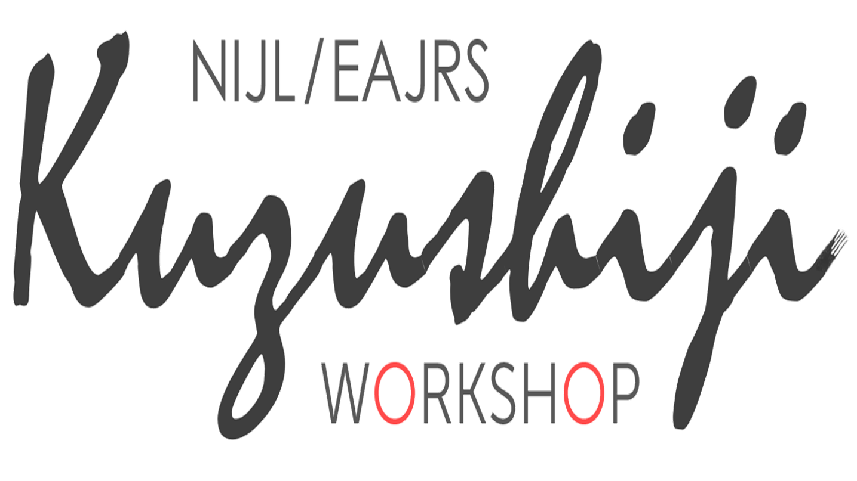

NIJL/EAJRSくずし字ワークショップ2023参加申込用紙
Application Form for NIJL/EAJRS Kuzushiji Workshop 2023

- 氏名 (Name):

- 所属 (Affiliation):

- 職名 (Job title):

- Email address:

- これまでに受講したNIJL/EAJRSくずし字講座、もしくは他のくずし字・古典籍研修:
List NIJL/EAJRS Workshops or other workshops/training sessions related to kuzushiji you have attended:

- 仕事・研究におけるくずし字解読の必要性:
Why do you need to decipher kuzushiji in your work or research?:

