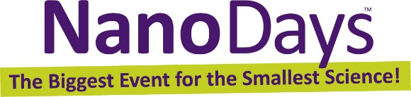

Celebrate NanoDays 2015
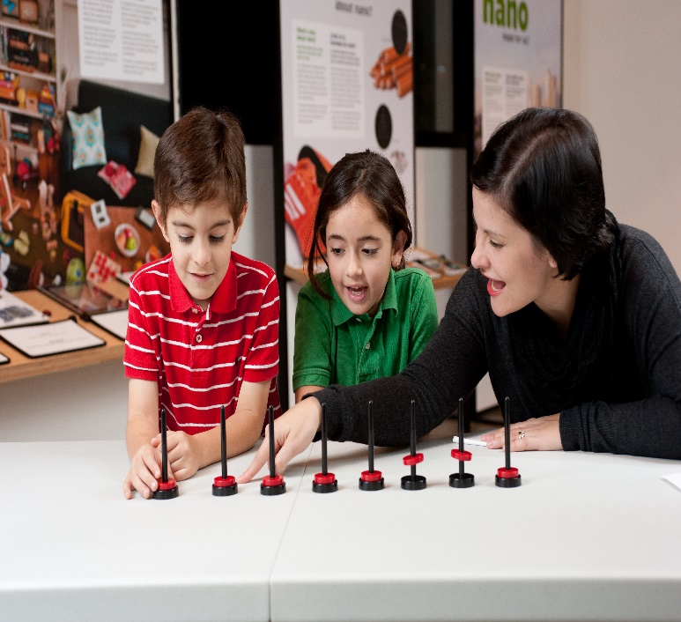 | 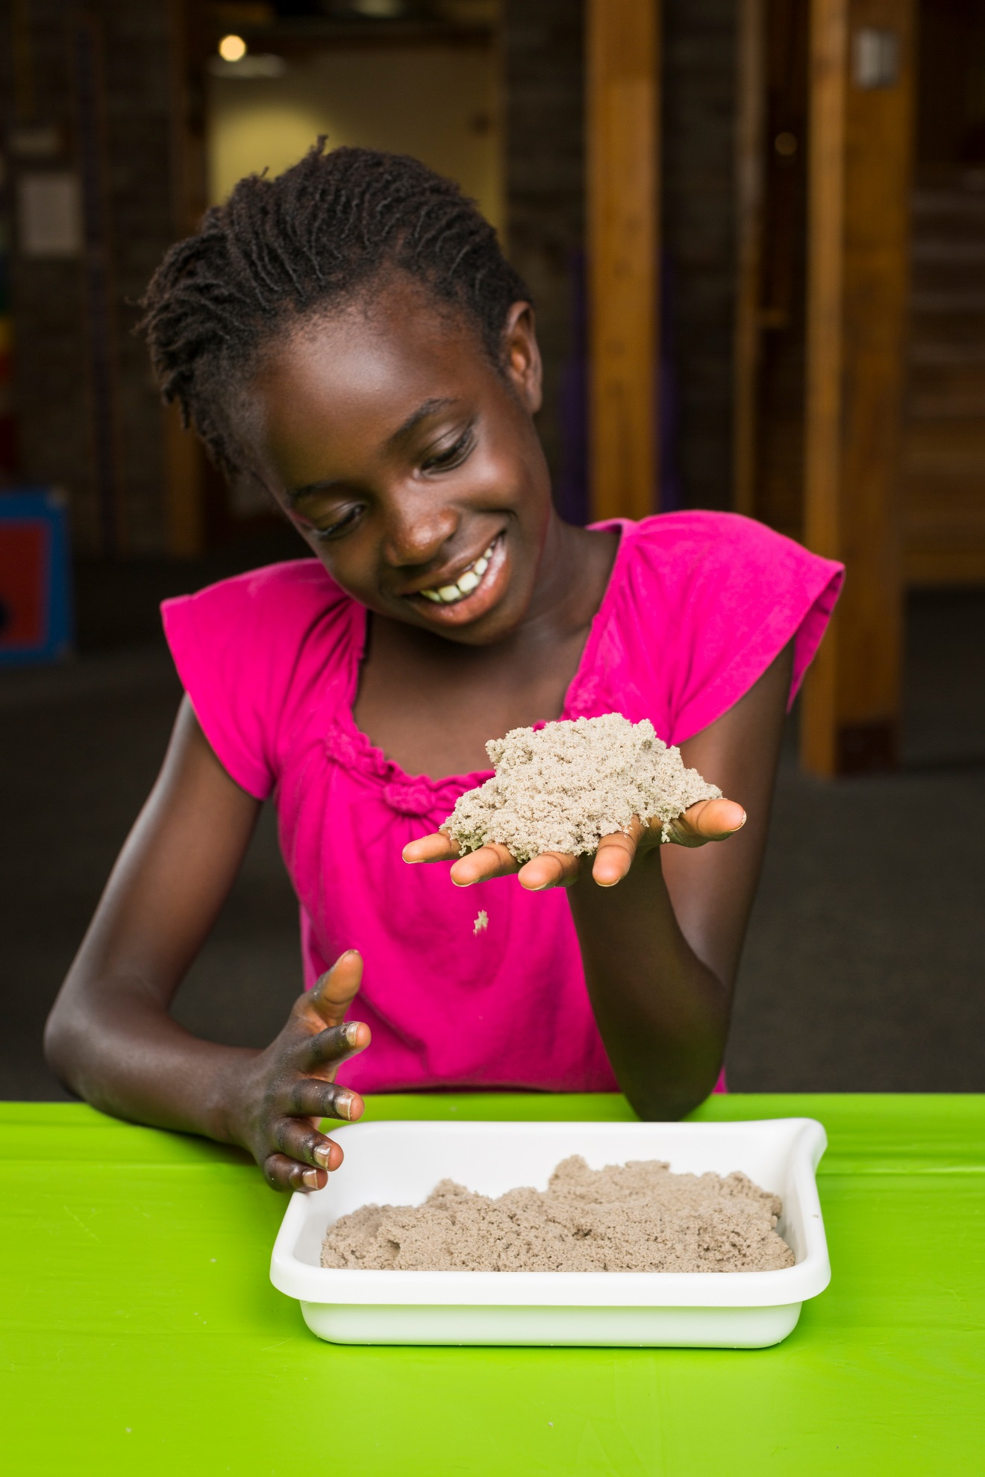

Monday March 30, 2015 from 2 - 4 p.m.
Cook Library Room 123
The University of Southern Mississippi
NanoDays is an annual nationwide festival of educational programs about nanoscale science and engineering and its potential impact on the future. The NanoDays event will offer a range of exciting programs that demonstrate the special and unexpected properties found at the nanoscale, examine tools used by nanoscientists, showcase nano materials with spectacular promise, and invite discussion of technology and society as well as a special exploration of nano and children’s literature. The event is free and open to the public. For more information about the March event, contact Tracy Englert, Reference Librarian for Science and Technology at 601.266.6396 or tracy.englert@usm.edu.
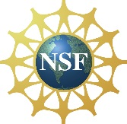 This project is based on work supported by the NSF under Award Nos. 05322536 and 0940143. NanoDays™ is trademarked by North Carolina State University and used by the NISE Network with permission.

