Grand Island PhotoVoice Guide

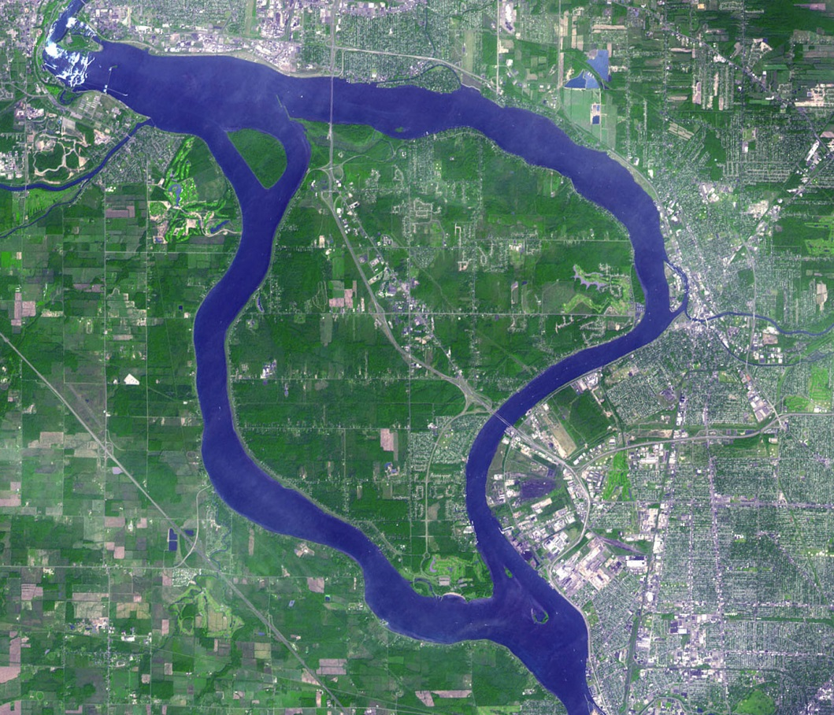

Summer 2014

by

Grand Island – An Environmental Initiative Collaboration

Section 1 – Forms and Handouts
Section 2- Toolkit for Leaders Planning a PhotoVoice Group

Section 1
Forms and Handouts

Handout 1
Grand Island PhotoVoice Introduction

The viewpoints of the members of the community about their health and the environment are essential to plan any successful future action or programs (often called a social assessment).

Background
- In 2013, Tonawanda Coke Corporation was convicted of polluting and violating United States Clean Air Act; some people on Grand Island have been exposed to these pollutants.
- There is also a long history of industrial pollution in the region.
- A New York State Department of Health study using cancer registries found a higher incidence of cancer in people who live in the portion of Grand Island nearest to Tonawanda Coke.
- There are also many health or environment strengths and assets in the Grand Island community.
Goals
- Represent the positive and negative influences of the local environment on health
- Define potential solutions
- Share personal and community experiences through photographs and discussion
- Inform positive community and personal change, often by sharing experiences with community leaders

Examples of Other Community PhotoVoice Projects
Here are some resources and examples of other, completed PhotoVoice projects on different topics:
- Health in my Hometown – A Youth PhotoVoice Project (Youtube Video) at
https://www.youtube.com/watch?v=X8lSw5Cdi8k
- PhotoVoice – Kaiser Permanente Community Health Inititatives (Youtube video) at https://www.youtube.com/watch?v=b5VDu8MWegg
- PhotoVoices Across our Region (Western New York-based website) at http://www.oneregionforward.org/sustainability-101/photovoices-across-the-region/
- Clean Air Coalition PhotoVoice Project (Vimeo video) at http://vimeo.com/72392047
- PhotoVoice (website) at http://photovoice.org/

Handout 2
The What, Why, Where, and When of Our PhotoVoice

What is PhotoVoice? A picture is worth a thousand words

PhotoVoice is a type of documentary activity to powerfully express the voices and viewpoints of people living in the community. PhotoVoice is a tool that has led to positive community change in many previous projects. People who participate in this particular project will be asked to:

- Take pictures to represent their points of view on the following questions:

How does the outdoor environment improve your health or quality of life?
How does the outdoor environment threaten or harm your health or quality of life?

- Email the pictures to the facilitator
- Share the pictures in small group discussions/workshops about the photos and what they mean
- Write a caption to explain their point of view focused on one or more of the following “SHOWED” questions:

What do you See here?
What’s really Happening that we can’t see here?
How does this relate to Our community life?
Why does this problem/condition/strength exist?
How could this picture Educate others? Who should we Educate?
What can we Do about it?

- Select photos and stories for final public display

Why PhotoVoice?

We plan to use PhotoVoice to define, communicate, and encourage solution-focused public dialogue about the community’s environment-related health concerns. PhotoVoice has been used in many other communities to raise awareness and influence policy makers and community leaders from the grassroots perspective. You are the expert of your own health, and have a unique an important perspective about the environment around you.

Who should be involved?

This project is designed to be owned and implemented by the community. Anyone interested in sharing a perspective about health and the environment who are engaged in the Grand Island, New York community (past or present) are welcomed to be involved. This includes people who live, work, or simply enjoy the recreational opportunities on Grand Island. Children under 18 require parental permission.

Where and When?

An initial project will be implemented over the Summer of 2014 as follows:
- Introduction: Wednesday, June 18, 7-9 pm, St. Timothy Lutheran Church
- Show your photo workshop 1: Tuesday, July 1, 7-8:45 pm, Grand Island Library
- Show your photo workshop 2: Tuesday, July 15, 7-8:45 pm, Grand Island Library
- Show your photo workshop 3: Wednesday, August 6, 7-9 pm, Grand Island Town Hall Lower Level Conference Room
- Public display – Electronic video posted by August 20.

Note: Other groups are most welcome to use this guide to implement their own PhotoVoice project in groups or social settings where people already gather together and discuss community outreach and improvement. In the spirit of community ownership and ongoing dialogue, collaboration and duplication is welcomed.

PhotoVoice can be implemented by community leaders with experience in facilitating group discussion anywhere people gather to consider community concerns. Examples might include existing youth groups, service organization meetings, or advisory boards. The end of this guide includes facilitation resources to get started. Please consider joining us in the initial project to learn more or contact representatives listed at the end of this guide. Please be sure to change all dates and contact information for your group.

Handout 3
Agreement Statement: Grand Island Photovoice Project
For People Taking Photographs and Sharing with the Community
Introduction
The goal of these projects is to define, communicate, and encourage solution-focused public dialogue about the community’s environment-related health concerns.
What will I do?
In this project, you and other participants will take pictures, discuss, and write narratives about how the outdoor environment in our community improves and threatens/harms your health and quality of life.
As part of this project, you will:
- Agree to the ethics of PhotoVoice.
- Take pictures in the community.
- Email your photos to the facilitator (or bring them in a form that will transfer electronically).
- Write narratives about your photos, discuss them with others, and identify common themes.
- Contribute to a public exhibit of the photos.
Agreement statement: By signing this form, I agree to participate in the project through taking pictures of my community, discussing my pictures with others, and sharing my photos with the public.

Unless otherwise notified in writing, I give permission for the unlimited use of my photograph(s) and accompanying narrative(s) for public exhibits, presentations, and publications and/or other educational purposes. I understand that the Copyright for these photographs remains mine and I can remove my photograph(s) or narrative(s) at any time by contacting St. Timothy Lutheran Church at 773-4400. You may also withdraw from the project at anytime and there will be no negative consequences.

PRINT NAME: _______________________________
Signature:________________________Date:_______

Initial one of the following:
___I am over the age of 18
___I am younger than the age of 18 and have also turned in a parent/guardian permission form
Initial one of the following: In any public exhibit, presentation, or publication, I’d like the photograph to be listed:
___With my name as the photographer
___As Anonymous

Please contact [name] with any questions at [email] or [phone].
Handout 4
Parental/Guardian Permission Statement: Grand Island PhotoVoice Project
Introduction
The goal of these projects is to define, communicate, and encourage solution-focused public dialogue about the community’s environment-related health concerns

What will my child do?
In this project, your child and other participants will take pictures, discuss, and write narratives about how the outdoor environment in our community improves and threatens/harms health and quality of life.

As part of this project, your child will be asked to:
- Agree to the ethics of PhotoVoice.
- Take pictures in the community.
- Email the photos to the facilitator (or bring them in a form that will transfer electronically).
- Write narratives about the photos, discuss them with others, and identify common themes.
- Contribute to a public exhibit of the photos.

Agreement statement: By signing this form, I agree to allow my child to participate in the project through taking pictures of the community, discussing the pictures with others, and sharing the photos with the public.

Unless otherwise notified in writing, I give permission for the unlimited permissions to use my child’s photograph(s) and accompanying narrative(s) for public exhibits, presentations, and publications and/or other educational purposes. I understand that the Copyright for these photographs remains my child’s and I can remove his/her photograph(s) or narrative(s) at any time by contacting the facilitator at 773-4400. You or your child may also withdraw from the project at anytime and there will be no negative consequences.

PRINT CHILD’S NAME:_______________________

PRINT YOUR NAME:_________________________

Signature:_______________________Date:___________

Please contact [name] with any questions at [email] or [phone].

Handout 5
Photo Release Form for People who May Appear in Photographs

Introduction
The goal of these projects is to define, communicate, and encourage solution-focused public dialogue about the community’s environment-related health concerns.

What will Am I Being Asked to Do?
The photographer may take pictures that contain images of you. It is good to remember that there is always the chance someone may recognize you in the photographs, even if your name or identity are not revealed. Your willingness to be photographed is voluntary and you may decline.

Why?
You are being asked to be part of a picture that represents the strengths or challenges in our community’s health-related environmental concerns. The pictures will be discussed at public outreach meetings among other photographers, who will explain what the picture means to them and common themes among all of the pictures. The pictures will then be shown and discussed in a public exhibit (which may be an online video) in order to raise awareness of this issue and facilitate solution-focused ideas.

What happens to the photographs?
Photographs remain the Copyright of the photographer, and may be used in public exhibits, presentations, publications and/or other purposes.

By signing this consent form, I agree to voluntarily have my photograph or my child’s photograph taken. I also understand and agree that unless otherwise notified in writing, the photographer assumes that permission is granted to use the photograph(s) for public exhibits, presentations, publications and/or other purposes.

Print Your (or Child’s) Name: |  | Date:
Print Parent/Guardian Name:
Your (or
Parent/Guardian’s) Signature:

Thank you so much!

Please contact [name] with any questions at [email] or [phone].
Handout 6
PhotoVoice Ethics
- Safety: Your safety is the first priority. Don’t do anything you wouldn’t normally do, go places you wouldn’t normally go, trespass, or violate any laws or norms of respectful conduct to take your pictures. No photograph is worth personal danger. Be aware of your surroundings and consider a buddy system.
- Voluntary & Non-intrusive: Obtain permission from anyone represented in your photos. This project is entirely voluntary for both the photographer and the people being photographed. All have the right not to participate or withdraw their participation at any time. Do not intrude on anyone’s private or personal space without their permission, even if they are in public.
- No Harm: Do not misrepresent a person intentionally in a photograph or put them in a false light. Consider and avoid potential harm to the people represented or depicted. Ensure that you are fairly representing the real situation in the photograph.

Handout 7
PhotoVoice Homework
Homework checklist:
- Submit written consent (if not done at the first meeting)

- Take photos, following PhotoVoice ethics, that represent:
- How does the outdoor environment improve your health or quality of life?
- How does the outdoor environment threaten or harm your health or quality of life?

- Write a caption to explain your point of view focused on one or more of the following “SHOWED” questions:

  - What do you See here?
  - What’s really Happening that we can’t see here?
  - How does this relate to Our community life?
  - Why does this problem/condition/strength exist?
  - How could this picture Educate others? Who should we Educate?
  - What can we Do about it?

- Email the pictures and captions you’d like included in the public meetings to the facilitator, [name] at [email]

- Come to the next meeting with consent forms and engage in small group discussions/workshops about the photos and what they mean
Section 2
Toolkit for Leaders Planning a PhotoVoice Group

The whole PhotoVoice process should include the following four steps:

- An introduction and training session
- Photograph discussion meetings (at least two are recommended)
- Public display to engage community leaders/other PhotoVoice groups
- Consideration to submit the project for ongoing research

Planning Considerations
- Connect with other organizations, leaders of other PhotoVoice projects, or other community-members who you consider key stakeholders to your own project.
- Determine leader/facilitator roles and responsibilities.
- Begin with the end in mind – determine what will be the ideal end results of this project for your group? If you plan for a physical exhibit, consider the need for funding.
- Develop the meeting logistics:
  - A timeline (at least 4 encounters, 1 for training, 2 for discussion, 1 for public display – more sessions are often used for discussion).
  - Meeting space (reserve as needed)
  - Plan for refreshments and supplies; determine how they will be purchased/budgeted
- Determine a system for participants to submit photographs (electronic by email, bringing hard copies, thumbnail drive, etc.) and how these photographs will best be displayed for group discussion, and later public interaction.
- Invite and engage potential participants/groups to your events – advertise, call, use social media, postcards, fliers, etc.
- Repeat/revise as necessary.

Facilitator Guide for Each Meeting
Meeting 1: PHOTOVOICE INTRODUCTIONS AND ETHICS

Introduction | This first PhotoVoice session marks the beginning of a group process to define, communicate, and encourage solution-focused public dialogue about the community’s environment-related health concerns. The session is designed to introduce interested community members in the process, discuss ethics in photo-documentary, and establish ground rules and expectations.  The activities in this guide are suggested guidelines, but there is an important emphasis on the ethics of PhotoVoice. If you are an experienced facilitator, integrate strategies that have worked well for you in the past.  Note: If you are working with youth, invite parents to this session and include them in this initial activity. Allow ample time to answer questions.
Outcomes | By the end of this meeting, participants should be able to  - Identify the goals of the project  - Describe the who, what, where, when and why of this PhotoVoice Project  - Create ground rules for a supportive, respectful, and inclusive environment  - Verbalize the process needed to have written consent from 1) those who wish to be the photographers and be a part of the PhotoVoice workshops, 2) minors (under the age of 18) who wish to be a photographers and be a part of the PhotoVoice workshops, and 3) people who are in the photographs.
Suggested Agenda | Personal Introductions and Icebreaker as needed (10 minutes)  Background and Goals of this project (10 minutes)  (optional) Example video from other, similar projects (10 minutes)  The Who, What, Where, Why and When of our PhotoVoice (15 minutes)  Ethics of PhotoVoice (20 minutes)  Consent Forms (15 minutes)  Ground Rules for Group Process (10 minutes)  Additional Questions and time to complete forms (20 minutes)  Homework, conclusion, and reminders for next meeting (10 minutes)
Materials & Advanced Preparation | Facilitator Resource Materials  - Review and bring a copy of this guide  - Prepare packets for participants with copies of Forms 1-7 of this packet. Make several copies of the consent for people who may appear in photographs for participants to take home.  - Visual presentation of all handouts material (e.g. handouts, powerpoint slides, overhead transparencies)  - Equipment and Supplies  - Power point set-up (digital projector and computer), overhead projector and screen, or handouts  - If using the video, a computer with internet should be connected to the projector and speakers, and the video should begin loading a half hour before the meeting to reduce interruptions.  - Flipchart/easel and markers  - Name tags or tents

Meeting 2-4: PHOTOVOICE DISCUSSIONS

Introduction | These PhotoVoice sessions enable sharing of photographs, perspectives, and dialogue about problems and solutions. The session is designed to reflect on the first round of photos group members have taken.  The activities in this guide are suggested guidelines, but there is an important emphasis on the ethics of PhotoVoice. If you are an experienced facilitator, integrate strategies that have worked well for you in the past.
Pre-work | Prepare all emailed pictures into a PowerPoint presentation, ensure equal representation from all photographers, prepare to include additional pictures for people who arrive with their work on electronic drives. Keep the “SHOWED” captions for your own use to explain only if an individual submitted a picture and isn’t there to discuss in their own words
Outcomes | By the end of this meeting, participants should be able to  - Share their photos and captions  - Compare and contrast pictures and viewpoints  - Determine common underlying themes
Suggested Agenda | As participants arrive, continue to ensure agreement/consent forms are submitted for all photos (additional facilitator)  Personal Introductions and Icebreaker as needed (5 minutes)  Reminders of group ground rules and PhotoVoice ethics (5 minutes)  Silent viewing of slideshow of each photograph (5 minutes)  Discussion about each photograph (80 minutes)  Common Themes (10 minutes)  Public Display Homework for next session (5 minutes)  Evaluation and Lessons Learned (10 minutes)
Materials & Advanced Preparation | Facilitator Resource Materials  - Review and bring a copy of this guide  - In case there are newcomers to the group, prepare packets for them with copies of Forms 1-7 of this packet. Make several copies of the consent for people who may appear in photographs for participants to take home.  - Equipment and Supplies  - Power point set-up (digital projector and computer), overhead projector and screen, or handouts  - Flipchart/easel and markers  - Ipads or several computers to display electronic pictures may be appropriate if you are expecting large groups and can break into smaller groups of 4-6.  - Name tags or tents  Display on flip charts or poster board the following 1) Group Ground Rules and 2) SHOWED questions:  What do you See here?  What’s really Happening that we can’t see here?  How does this relate to Our community life?  Why does this problem/condition/strength exist?  How could this picture Educate others? Who should we Educate?  What can we Do about it?
Reminders | Review:  Group Ground Rules – ask if there are any additions  Ask if there are any questions about PhotoVoice ethics  Ensure all participants submitting photos have turned in appropriate consents  If there are new participants who were not present at the introduction workshop, give them the introduction packet and encourage them to participate in the dialogue and bring pictures/consents to future meetings.
Group Size | If there are more than 8-10 participants present, break into smaller groups for discussion.
Discussion | Present photos in a silent slideshow, with 15 seconds for each photo. Organize photographs in a way that every participant rotates discussion of the photos they submitted (avoid allowing the first participant to present several photos, potentially running out of time for everyone). Allow the photographer to discuss the meaning of the photo first, then open to other group members. Consider using the SHOWED mnemonic to guide the discussion to solution-based ideas:  What do you See here?  What’s really Happening that we can’t see here?  How does this relate to Our community life?  Why does this problem/condition/strength exist?  How could this picture Educate others? Who should we Educate?  What can we Do about it?  Recall, as needed, important facilitation skills to allow everyone to have a voice, minimize any one person dominating the conversation, and keep the dialogue focused on forward-thinking action and solutions to identified problems as much as appropriate.
Themes | Guide participants to quickly think of the main ideas or “themes” that come to mind when all of the photographs are considered together. Have them jot these main ideas down on post-it notes. Organize the post-it notes into preliminary similar groups or themes. Attempt to reach consensus about the themes.
Next Steps | Encourage participants to take additional photos for the next workshop, which will repeat the same process. Now that the group has shared ideas, it is likely that participants are prepared to take additional pictures of new subject matter/concerns or continue the discussion at the next workshop.
Public Display | Remind the group that there is another session to take additional photographs, now that we have learned from each other  Remind participants that one end goal is a public display for community leadership/decision-makers.  Ask how, as a group, people feel about contributing to the potential public display, select exemplar photos.  Discuss any ideas about how the public display should take shape.
Evaluation and Lessons Learned | Ask participants what went well about the session and what could have gone better in their PhotoVoice and the session. Record main ideas on a flipchart and dialogue about changes for next session. Ask any important lessons learned thus far and how their next round of photography discussion may change because of it.

Sample Group Agreements

Purpose: To establish an agreed-upon code of behavior for the group so that each participant feels safe and able to rely on others in the group.
We can revisit these as often as possible and change as needed.

Examples of Commonly Used Ground Rules:
- Respect – Give undivided attention to the person who is speaking.
- Confidentiality – What we share in this group will remain in this group.
- Openness – We will be as open and honest as possible without disclosing others’ personal or private issues. It is okay to discuss situations, but we won’t use names or other identifications.
- Right to pass – It is ok to pass or not answer.
- Nonjudgmental approach – We can disagree with another person’s point of view without putting that person down.
- Taking care to claim our opinions – We will speak our opinions using the first person and avoid using “you.”
- Sensitivity to diversity – We will remember that people in the group may differ and be careful about making insensitive or careless remarks.
- Have a good time – Creating a safe space is about coming together as a community, being mutually supportive, and enjoying each other’s qualities.
- Practice timely attendance.
- Step Up and Step Back – Participate to the fullest of your ability. If you are talking a lot, step back and let others participate. If you aren’t talking much, push yourself to step up.
- Decide how to manage who talks and when – Raise of hands? Consensus?

PhotoVoice Ethics EXAMPLE 2
Autonomy (See Consent Table)
- In what way can I show respect for a person’s right to decline or consent to photography?
- How do I handle informed consent?
- What is an acceptable way to approach someone when taking their picture?
- Should someone take pictures of others without their knowledge?
- What would you not want to be photographed doing?
Do No Harm
- Am I creating and using photos in a way that will do no harm to persons appearing in photos?
- This includes me.
Do Good
- What is my intention or purpose for taking this photo?
- How can I use a photo to promote a good cause while ensuring that I do no harm to individuals in photos?
Fidelity
- Am I using photos in a context that fairly represents the real situation, subject identity, or physical location of the image?
Justice
- Am I photographing people and subjects with the same respect that I would want others to show me, my community or my family?

PhotoVoice Consent Table

Consent  Not Needed | Obtain  Written Consent | Obtain  Verbal Consent
Non recognizable individuals in public (faces and all other identifying features are obscured). | Individuals whose faces or other features can be recognized (in a public or private setting). | All individuals in all settings when possible.
Photos taken of public places, objects, or environments without people in them. | Parents, guardians, or teachers of children that appear in your photograph.
Public figures in public (celebrities, politicians at campaign events). | Individuals in any setting where personal, private information is exposed in the photo or caption/narrative.

This guide was compiled and prepared by the Grand Island – An Environmental Initiative Collaboration whose leadership includes: Dr. Jessica Castner, PhD, RN from the University at Buffalo School of Nursing, Pastor Dean Hunneshagen of St. Timothy Lutheran Church, and Grand Island Town Supervisor Mary Cooke. Special acknowledgment in this project to facilitator Ms. Kim Yeager, Grand Island Resident and SUNY Stony Brook student.

Selected References
Wallerstein, N. (1987). Empowerment education: Freire's ideas applied to youth. Youth Policy, 9, 11‐15.
Wang, C. & Burris, M.A. (1994). Empowerment through photo novella: Portraits of participation. Health Education & Behavior, 21(2), 171‐186.
Wang, C. & Burris, M.A. (1997). Photovoice: Concept, methodology, and use for participatory needs assessment. Health Education & Behavior, 24(3), 369‐387.
Washtenaw County Public Health. (2009). Youth Photovoice Implementation Toolkit. Retrieved from http://www.ewashtenaw.org/government/departments/public_health/health-promotion/substance-abuse-prevention/pv_toolkit.pdf
Wilson, N., Minkler, M., Dasho, S., Wallerstein, N., Martin, A.C. (2006). Getting to social action: The youth empowerment strategies (YES!) project. Health Promotion Practice, 7(3), 1‐9.

