Vessel Design for CO2 Removal by Iron Increase.

S H Salter, University of Edinburgh. S.Salter@ed.ac.uk. Draft 7 January 2021,

The climate policies of most Governments, with a few predictable exceptions and despite little change in the slope of the Keeling curve, concentrate on the desperate need to get to “zero carbon emissions as soon as possible”. However, if we were able to get to zero, the concentration of atmospheric greenhouse gases will be what we have now plus what we will be emitting between now and the zero-emission date minus the amount taken up by the oceans. This means that typhoons, floods, droughts, bushfires, sea-level rise, Arctic ice loss and damage to coral will all be worse, perhaps much worse, than at present. Zero is not a low enough number.

As well as reducing emissions we will HAVE to do direct cooling and also remove greenhouse gases. Even if future generations decide that global warming is a good thing after all we should at least have done the research to allow the option to use it. The obvious way for CO2 removal is from the high concentrations of industrial processes. But this will only reduce the rate at which we are making things worse. If we want to make things better we have the more difficult task of taking CO2 from the much more dilute, only 410 parts per million, concentration of the open atmosphere.

In 1988 John Martin of the Moss Landing Marine Laboratory triggered a debate with a claim that with half a tanker of iron he could give us a new ice age. This was based on careful work on the concentrations of trace materials needed by phytoplankton and in particular, the concentration of iron. Phytoplankton are microscopic vegetable organisms which form at the start of the marine food chain. Their growth takes very large quantities of CO2 from the atmosphere. Quite a large fraction can end as organic ooze on the sea bed. This paper suggests the design of a vessel to increase plankton growth.

The maps in figure 1 below are NASA data from the SeaWiFS project. They show monthly marine chlorophyll production by phytoplankton expressed as grams of carbon per square metre-month for January and July of 1998 and 1999. There are wide variations between regions and year-to-year for the same season. The bright red patches show areas 50 grams of carbon per square metre-month are being absorbed. Most of the oceans (dark blue) are effectively wet deserts because deep, nutrient-rich water cannot move against the density gradient of warm water near the surface and so cannot get to where there is enough light for phytoplankton to grow. The exceptions are where a nutrient-rich deep-water current is forced upwards by some feature on the sea bed.

The concentration of iron in some mid ocean sea water is very low ranging from 1 to 3 parts per billion rising to very much higher values up to 1 part per million near river mouths. Large areas of the oceans are wet, lifeless deserts. Martin’s work triggered an extensive research programme with laboratory tests confirming the increase of phytoplankton. These were followed by 13 official open sea trials, well-described by Yoon at doi.org/10.5194/bg-15-5847-2018. They all confirmed the expected growth of phytoplankton when iron was increased but only one of them, EIFEX, described in more detail by Smetacek at doi:10.1038/nature11229, showed permanent removal of half of the increased carbon safely down to deep water. I found this convincing. There was also an unofficial but extremely successful Ocean Pasture Restoration trial by Russ George which produced enormous increases in salmon catch, one salmon generation after the injection. The increase was from 50 million to 225 million pink salmon caught in a year. This continued for several following years. The success of this project did not receive approval from less successful workers.

Figure 1. NASA satellite measurement of chlorophyll showing seasonal and regional variations.
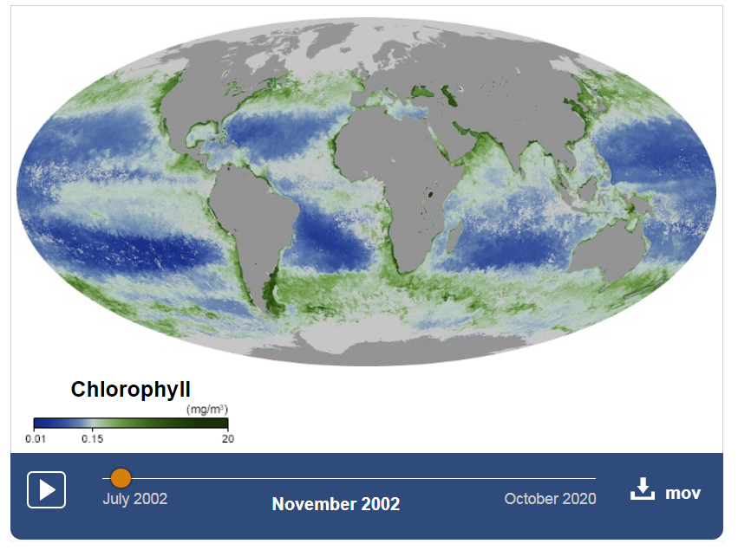

Figure 2. NASA through year chlorophyll concentrations. The web version from
https://earthobservatory.nasa.gov/global-maps/MY1DMM_CHLORA lets you drag the date.
One milligram per metre cubed in one part per billion.

It might be useful to think of reasons why permanent carbon removal was observed in only the EIFEX sea trial. Initial iron concentrations were very low. Initial injections were much higher and perhaps uneven and we know that overdosing can produce oxygen deprivation and dangerous algae growth. The large increase of the extra iron may have depleted other important trace materials. Water moves differently at different depths in ways that are hard to measure at the surface so that the post-injection water samples might have been from the wrong place. Keeping ships and crews at sea is expensive and so there was pressure to keep the trials short. Table 5 of the Yoon paper shows a range of 11 to 34 days after injection. Phytoplankton are grazed by zooplankton which migrate up at night and then retreat down to escape larger predators: we may have inaccurate understanding of the depths and velocities of this removal path. Zooplankton may have evolved methods to escape predators which may also work for escaping capture in sample bottles. Perhaps there was not enough time for the zooplankton to adapt to the new conditions. Some experiments took place in the cores of eddies. The successful EIFEX trial may have had a better-behaved eddy than the others or perhaps the Smetacek team were particularly skilled at tracking changes in eddy position. The eddies might also prevent organisms from outside the eddy getting at iron in them. All the trials used ferrous sulphate because it is one of the very few iron compounds which is soluble in water. We may not know enough about what the sulphur does to all the species of phytoplankton and zooplankton. While this is an excellent fertilizer for lawn grass it also kills moss and clover. Its acidity might be worse for hard shelled organisms than weaker CO2.

As the Wright brothers showed, a single success outweighs a long series of failures even if the certainty of failure of their work was very emphatically predicted by the President of the Royal Society of London and supported by an eminent inventor only a few years previously.

Some engineer’s suggestions for future work on iron enhancement are as follows.

We should use iron in its simplest nonacidic form by getting into sea water as Fe+ ions.
The injection rate must be carefully controlled starting as a small fraction of present values and never above concentrations in regions with good biodiversity.
We should check that growth increases are not depleting other essential nutrients or oxygen.
Injection and observation should be done over years not a few weeks.
We should avoid the costs, risks and time-pressures of crewed vessels.
We should test in a wide range of ocean regions, even unpromising ones.
We must improve understanding of the negative effects of ferrous sulphate on moss and clover.
We should try to narrow, or at least understand, the very wide range of estimates for the mass ratio of iron to carbon and its effects on the migration and evolution of zooplankton.
We should collect data on many other chemical and biological parameters, even ones we might think are irrelevant so that we can maximise beneficial effects.

Engineering

Most ships are designed to maximise useful internal volume for cargo and passengers but minimise external wetted area which causes drag. We want to do the very opposite. This suggests a cross section of a Y as shown in figure 3. The top ends of the Y are connected to 4500 mm tubes acting like the hulls of a catamaran. Iron will released from all four faces of the sloped arms of the Y and both faces of the vertical section below them. Together the entire Y acts like an over-size keel. Iron is supplied in almost the cheapest form of a rolled 250 mm angle, 15 mm thick in 12 metre lengths.
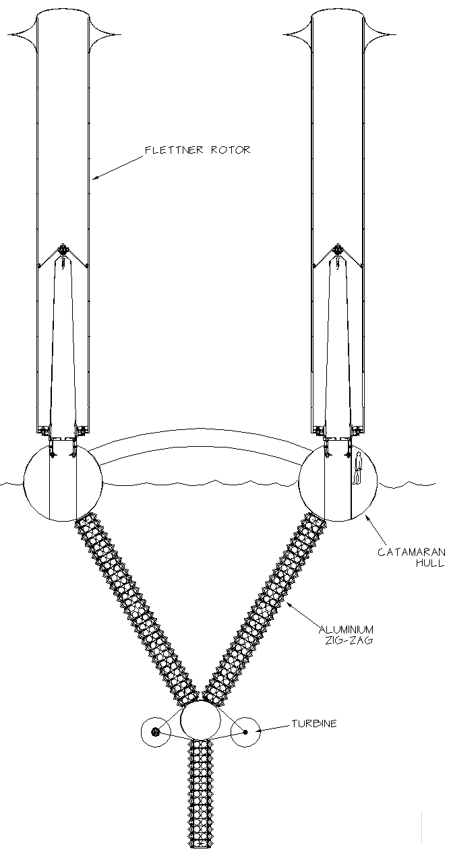
Figure 3. The Y-section vessel design.

Either side of the steel angles are aluminium sheets folded into a zig-zag. The gaps between aluminium and iron are open to the sea at each end and also at intervals along the 24 metre length of the two angle sections. The initial gap between aluminium and iron is 20 mm but will increase by about 12 mm as iron as removed. We need to leave enough for the remaining length to be removed intact for recycling. The motion of the vessel will move sea water through the gap between iron and aluminium.

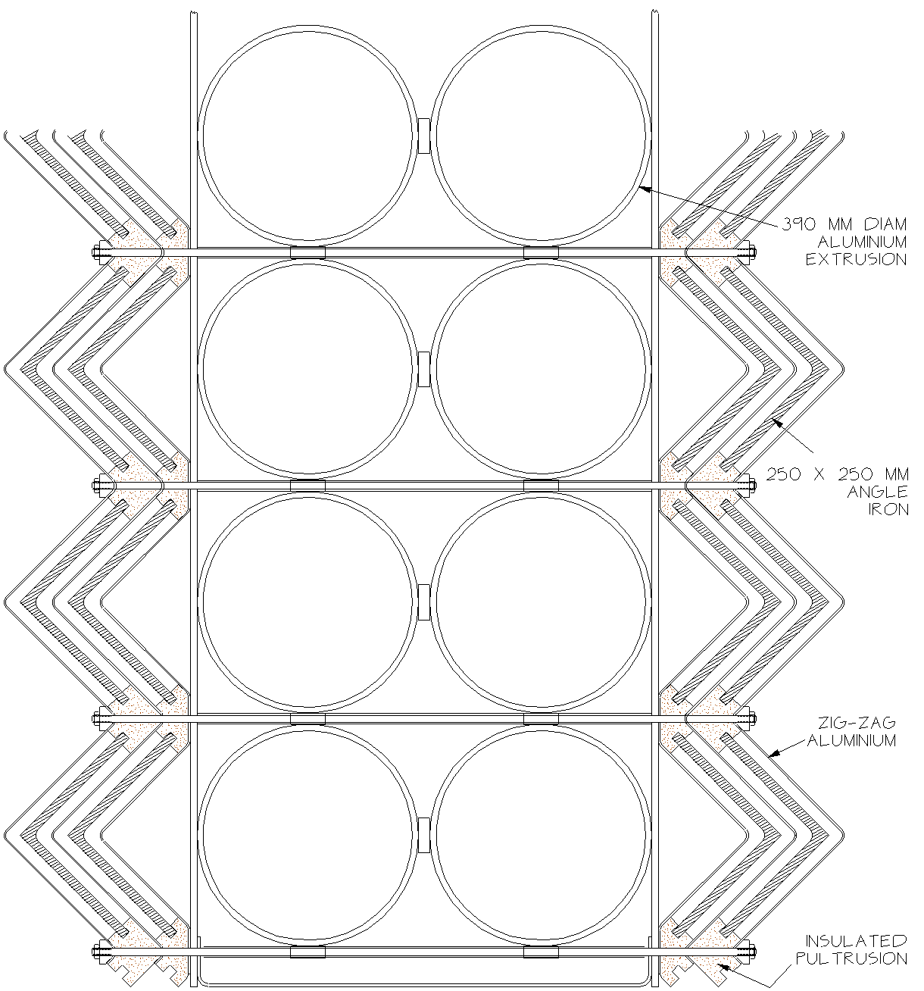

Figure 4. A closer view of the Y structure.
A close up of the Y is shown in figure 4. The hatched iron angles are supported along their full length by lengths of an electrically insulating material, dotted, such as a glass fibre pultrusion. The lengths will be inserted from both bow and stern.

Instead of an acidic ferrous sulphate solution, iron injection is achieved by reversing the current flow often used for cathodic protection of steel marine structures. This could be called ‘accelerated anodic corrosion’. From Faraday’s work on electrolysis we know that the current flow is a good measure of iron transfer rate. While sea water contains an immense range of materials the dominant ones are ions of Na+ Cl – . The Cl – ones will be attracted to the positive voltage of the iron and remove Fe+ into the water stream as soluble FeCl3. The Na+ and Fe+ ions will be attracted to the negative voltage of the aluminium zig-zag sheets. The Na+ can strip OH- ions from water to leave hydrogen and sodium hydroxide as in electrolysis. However we want iron to be left in the water stream rather than plated on to the aluminium electrodes so we need to do the opposite of electroplating technology. We must give the aluminium surface a film of conducting material with a crystal structure different from iron. Copper and carbon look promising but there will be new materials with similar requirements being developed for new batteries. A very thin film will be adequate, so the cladding material does not need to have a very high conductivity.
The core of the Y arms and vertical which joins them is formed from 390 mm diameter aluminium tubes which can be friction-welded to one another by 10 mm thick aluminium pads. The present design has quite a large buoyancy margin so we can surround the lower tubes of the vertical part of the Y with concrete. The low weight and the much longer lever arm than the keels of conventional vessels will give self-recovery from capsize. The extruded tubes can be glued to flat vertical aluminium sheets by a line of prepreg material cured by a hot pad from outside. The zig-zag aluminium and steel support pultrusions can be bolted either side of the flat vertical sheet with M12 tie bars running between the tubes.

To avoid wasting time returning to land for refuelling we want to generate electrical energy for iron injection from wind. Although currents are very high, about 40 amps into each of 600 lengths of angle iron, the voltage will be very low, the resistance of a 30 mm length of sea water with a conductivity of typically more than 3.5 Siemens per metre and will be helped by the favourable electrode potential difference between steel anodes and the cathode material.

The site https://earth-planets-space.springeropen.com/articles/10.1186/s40623-017-0739-7
shows a map of sea water conductivity. A power requirement of 50 kW is likely. This power requirement is lower than for marine cloud brightening used for temperature reduction.

The size of wing sails needed for low wind speeds is rather high and would produce a large heeling moment in higher wind speeds. Flettner rotors would have a higher thrust coefficient and a lower centre of pressure. Spin speed allows convenient control of thrust. They can fit around a much larger diameter mast capable of withstanding the bending moments category 5 hurricanes. It turns out that rigidity to limit the deflection angles of spherical bearings is more important than strength for masts and rotors. Movement of the vessel through the water will power a pair of underwater turbines, 1.7 metres in diameter, mounted low down on the vertical of the Y so that the higher hydrostatic pressure will reduce cavitation. Their rather low rotation speed can be increased up with epicyclic gearing to a nice generator speed using designs for long thin units used for down-hole pumps. Grundfos make units up to 200 kW with a diameter of only 220 mm. While induction motors can be used as generators if they can feed into an existing grid it will be better to fit permanent magnet excitation. We can put step-down transformers, centre-tapped for full-wave rectification, at the connection to every pair of angle iron lengths. The forward voltage drop at the rectifiers will be a significant energy loss so pairs of Schottky diodes would be attractive.
Vessels designed for iron control can also collect information for many scientific research programmes. Lessons from doing electronics underwater, not all painless ones, have taught that the only containers that work are metal tubes with a double weld to close one end and duplex O-ring seal at the other. A design for marine cloud brightening in has a diameter of 1.5 metres fitting vertically. Rotating by 45 degrees about a vertical axis makes contact with AC and DC power and data communications. A wide variety of modules can be inserted or replaced as rapidly as cards in 1960’s mainframe computers. We can therefore use iron vessels to carry out a wide range of other scientific work.
We will also need power for vessel movement near harbour and in windless conditions. This can come from a Diesel-driven generator and storage batteries. The Delta Hawk engine design with reliability for aircraft use would be very suitable. There will plenty of volume for Diesel fuel in some of the aluminium tubes. We can also move water in or out of other to adjust trim and draft.

Misery list

Proposals for un-crewed vessels were until recently ridiculed but an increasing number of successful applications have now been achieved. The first vessels will carry a crew. Plenty of governance problems remain.

The use of fertilizer on land is now widely accepted and indeed is essential, even not quite adequate, for feeding the present world population. However it is not without problems and similar, perhaps unknown ones, may affect efforts to increase the supply of fish protein. There will be a need to adapt and agree to international fishing quotas.

Preventing iron deposition on the cathodes may require new materials.

Engineers are seriously ignorant of marine biology. The lowest estimates for iron-to-carbon ratio are a definite show-stopper.

All the known problems of marine engineering plus some unknown unknowns. I leave some room below.

Calculations
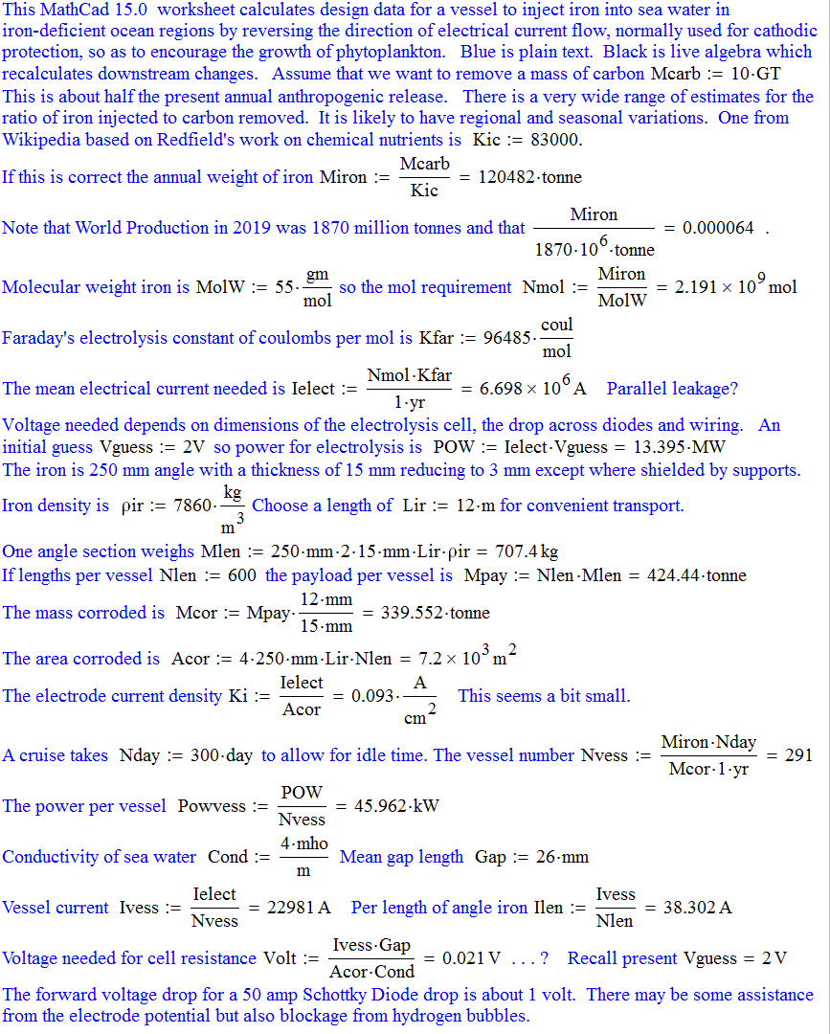
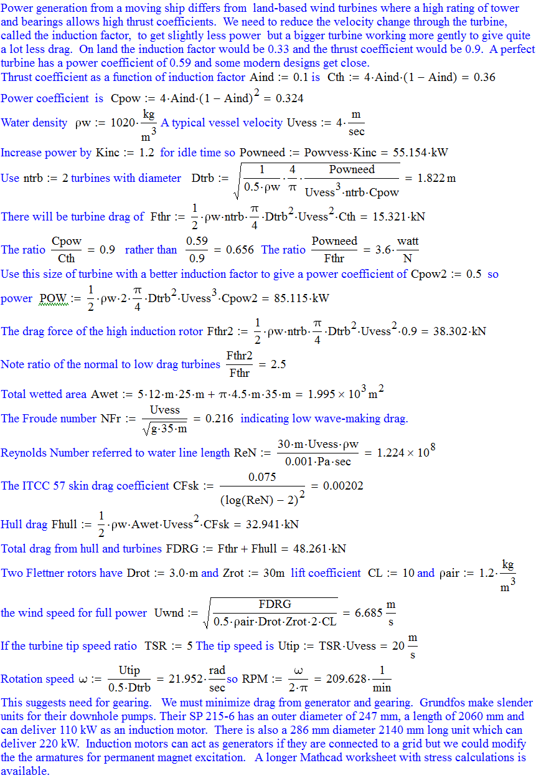
This table assumes the 83,000 iron/carbon ratio from Wikipedia and the removal of half the annual anthropogenic CO2 release of 33 Gigatonne. The calculations have not yet been checked by professional sailors, electro-chemists or marine biologists but arms are being twisted.
Total displacement | 1580 tonne
Spare Buoyancy 7 January. | 370 tonne
Waterline length | 35 m
Iron payload and released | 424 tonne x 12/15 = 340 tonne
Freeboard change | 0.93 m
Corroding area | 7200 m 2
Corroding current | 23,000 amps
Cruise duration | 300 days
Estimated voltage | 2V
Corroding power | 46 kW
Flettner rotors | 2 x 3.5 m x 30 m
Vessel speed | 4 m/sec = 7.8 knot in force 4 wind speed.
Froude number | 0.27
Turbine diameter | 1.8 m
Weight of aluminium | 250 tonne
Angle iron | 600 off 250 mm x 15 mm = 700 kg each
Vessel number | 300 ++ for ones in the wrongs place.
World electrolysis current | 6.7 x 106 amps

References and useful reading.

Yoon J-E +15 al.. Reviews and synthesis: Ocean iron fertilization experiments – past present, and future looking to a future Korean Iron Fertilization Experiment in the Southern Ocean (KIFES) project. Biogeoscinces vol.15, pp 5847-5889, 2018. https:doi:/10.5194/bg-5847-2018.

An excellent review of all 13 iron sea trials.

Smetacek V. +29 al.. Deep carbon export from a Southern Ocean iron-fertilized diatom bloom.
Nature. Vol. 487 pp 313-319 2012. doi:10.1038/nature 11229.

A description of the problems of doing analytical bio-chemistry at sea and how the EIFEX project solved them to give promising results for carbon removal.

Glasstone S. Textbook of Physical Chemistry. MacMillan, London. 1956.

Schlesinger M, Paunovic M. Modern Electroplating. 5th edition. Wiley 2011.

The best resource on electroplating. We want to opposite on cathodes.

https://www.nature.com/scitable/knowledge/library/the-biological-productivity-of-the-ocean-70631104/

A good survey by the Nature Knowledge project.

https://theconversation.com/tiny-plankton-drive-processes-in-the-ocean-that-capture-twice-as-much-carbon-as-scientists-thought-136599.

About research for the JETZON project.

https://www.geoengineeringmonitor.org/2018/05/ocean-fertilization/

A listing of all the objections by the well-funded ETC group. With enemies like these . . .

George R. Personal communication 2021.

