Machine update settings
Contents
MU Settings 2
TRUEBEAM CONSOLE MU Settings 2
Pinnacle MU Settings 2
Other Settings 3
Tolerance Table 3
Leaf Gap 3
Gantry Angle Start/Stop Checks 4
Corner MLC settings 4
Max MLC tip positions 5
Variable Jaw Settings 6
Dose Rate for FFF 6

MU Settings

TRUEBEAM CONSOLE MU Settings
(System Admin -> Treatment -> MU Limits)
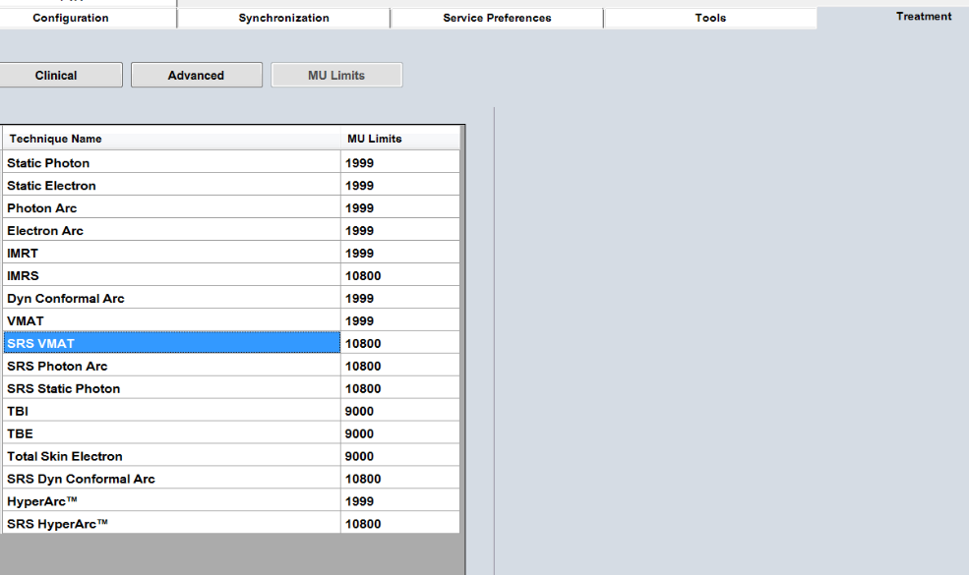

Pinnacle MU Settings
It is suggested to do the following steps before changing settings:
- Delete the current (uncommissioned) copy of the machine in physics
  - (this is in case something got changed unknowingly while sitting there)
- Copy the currently commissioned machine
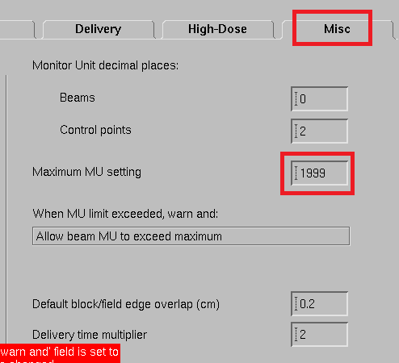
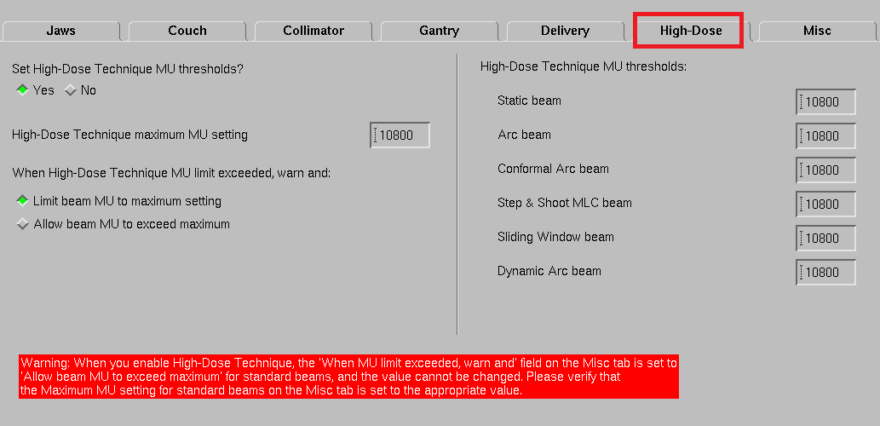

Other Settings

Tolerance Table
Need at least 1 tolerance table (plus set as default)
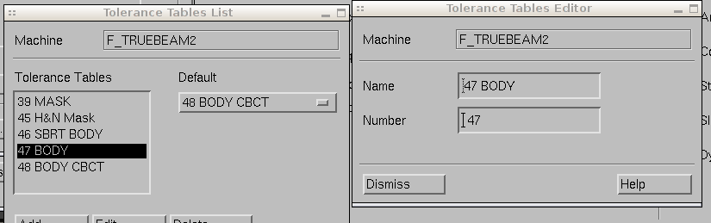

Leaf Gap
NOTE: If this needs changed, all profiles (photon and electron) need calculated, and the photon output factors
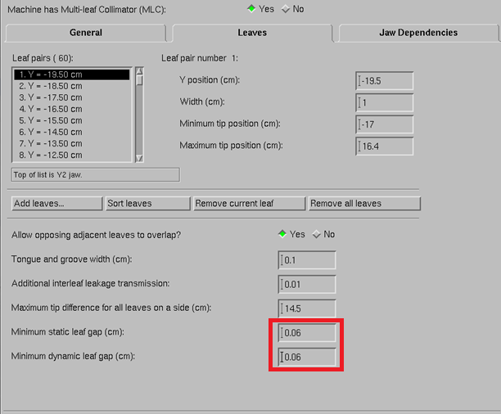

Gantry Angle Start/Stop Checks
(stops arcs through180)
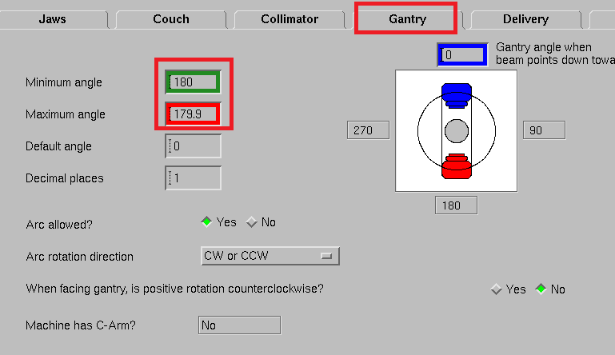

Corner MLC settings
Varian does not allow the mlc’s to go beyond this point, but won’t say the plan is invalid
Leaf Pair | Maximum tip position (cm)
1 | 16.4
2 | 17.5
3 | 18.4
4 | 19.5
5-56 | 20
57 | 19.5
58 | 18.4
59 | 17.5
60 | 16.4

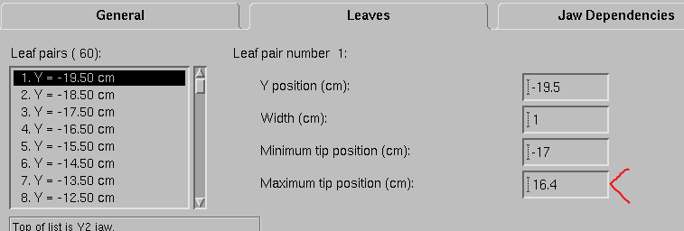

Max MLC tip positions
Two spots, same number
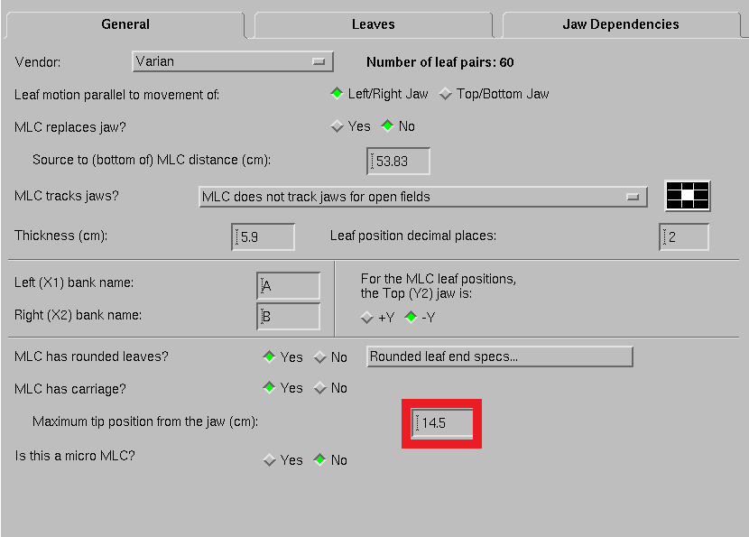
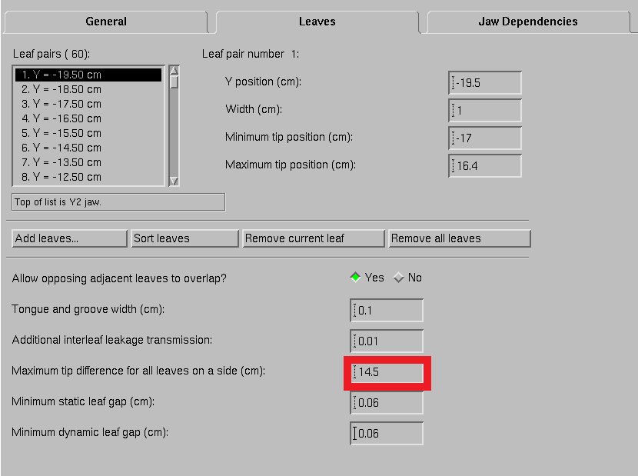

Variable Jaw Settings
IF TURNING ON REMEMBER TO VERIFY VARIABLE JAWS IS ENABLED IN MOSAIQ
MLC->Jaw Dependencies
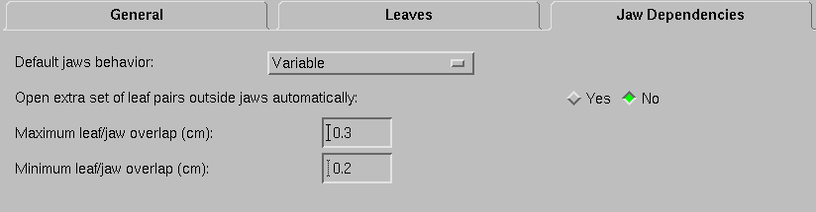

Dose Rate for FFF
Remove 600 Dose Rate
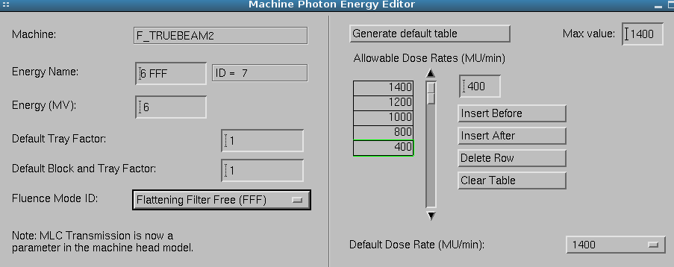

MOSAIQ
Remember to make sure your machine characterization has moveable jaws = Yes
