About us:

Ape Action Africa is a small UK NGO charity responsible for running one of the largest primate sanctuaries in Africa.

We are based in Mefou Park, just outside Yaoundé in Cameroon.

We currently provide lifelong care to 24 critically endangered Western Lowland gorillas, 124 endangered chimpanzees and over 100 native monkeys of different varieties who live in natural forested enclosures, following their rescue and rehabilitation.

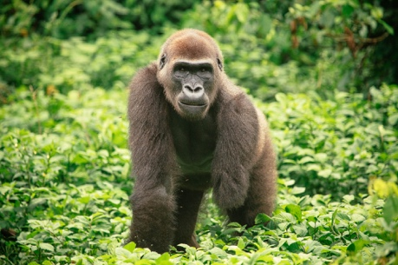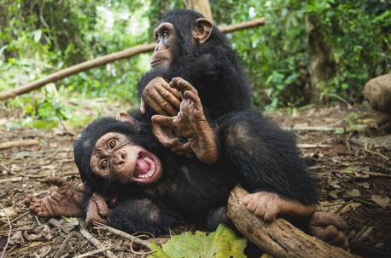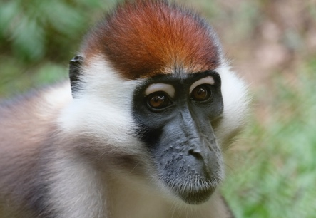

Our work started in 1996 and focuses on three key areas:

Ape: To provide a sanctuary for individual, endangered primates orphaned by the illegal logging, bushmeat and pet trades.
Action: To actively rescue orphaned primates, providing rehabilitation and long-term care in a protected forested environment.
Africa: To work closely with the Cameroonian people to preserve and protect their natural heritage against the devastating impact of climate change through education and social support.

Job summary:

The Deputy Director will be responsible for the successful operation of Mefou Primate Park and the care of the primates, staff, and volunteers therein.

Reporting to the Director of Ape Action Africa, the Deputy Director will be the line manager for three staff members: Head Vet, Head of Education and Controller of Mefou Primate Park.

Key Accountabilities:

- To develop work programmes for staff and volunteers at Mefou Primate Park, in collaboration with direct reports, to reflect the primate’s needs and priorities and ensure they are being completed effectively, to agreed standards.
- To manage the finances and assets of the organisation by accounting for all cash and project expenditures.
- To manage the design of all new construction projects and write the accompanying budget, in collaboration with the Director, to ensure they reflect current and future needs of the sanctuary and plans are delivered on budget and on time.
- To continuously review and maintain Ape Action Africa’s operational protocols and internal policies alongside the Controller, to ensure they are adequate, and all staff fully comply with them.
- To ensure staff issues are being dealt with appropriately and comply with the project’s disciplinary protocols and the Cameroon Labour Code.
- To manage the on-site volunteer programme so that Ape Action Africa benefits from the placements and each volunteer has a rewarding experience.
- To be a source of proposals for fundraising and grant opportunities and work closely with the Fundraising Coordinator to deliver financial success.
- To develop relationships with key sponsors and stakeholders, under the guidance of the Director and deputise in the Director’s absence as required, to support the success of Ape Action Africa’s operations.
- To work collaboratively with local communities and their leaders, to ensure the existing relationship is maintained, contributing to the success of Ape Action Africa.
Additional Responsibilities:
- To prepare reports as required by key sponsors and partners, the Board of Trustees, and the Director.
- To learn and apply key aspects of Cameroon employment law, salary system and PASA Sanctuary guidelines.
- To represent the Director in her absence.
Required experience:
- At least 4 years’ experience of working with primates
- At least 3 years’ experience managing team
- Excellent command of English and French - Both written and verbal (or be willing to learn)
- High level of competence with computers, particularly MS Office programs
- Experience in improving systems and processes
- Pragmatic, resilient and self-motivated
- Good negotiator, able to build partnerships
- Ability to withstand pressure, able to manage crisis situations.
Desired (but not essential) experience:
- Previously worked in Africa
- Previously worked in a sanctuary

Required Skills:
- An inspiring leader, sensitive to local culture, able to lead and manage in a complex and challenging environment, in alignment with the vision, mission, and values of Ape Action Africa.
- Dynamic, able to motivate a team and build relationships.
- Effective communicator, confident and accessible to staff, volunteers, community members and leaders, partners, donors, and government leaders.
- Able to work with humility and respect for other team members, who may offer advice and guidance based on their long-term experience at Ape Action Africa.
- Able to inspire trust and respect from staff, management and donors through actions and leadership.
- Able to work in a team and motivate staff with a long-term vision while managing daily activities.
- Able to deliver a project from concept to conclusion, with the ability to plan, prioritise, implement, communicate, and manage effectively.
Compensation:

- Monthly salary (300,000cfa/$540 USD during the 3-month trial period, increasing to 500,00cfa/$900 USD thereafter) paid in local currency.
- Private 2-bedroom forest house, with cooking facilities.
- Three meals a day, from staff kitchen, if preferred.
- One return airfare and eight weeks paid holiday per year.
- One rest day a week, to be taken in the forest.
- All visa and residence permit costs.
Notes:

- The chosen candidate must provide evidence of personal travel and health insurance, a negative TB test and Covid 19 (Inc. Booster) and Yellow Fever vaccinations.
- While scheduled working hours are 7am to 5pm, with a 90-minute lunch break, it is expected that the chosen candidate would be flexible with these times, as working with wild animals can be unpredictable.

If you are interested in applying, please send your CV and covering letter to info@apeactionafrica.org

