Rapid Need Assessment Report

Of Flood Affected Areas of District Sibi Balochistan

This Rapid Need Assessment practice has conducted by Dehi Terquaiti Tanzeem Sibi in affected areas District Sibi in its (Sibi & Lehri Tehsil) which affected recent heavy rainfall/ flood.

- Background:
This rapid need assessment practice summaries the current situation of recent heavy rainfall and flood affected areas of District Sibi in its Sibi Tehsil namely UC Mal, Talli, Sultan Kot, Bakhara Ghulam Bolak, Gullu Shahir, Mohalla Allah Abad and UC Khair Wah Tehsil Lehari. Food Security, Livelihood, Health, WASH and Shelter are urgent needs of affected population. 15 water tube wells and their Solar Panels also damaged, link roads, bridges, Livestock’s and agricultural lands including crops also effected in large scale. The rapid need assessment practice has conducted by Dehi Terquaiti Tanzeem Sibi on 29th & 30th July 2022. The objective of the Rapid Need assessment was to identify the needs of the most vulnerable communities affected during heavy rainfall and flood as per the PDMA and DDMA response strategy. The Rapid need assessment was conducted through random visits, FGDs and KIIs. For the RNA above mentioned Union Councils was selected randomly and from each UC 3 villages were selected randomly for FDGs.
A recent storm caused a spell of heavy rainfall and flood in Balochistan, which resulted in extreme flash floods on 5th July to 7th July 2022 and onward which is still continue and hitting the communities. These flash floods were sudden and unexpected at this time of the year and affected majority population, in the result Two thousand five hundred (2500)families have been affected including more than 24 injured and 6 death cases reported from District Administration Sibi, 258 houses damaged, and displacing to as per current information more than 650 peoples rescued by local communities from effected areas to safer places and Livestock also effected mostly peoples depends on livestock and Agriculture (Cultivation) for source of income which are affected by Heavy rains and flash flood water.
Purpose of the Assessment:
A team was organized by Dehi Terquaiti Tanzeem Sibi to get the rapid assessment details regarding the flood affected communities in the locality of the District Sibi tehsil Sibi affected UCs (Sultan Kot, Talli ,Mal, Bakhara Ghulam Bolak,Gullu Shahir and Allahabad area of Sibi and Khair wah tehsil Lehari). The purpose of this assessment to identify the contemporary issues and problems to be controlled with immediate appropriate and feasible interventions.

- Current Situation:
According to the Rapid Flood Assessment Report by team it is identified that the flood in the District of Sibi has affected 2500 families, included Man, Women and children, 06 death cases reported. Whereas more than 24 have been injured, 258 houses damaged, and per current information more than 650 peoples rescued by local communities from effected areas to safer places. The flood has caused further damage to existing infrastructure, and impacted road conditions, connecting Bridges, Local Dams (Gandah Jat) and Bandat, transportation, Educational Institutes, livestock and agriculture land erosion. Already deprived health facilities are facing acute shortages of skilled human resource. This critical situation has placed the poor communities of affected Union Councils at risk of communicable and water borne diseases on one side and loses of income earning sources (Livestock, Agriculture, local Dam (Gandah Jat) and Bandat, Tube well and their Solar Panels), There is a high risk of post flood disease outbreaks such as gastroenteritis, malaria, skin infections, snake bites, ARI (due to winter season), leishmaniosis (through sand fly bite) etc.
- Need of the affected population/Problems Identified:

As per assessment the following items are the need of affected population

- Urgent need food items
- Urgent need of tents/shelters
- Urgent need of primary medicines
- Urgent need of NFIs including
- Water storage items (water cooler, jerry can)
- Temporary Shelter/Tents
- Mosquito Nets
- Installation of latrines
- Clothes (women and children)
- Kitchen utensils and stove/gas cylinders)
- Hygiene items (NFIs)
- Solar items (Lights etc.)
- Limited access to safe water, sanitation and hygiene;
- Limited access to health services due to damaged health facilities, long distances, human resource, transport availability;
- Increased risk of water and vector borne diseases
- Frequent outbreaks of communicable Means.
- There is a need to urgently provide medicine kits, water purification tablets (aqua tabs) and support to community mobilization to improve hygiene practices.
- Damage to public infrastructure affects a far greater proportion of the population than those whose homes or businesses are directly inundated by the flood and have significant impacts on regional economies.
- Immediate emergency relief interventions are required.
- Buldozer & Tractor hours for rehabilitation of local Dams (Gandah Jat) and Bandat (Agriculture Land).

- Statistics:

No | UCs
1 | Mal
2 | Talli
3 | Sultan Kot
4 | Bakra Ghulam Bolak (Partially affected)
5 | Gullu Shahir (Partially affected)
6 | Mohalla Allah Abad (Partially affected)

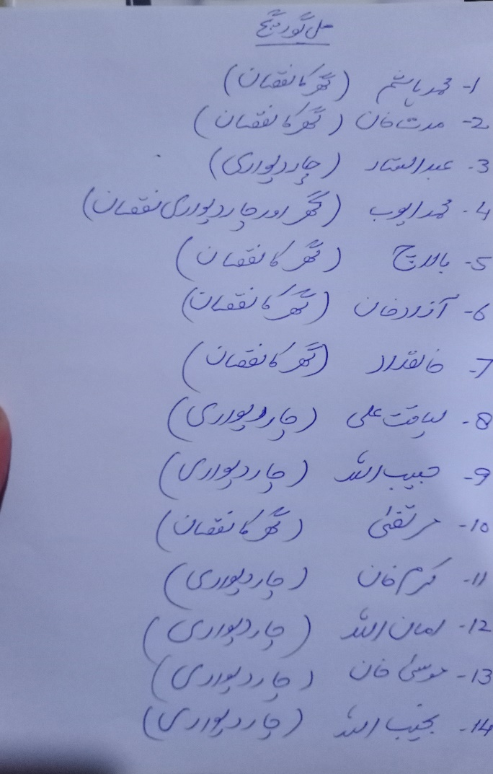 | 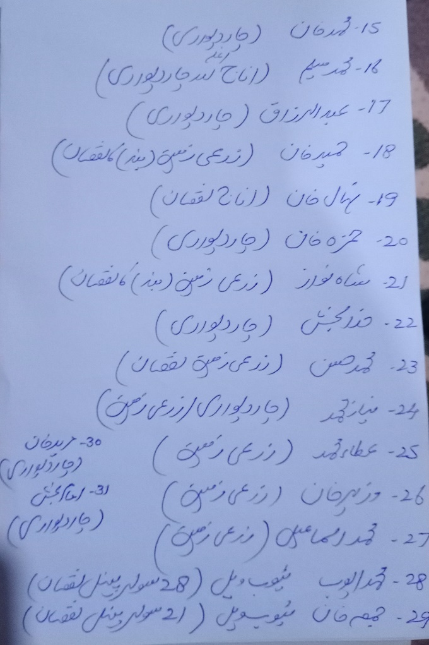

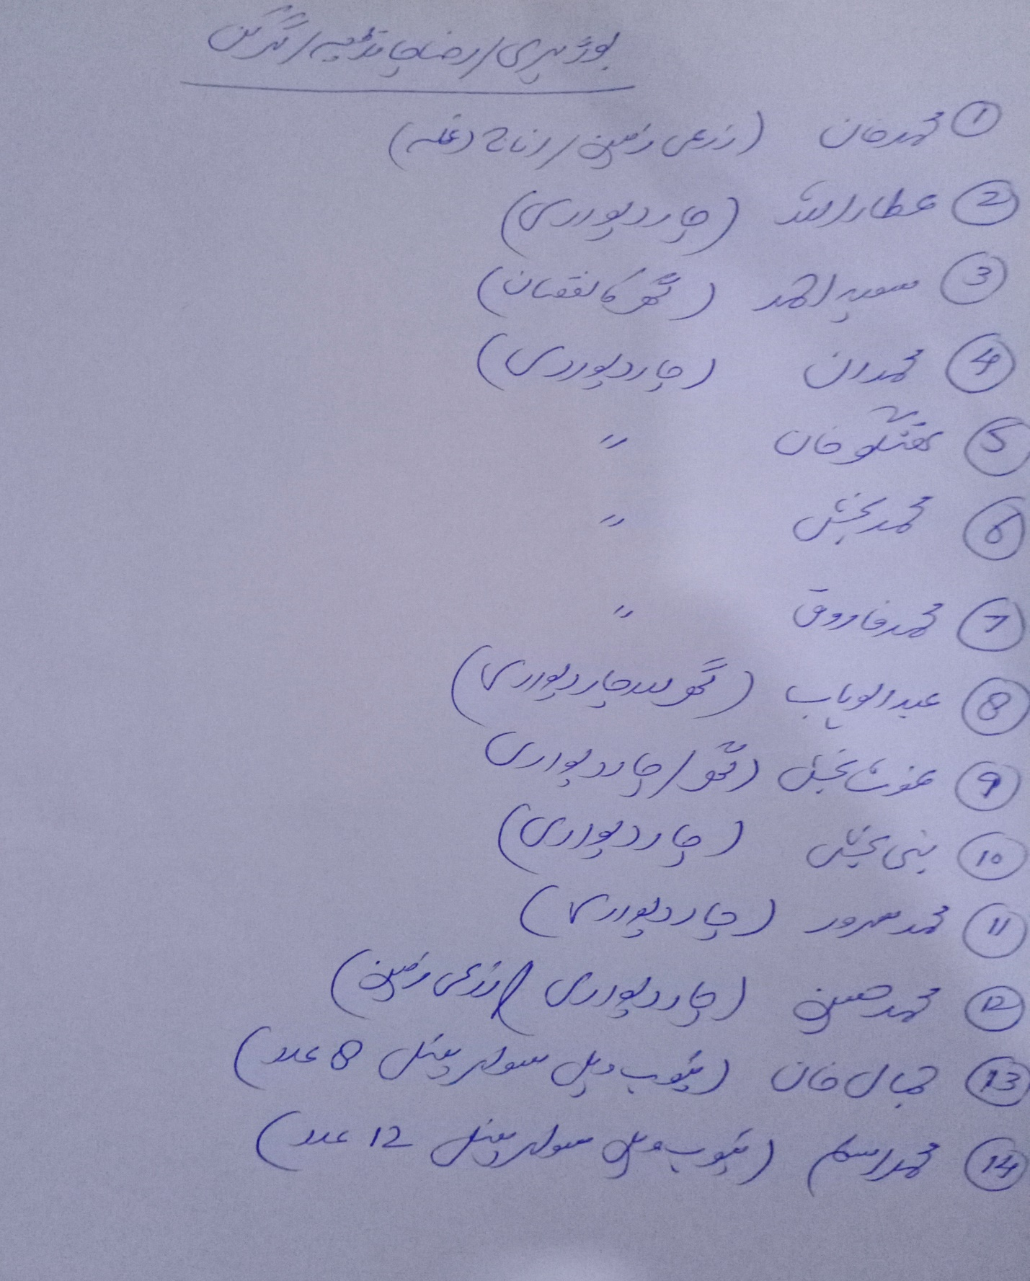

VI. Government and other Humanitarian Actor Response
In the current situation PDMA is working in the area with very limited resources.

Picture:
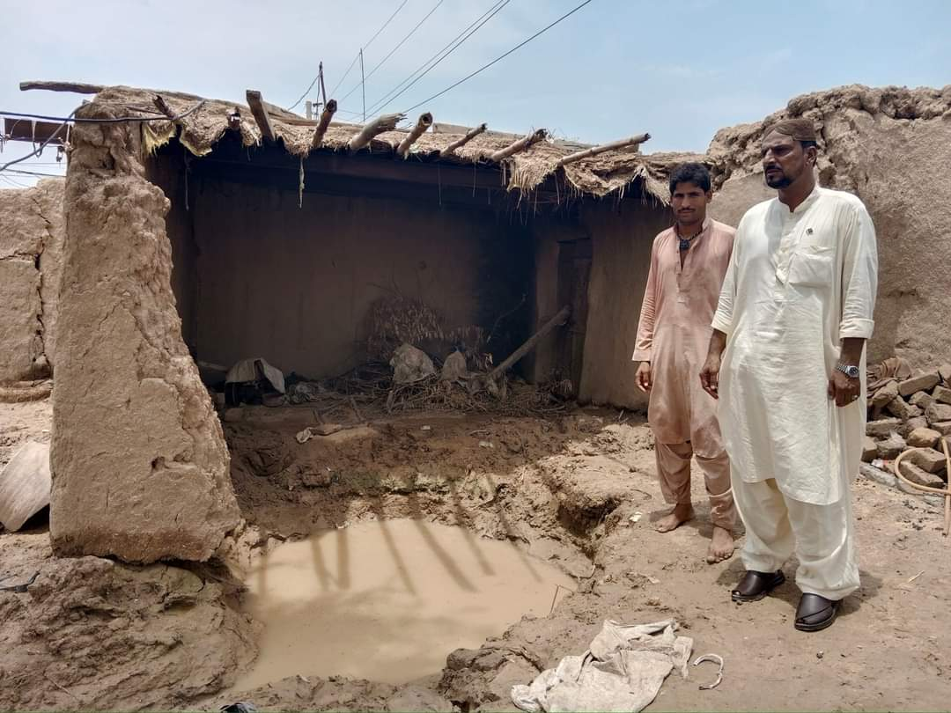 | 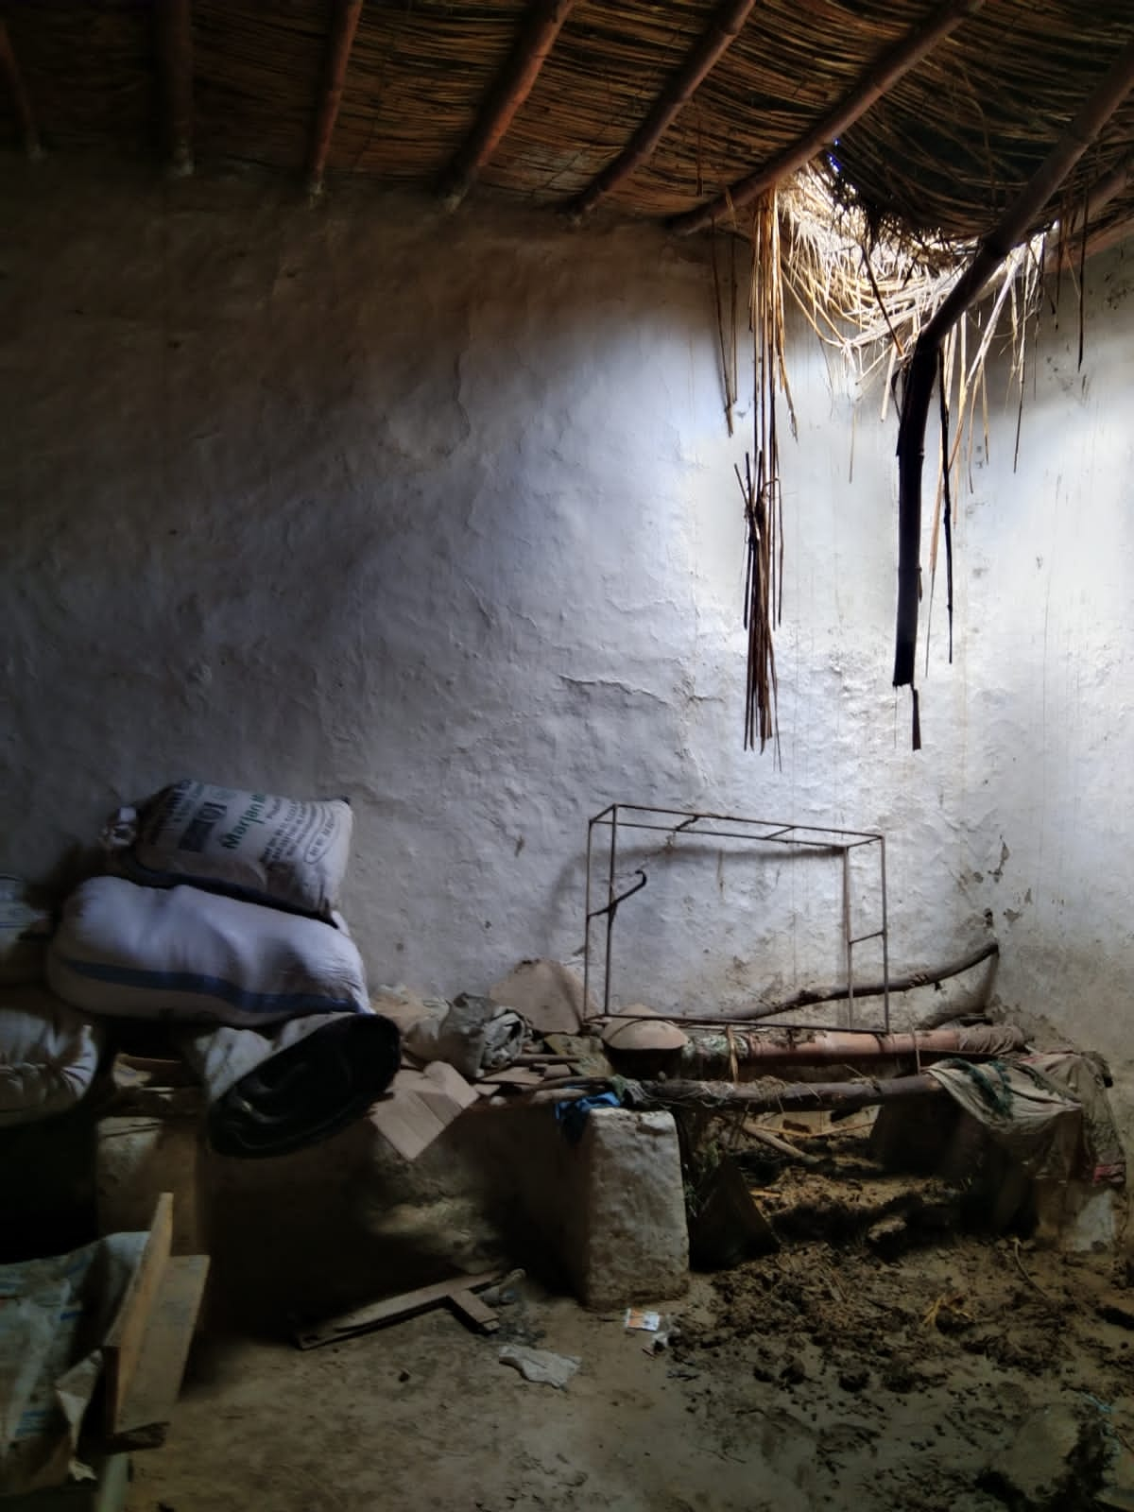
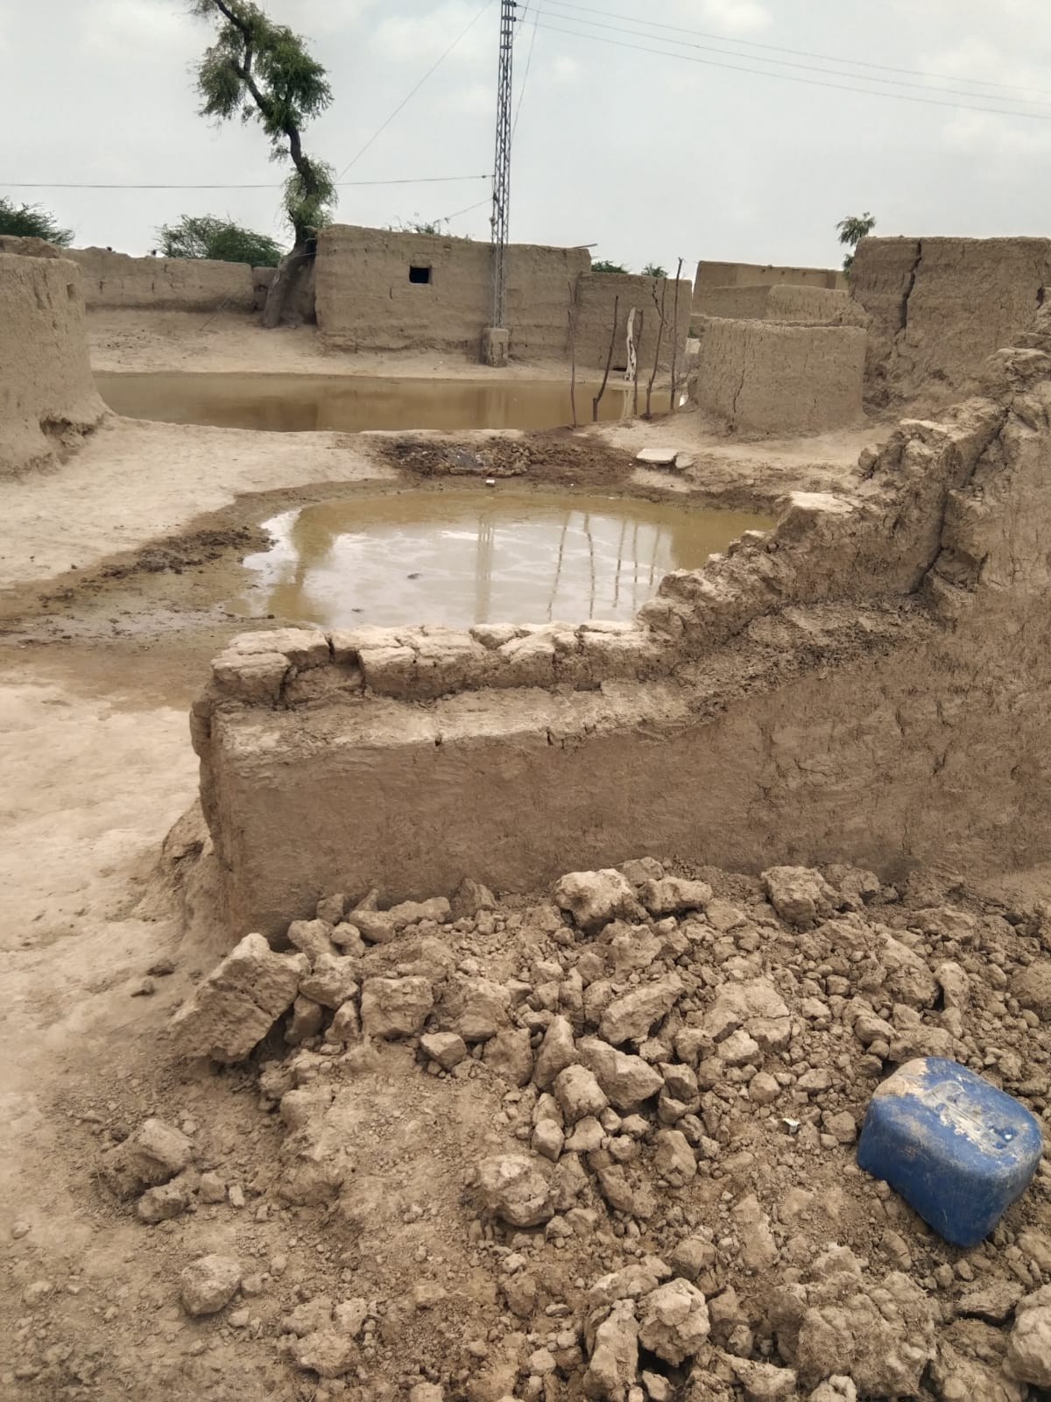 | 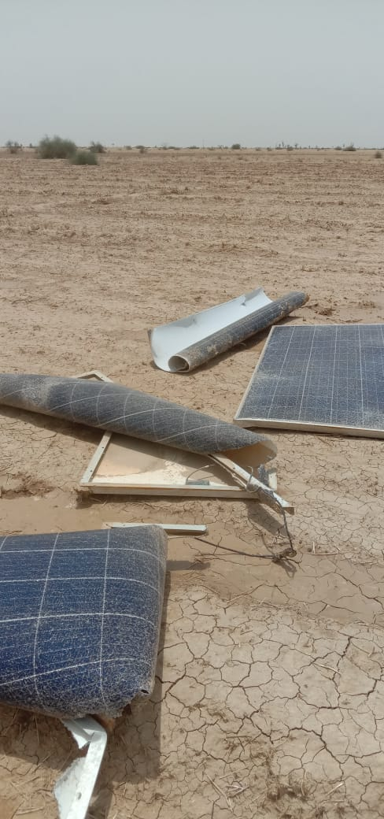
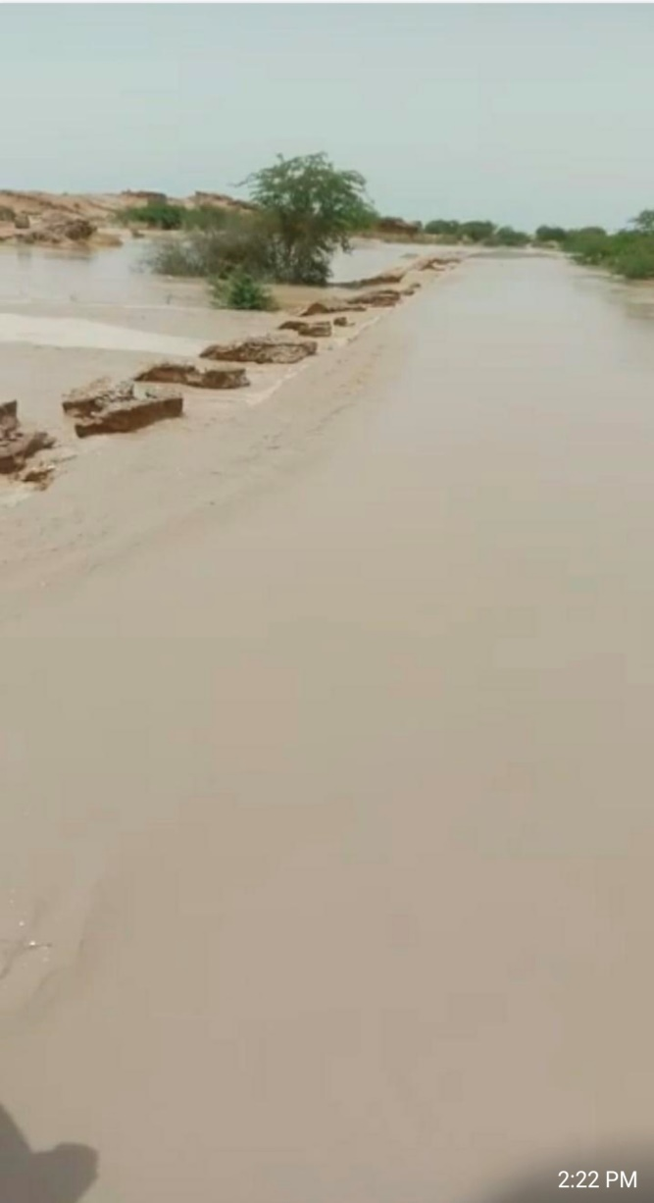 | 