Target Product Profile for Vaccine Logistics Management Information Systems
  - dd month, 2018

Background
Well-functioning supply chains save lives. They are essential to getting medicines, vaccines, and other health products to clients, wherever and whenever they are needed. A hallmark of effective supply chains is end-to-end (E2E) visibility of supply and demand data that are used to make decisions and take effective action. For example, district supervisors should routinely be able to use data to—
- identify and address a stockout of a needed vaccine, diluent or injection device;
- identify risk of expiries and reposition stocks accordingly;
- trace a batch/lot to all facilities in order to respond to a recall;
- identify a broken refrigerator, and restore a site to service.

For immunization programs, a critical success factor is access to accurate, complete and timely data on vaccine utilization and distribution, the performance and deployment of cold chain equipment (CCE), and the routine use of this data to inform operations and management decisions. Accurate and timely supply chain data at the country level can also be leveraged at the global level to improve demand forecasts, ensuring that funds are available when needed, and that vaccine suppliers and cold chain equipment manufacturers are able to meet market demand on time and in full. And visibility of product data throughout the supply chain enables traceability of every product, reducing risk and improving quality assurance and accountability for the valuable products flowing through the system.

The Market Gap
Growing demand for digital logistics management information systems (LMIS) software solutions from Gavi-eligible countries has stimulated software developers and service providers, remote temperature monitoring device innovators, and refrigerator manufacturers to develop and test a variety of software and hardware products. However, the absence of a normative standard of features required of a LMIS has resulted in costly development of bespoke local solutions, and very few choices of off-the-shelf systems that are interoperable, extensible, and scalable. For example—
- Current bespoke solutions may meet the needs of one or more immunization supply chain (iSC) functions, but may not follow supply chain best practice, or may disregard principles of interoperability and security of national data.
- Bespoke solutions may be so customized for the local context that they are not easily replicated in other countries. Investments made in one country context have been repeated in multiple subsequent countries (“reinventing the wheel”) because of the lack of globally-applicable, reusable software solutions.
- Lack of interoperability and open data standards has resulted in users having to access multiple dashboards, each with unique logins and siloed data.
- There is inadequate choice in the market for robust off-the-shelf LMIS solutions that are optimised for vaccines and that offer a range of business models, services, and sustainable cost models.

Purpose & Objectives
The purpose of this TPP is to help guide the market of potential LMIS solution providers by defining normative standards for LMIS solutions adapted to the unique needs of immunisation supply chains in low and middle income countries.
The objectives of this Target Product Profile (TPP) are to ensure countries have access to—
- best-in-class digital LMIS that meet the unique needs of the iSC and a country’s particular supply chain design and strategy;
- choice in software hosting, administration, and value-added business intelligence services;
- a range of cost models that enable cost-benefit analysis of different solutions and sustainable total cost of ownership.
This TPP addresses both the need for different business models underlying the LMIS, and the need to standardise structural aspects of the LMIS architecture and provide a high-level set of core functions, configurable and expandable to meet additional country needs. The standards and core functions are intended to shape the market for a range of LMIS software solutions and cost models that meet the particular needs of vaccine distribution, while not being unduly restrictive to innovation. Finally, this TPP seeks LMIS software solutions that align with the Principles for Digital Development.

Limitations
- This TPP does not assume that all countries are ready to deploy a robust end-to-end LMIS solution. However, it does seeks solutions that support both large scale, full-feature deployments that connect all tiers in the supply chain, and also limited-feature deployments that may only support some business processes or only connect a few tiers (e.g. national and provincial stores, or district store and health facility) based on country priorities and context. Solutions should address current needs and limitations while enabling further scale as supply chains and ICT infrastructures mature.
- This TPP does not suggest vertical solutions restricted to vaccine products alone; integrated systems that are or can be used for other health commodities are preferred if they meet the vaccine-specific functional scope discussed below. Solutions that support many products offer economies of scale and reduce the total cost of ownership as a percent of annual product value managed by the LMIS.
- The TPP does not suggest that a single monolithic solution is needed to meet the entire functional scope outlined below; interoperability between a central VxLMIS and constituent stand-alone applications or extensible modules is core tenet of this TPP.
- This TPP does not address the need for expert support for system implementation.
- This TPP is not a software requirements specification, nor is it intended to be used by countries as a software selection guide or procurement document. It is intended to identify qualified Vaccine LMIS solutions; countries will need further analysis of their needs (including supply chain design and ICT capacity) to enable them to select the best solution from the qualified list for their particular context.

Market Incentive
Of the 68 Gavi-supported countries, only 23 are currently working to improve data visibility and use through better LMIS, and most of these countries are either relying on bespoke systems that were developed to support existing workflows and business processes that were designed for a low–tech, data-poor environment. Most other countries are relying on a combination of paper, Excel, and Access-based systems. While not every country is ready to implement an E2E digital solution to operate their vaccine supply chain, every country needs to begin leveraging robust technologies that will enable them to evolve as their supply chains optimise, their Internet access expands, and their human capacity improves. Furthermore, many Gavi-graduated countries are looking for low and moderate cost solutions to support their maturing supply chains. Finally, solutions that meet this TPP will be well-positioned to meet the needs of other pharmaceuticals in the health supply chain, such as contraceptives and medicines to treat HIV, tuberculosis, malaria, and non-communicable diseases.
To reduce the cost of country adoption and to provide predictable payment, it is anticipated that Gavi or its procurement agent(s) will enter into global agreements with select TPP-qualified solution providers. Based upon country requests, the global agreement would provide pooled country funding for fees associated with cloud hosting, system administration, global help desk, and value-added business intelligence services (insights, optimization, and predictive analytics).

Software Business Models Sought
The market of supply chain software solutions ranges from open source off-the-shelf (OOTS) to commercial off-the-shelf (COTS) to SaaS. Many of these solutions are high-cost commercial enterprise resource planning (ERP) packages. The market of solutions designed for resource-constrained countries with weak information technology and energy infrastructure is very limited. The table below identifies three different business models that Gavi seeks to stimulate in order to provide adequate choice to Gavi eligible countries. Each of these models will require implementation consulting services for requirements analysis, design, configuration, customization, testing, training, change management, deployment, and documentation.
BUSINESS Model | software License | Hosting and Support/ MAINTENANCE services | Business Intelligence SErvices
Open source off-the-shelf software | No license cost | Local hosting and software administration support  Upgrades can require effort or support | No services associated with software; requires a separate contract.
Commercial off-the-shelf software | Annual license cost | Local tier 1-2 software administration and support. Tier 3 support from the vendor for a fee  Requires local hosting or offers optional cloud hosting for additional fee  Access to bug fixes and upgrades with paid annual maintenance contracts | No services associated with software; requires a separate contract.
Software as a Service | Annual fee per user, service level agreement | Includes tier 1-3 support, software administration  Includes cloud hosting  Includes continuous upgrade | Services may be included as an integrated service

Each of these business models offers a range of cost-benefit considerations:
- OOTS are license-free and therefore perceived to be cost free, but one still has to pay for implementation and administration. They may have a higher total cost of ownership over the life of the product, especially if software upgrades and bug fixes are needed, and there is some risk associated with whether there is a viable community dedicated to maintaining and upgrading the core software. OOTS can be highly customizable (including by locally-hired programmers) compared to COTS and SaaS, however there is a risk that poorly-done customization can cause unique forks or require re-implementation to take advantage of enhanced features available in the upgraded core version. Implementation costs are additional and must be contracted.
- COTS offers a standard business model in which the commercial software provider routinely upgrades the software with new features and offers these upgrades to its clients, sometimes for an additional fee. There are low and middle-tier priced COTS solutions for warehouse management that might be able to service the broader LMIS needs of the iSC. However, it would be difficult to find a warehouse management application that is designed to handle general pharmaceutical products as well as meeting the unique requirements of vaccine storage and distribution (e.g., temperature monitoring, cold chain management, etc.). Implementation costs are separate from license fees and need to be negotiated separately.
- SaaS offers a full-service combination of software, hosting and support, and value-added business intelligence services. They are perceived to be expensive, but total cost of ownership may be competitive with other options when the business intelligence support results in higher performing and optimised supply chains with reduced inventory holding costs. Implementation costs are separate from usage fees and need to be negotiated separately.

Functional Scope of a Vaccine LMIS
A vaccine LMIS (VxLMIS) should enable a supply chain manager to determine whether the Six Rights of the logistics system have been achieved:
- Is the right vaccine (and associated supplies),
- in the right quantity,
- in the right condition,
- at the right place,
- at the right time,
- for the right cost?
To achieve these Six Rights, a VxLMIS will connect different parts of the supply chain and different software applications in one integrated and interoperable system that achieves end-to-end visibility.
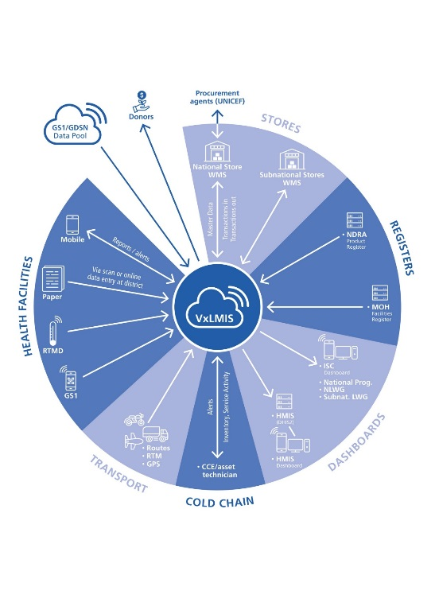
Some supply chain processes might be served by discrete software solutions at certain tiers of the supply chain, such as warehouse management systems (WMS) or enterprise resource planning (ERP) systems, or fleet management systems (FMS) that include load and route planning as well as fleet maintenance and other features. Electronic registries or medical records (EMR) systems used at health facilities might also support facility stock management and track vaccine utilisation. The VxLMIS should function in this digital ecosystem, interoperating with these systems through open data standards to provide E2E visibility of product flows (Figure 1, also see Annex 1). Optimally, the VxLMIS will enable software applications at service delivery points that track utilization and manage inventories to connect to their supplying store’s inventory management system to initiate a routine order or allocation. Each storage tier should be able to connect up to the next level in the supply chain. Transport resources should be connected for planning supply routes and loads, and to collect proof of delivery and service timeliness.
Figure 1: VxLMIS Conceptual Model (see Annex 1 for larger image)
The VxLMIS and constituent applications should generate all vaccine stock and transaction records, cold chain fixed asset records, and temperature records, and post data to the core VxLMIS routinely (optimally at the close of each business day). Therefore, foundational requirements of a VxLMIS or its constituent applications include—
- Transactional, event-driven data entry on the requisition, movement and losses/adjustments to stock of all products and all cold chain fixed assets and their temperatures at all points of storage.
- Offline functionality that supports and captures data for routine workflows (e.g. stock transactions, fixed asset management, temperature recording) and can synchronise data with the VxLMIS when access to the Internet is available.
- The ability to capture summary or aggregate inventory reports and/or temperature monitoring records, or importing Stock Management Tool (SMT) spreadsheet files from sites that use SMT or similar tools.
- Flexibility in how business processes are applied to the VxLMIS (e.g. requisition vs. allocation, delivery vs. pick-up, etc.), depending on the relative maturity of a country’s immunization supply chain and its ICT landscape.
- Support for open data standards to enable seamless interoperability with its constituent applications and devices (e.g. remote temperature monitoring devices), and with other health information system applications (e.g. DHIS2, master facility registry, immunization registry, EMR, etc.)

Vaccine distribution
Vaccine distribution involves a number of standard supply chain business processes that are common across all pharmaceuticals and other health products:
- Forecasting and supply planning (based on a mix of methods)
- Requisition/allocation (based on routine, accurate and timely data)
- Order processing/fulfilment (based on established rules and approvals)
- Transport (including load planning, route planning, fleet management)
- Receiving (including returns at all storage and dispensing points)
- Storage (inventory management at all storage and dispensing points)
- Dispensing (to client or HCW to administer)

Cold chain monitoring and servicing
In some supply chains, asset management is a critical subcomponent of the information system. In the immunization supply chain, cold chain equipment for storage and distribution play an essential role in maintaining vaccine potency, and factor into supply decisions (non-functioning equipment should be a factor in whether to replenish a facility). A VxLMIS therefore must support three additional business processes:
- CC Equipment inventory management, covering both active and passive storage equipment (including make/model, energy source, installed or stored location, spare parts management) and aligned with WHO PQS catalogue.
- CC Equipment service management (functional status, warrantee status, maintenance scheduling, service and repair transactions, etc.)
- Temperature & energy monitoring (including alarm management per refrigerator/refrigerated vehicle)

In order to clearly distinguish between information system features for managing consumable health products (LMIS) and information systems for durable assets like CCE, this TPP uses the term cold chain management information system (CCMIS) to describe the subset of asset-specific features listed above. Therefore, a robust and integrated VxLMIS should comprise LMIS + CCMIS; this can be achieved either in a single integrated system, or through data exchange between the core VxLMIS and a separate but interoperable CCMIS application.

Routine Reports and Alerts
A primary purpose of the VxLMIS is to generate routine reports and alerts that support the day to day management of the supply chain, and that enables analysis to maximise supply chain performance. Reports include operational decision-making support for routine transactions (standard reports, notifications and alerts) as well as dashboards for supply chain performance monitoring, displaying role-based KPIs at all levels.

System features
Over and above the business process a VxLMIS supports, any technology solution must also meet a normative standard for system requirements. These requirements describe system capabilities that are necessary to support any information system that relies on data exchange with other relevant system, and that can operate in a resource constrained environment in which electrical power or internet connectivity disruptions are common.

KEY FEATURES | ESSENTIAL | DESIRED
LMIS FUNCTIONAL CHARACTERISTICS
Forecasting & Supply Planning
Rules-based calculation of estimated product volume requirement by distribution tier and user-defined time periods | X
Rules-based calculation of annual national procurement and delivery quantities based on a combination of the following parameters: Stock on Hand, Coverage Targets, Max/Min, Consumption (vials/SKUs), Expiry Dates, Closed & Open Vial Wastage, Quantity on Order | X
Projected future stock positions based on Stock on Hand, Max/Min, actual Consumption (vials/SKUs), Expiry Dates, Quantity on Order |  | X
Requisition/allocation
Product selection by SKU including vial size | X
Suggested quantity to order/allocate, based on Stock on Hand, Max/Min, actual Consumption (vials/SKUs), Expiry Dates, Quantity on Order, batch tracking, bundling with syringes/diluents | X
Order confirmation, with ability to accept or adjust suggested quantity | X
Order approval by approving authority | X
Order receipt confirmation (from supplying facility) |  | X
Order processing/fulfilment (dispatch)
Order validation based on Stock on Hand at supplying facility | X
Order validation based on CCE status at receiving facility |  | X
Pick & pack list generation, constrained by FEFO and VVM status | X
Advance Shipment Notification (date shipment is planned, and contents to be shipped) | X
Shipment confirmation (actual shipment date and consignment contents ) |  | X
Proof of Delivery | X
Transport
Load planning |  | X
Route planning |  | X
GPS vehicle monitoring |  | X
Fleet management |  | X
Proof of Delivery (signature capture with data stamp) |  | X
Receiving
Accept in full | X
Return item(s), with reason code | X
Receive into inventory (auto-update e-stock card by product, batch/lot, and expiry date) | X
Inventory management
Maintain dynamic max/min levels (moving average) based on consumption/utilization | X
Record inventory audit (physical count in full or cycle count) | X
Record Inventory adjustment | X
[Receive; see above] | X
Put away stock by store/WICR zone, bin, and available capacity | X
[Issue stock: see order processing/fulfilment above] | X
Transfer stock (reposition between locations to address stock imbalances) | X
Quarantine stock with reason code | X
Manage stock transactions by barcode (GS1/GTIN preference) | X
Constrain stock by expiry date (FEFO) and VVM status | X
Update VVM status | X
Dispensing
Record number of vials/SKUs consumed by batch/lot (by event, or daily tally) | X
Capture number of doses administered (by event, or daily tally) via data transfer from EMR or electronic registry |  | X
Record VVM status of vial being used | X
CCMIS FUNCTIONAL CHARACTERISTICS
CC Equipment and spare parts inventory management
Maintain CCE Unit Profile (make, model, capacity, age, energy source, etc.) | X
Maintain CCE Location (installed, stored, service site) | X
Maintain CCE spare parts & tool sets profile |  | X
Maintain Spare parts & tools inventory (location, quantity, replenishment rule, transactions) |  | X
CCE Service Management
Update CCE functional status | X
Maintain a list of CCE service providers |  | X
Create a CCE service schedule, including maintenance activity tracking for services requested, services performed, and service outcomes. |  | X
Analyse CCE performance |  | X
Identify CCE requiring replacement | X
Temperature Monitoring (via remote temperature monitoring device)
Capture temperature reading by CCE unit | X
Capture temperature excursion alarms by CCE unit | X
Capture temperature reading by transport container |  | X
ROUTINE REPORTS & ALERTS
Transactional reports (order, invoice, pick list, packing list, shipment notification, shipment confirmation, proof of delivery, returns with reason code, stock adjustments on physical counts) | X
Inventory reports: product quantity per location (absolute quantity, months or weeks of stock), product aging (by expiry), closed vial wastage rate, open vial wastage rate, low stock alert, | X
CCE reports: volumetric capacity available (per unit, per location), temperature excursion rates and durations, CCE need attention, CCE non-functional, average CCE downtime, CCE service schedule, service due, service pending, technician responsible, service outcome | X
SMS/email/direct messaging and dashboard notifications for all exceptions and escalation logic for aging exceptions | X
Sorted and filtered lists of facilities, commodities, inventory cards, and transactions for all products, requisitions, shipment notifications and confirmations, and proofs of delivery. | X
Forecast reports for time periods & levels: forecasted requirements, constrained requirements (see forecasting & supply planning), future stock positions | X
Installed CCE capacity analysis: total available capacity availability and gaps against current and future capacity needs, based on inputted assumptions including supply intervals, vaccine presentations, population growth |  | X
Data quality, including on-time reporting, and completeness of data (e.g. sites reporting for the period) | X
Performance reports (aggregated national, aggregated by tier, aggregated by governing unit (e.g. district, state), by location
Full Stock Availability, all tiers | X
Stocked According to Plan, all tiers | X
On-Time, In Full delivery (OTIF), all tiers | X
Forecasted Demand Ratio (forecast accuracy) | X
Closed Vial Wastage, all tiers | X
Temperature Alarm Rate and (where possible) Average Duration, all units | X
Functional Status and (where possible) Average Downtime of Cold Chain Equipment, | X
Coverage Supply Ratio (coverage reported vs. doses utilized) | X
SYSTEM CHARACTERISTICS
Performance: speed of processing, load capacity, efficient use of communication data channels | X
Accessibility: Web-enabled and capable of operating offline for routine workflows, mobile optimized, GPRS compatible for GSM data exchange, local server or cloud-based hosting options | X
Compatibility: includes open standards for data exchange includes open standards for data exchange of key metadata, facilities and products, (interoperability) using industry data standards (e.g. GS1 and HL7), support for data acquisition from barcode readers and remote temperature monitoring devices. | X
Usability: ease of use and learning, user-centered configuration, real-time data verification and feedback, calculated values, user guides/faq/training manual. | X
Reliability: recoverability, accommodates irregular power and connectivity | X
Security: firewall, access privileges, auditability, etc. | X
Maintainability: documentation, software support, local administration control, etc. | X
Portability: accommodates changes in ICT infrastructure, extensibility for new services or functionality | X
Collaboration: enables real-time collaboration between managers and field staff |  | X
Documentation and learning: Built-in access training modules (e.g. videos, how-to tips), and integrated user support (e.g. right-click or mouse-over explanatory balloons) |  | X
Administration: master data, language, version | X

Additional Resources
Gavi, Bill & Melinda Gates Foundation, WHO, UNICEF. 2015. Guidance on Dashboards for Immunization Supply Chains.
John Snow, Inc. 2017. ‘Logistic Management Information Systems’. In The Supply Chain Manager’s Handbook, A Practical Guide to the Management of Health Commodities, 25-42. Arlington, Va.: John Snow, Inc.
PATH. 2010. Common Requirements for Logistics Management Information Systems. Seattle: PATH.
Principles for Digital Development
Systems for Improved Access to Pharmaceuticals and Services (SIAPS) Program. 2014. Promising Practices: Data Management. Arlington, VA: Management Sciences for Health.
USAID | DELIVER PROJECT, Task Order 4. 2012. Computerizing Logistics Management Information Systems: A Program Manager’s Guide. Arlington, Va.: USAID | DELIVER PROJECT, Task Order 4.
World Health Organization, PATH. 2013. Planning an Information Systems Project: A Toolkit for Public Health Managers. Seattle: PATH.

Acknowledgement: The following organizations contributed to the development of this Target Product Profile: WHO, BMGF, UNICEF, USAID, Global Fund…
Contact:

Annex 1: Vaccine Logistics Management Information System conceptual model
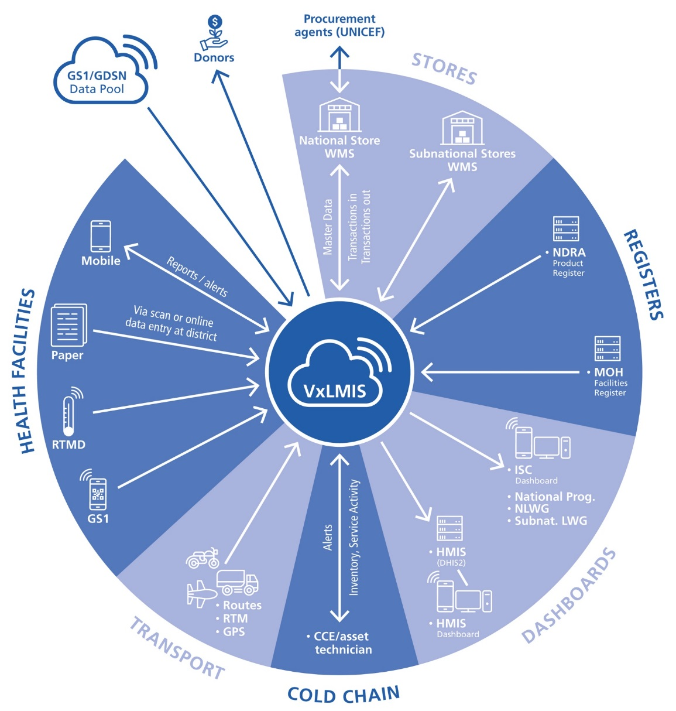
CCE: Cold Chain Equipment
GDSN: Global Data Synchronization Network
GPS: Global Positioning System
HMIS: Health Management Information System
ISC: Immunization Supply Chain
NDRA: National Drug Regulatory Authority
NLWG: National Logistics Working Group
RTMD: Remote Temperature Monitoring Device
WMS: Warehouse Management System

Includes both doses administered to beneficiaries and doses remaining but unusable in multi-dose vials (open vial wastage) based on WHO recommended multi-dose vial policy.
https://digitalprinciples.org/
http://apps.who.int/immunization_standards/vaccine_quality/pqs_catalogue/
Calculated open vial wastage rate =([number of vials used * doses per vial] – number of doses administered/[number of vials used * doses per vial], weekly or monthly average by antigen, by facility
For details and data definitions, see recommended indicators in Guidance on Dashboards for Immunization Supply Chains

