http://en.wikipedia.org/wiki/Ovid_(village),_New_York

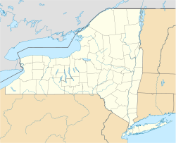
Ovid, New York
Location within the state of New York
Coordinates: 42°40.5′N 76°49.6′W﻿ / ﻿42.6750°N 76.8267°W﻿ / Coordinates: 42°40.5′N 76°49.6′W﻿ / ﻿42.6750°N 76.8267°W﻿ /
Country | United States
State | New York
County | Seneca
Area
• Total | 0.4 sq mi (1.1 km²)
• Land | 0.4 sq mi (1.1 km²)
• Water | 0.0 sq mi (0.0 km²)
Elevation | 968 ft (295 m)
Population (2000)
• Total | 612
• Density | 1,460.9/sq mi (564.1/km²)
Time zone | Eastern (EST) (UTC-5)
• Summer (DST) | EDT (UTC-4)
ZIP code | 14521
Area code(s) | 607
FIPS code | 36-55816
GNIS feature ID | 0959663

Ovid and the surrounding area was part the lands controlled by the Iroquois. The Sullivan Expedition of 1779 drove away or killed many of these natives to reduce their raiding in support of the British. After the American Revolution the village was in the Central New York Military Tract, used to compensate soldiers.
Ovid was the first county seat of Seneca County, and a courthouse was erected in 1806

