BOROUGH OF NORTH PLAINFIELD
NEW JERSEY
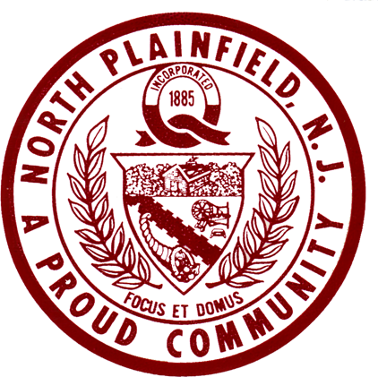

WEEKLY CALENDAR OF MEETINGS
Office of
Borough Clerk

WEEK OF SEPTEMBER 19, 2022

DATE | MEETING | PLACE | TIME
Monday, September 19
Tuesday, September 20 | Historic Preservation Commission  Parks & Recreation Committee  Library Advisory Committee | Conference Room  Community Center  Memorial Library | 7:00 p.m.  7:30 p.m.  7:00 p.m.
Wednesday, Sept. 21 | Board of Adjustment | Council Chambers | 7:00 p.m.
Thursday, Sept. 22  Autumn begins | 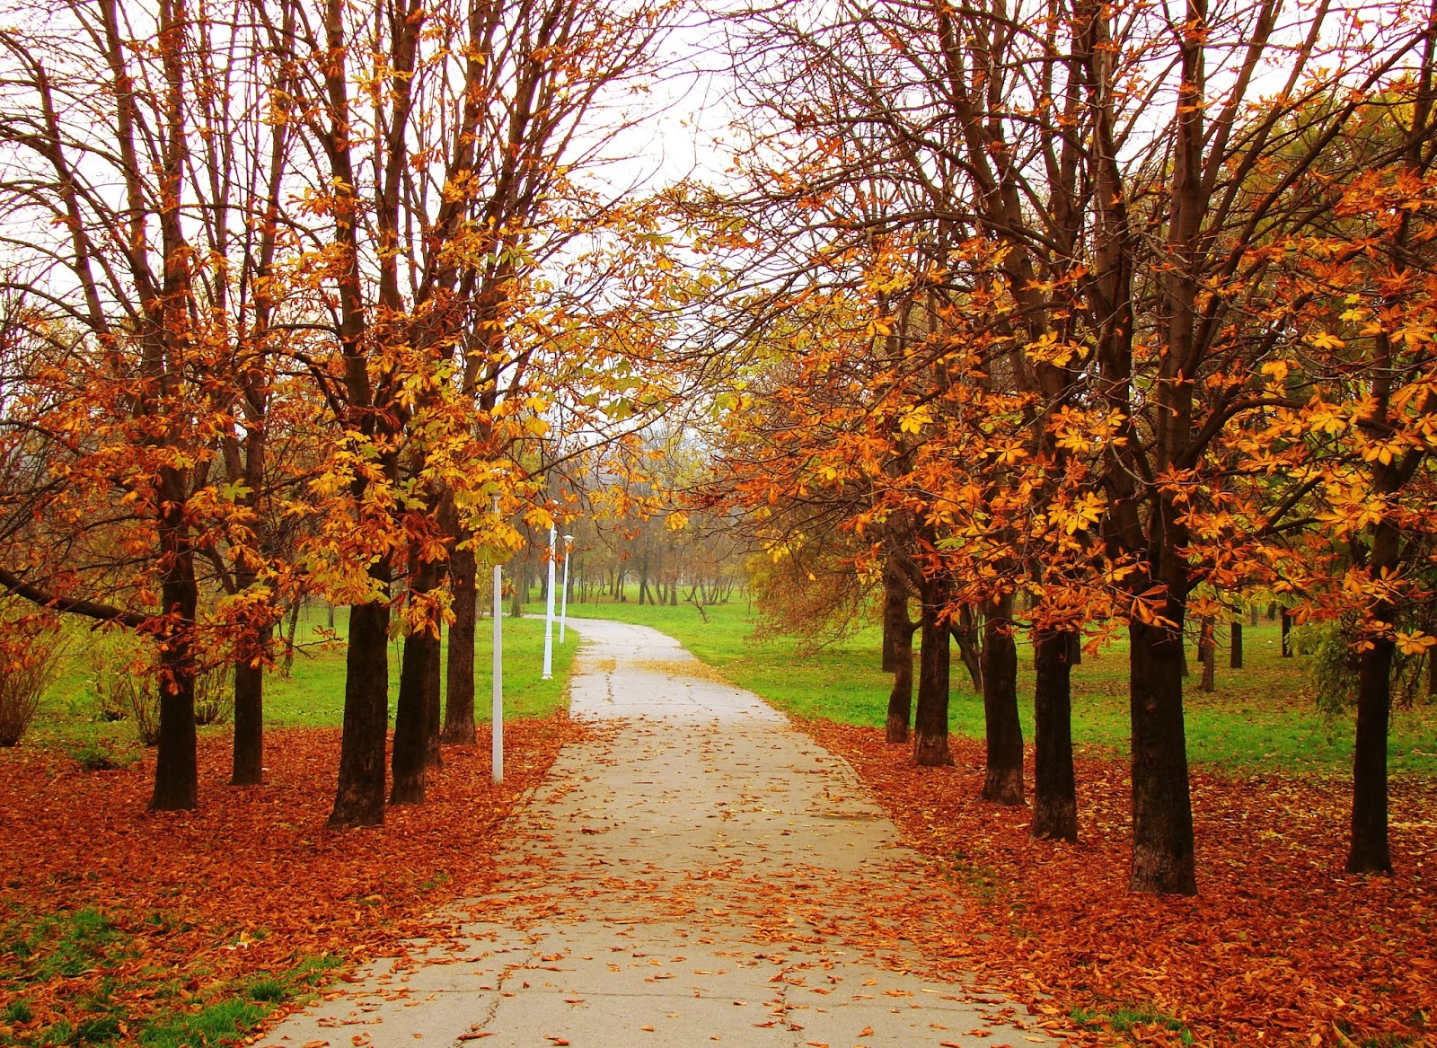
Friday, September 23
Saturday, September 24 | Food Bank Open  Fall Festival | Apgar House  Vermeule Place  North Plainfield H.S. | 9:30 a.m. -  11:30 a.m.  11:00 a.m. –  4:00 p.m.

Richard K. Phoenix
Richard K. Phoenix, RMC
Borough Clerk

IN THE EVENT OF SCHOOL OR MUNICIPAL CLOSURE DUE TO INCLEMENT WEATHER
PLEASE TURN TO 1630 AM RADIO FOR LATEST DETAILS AND 24-HOUR WEATHER
Also listen for 1630-AM audio at www.northplainfield.org

