BOROUGH OF NORTH PLAINFIELD
NEW JERSEY
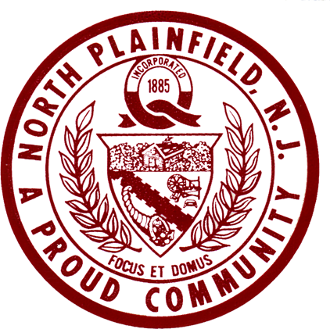

NOTICE OF MEETINGS
Office of
Borough Clerk

WEEK OF JUNE 13, 2022
DATE | MEETING | PLACE | TIME
Monday, June 13 | Juneteenth Freedom Jubilee  Shade Tree Advisory Board  Board of Health followed by  Regular Council Meeting | Memorial Library  2nd floor Conference Room  Community Center | 3:30 p.m.  5:00 p.m.  7:30 p.m.
Tuesday, June 14
Flag Day
Wednesday, June 15
Thursday, June 16
Friday, June 17
Saturday, June 18 Food Bank Open Today 614 Greenbrook Road 10:00 a.m.-
12:00 Noon
Rich Phoenix
Richard K. Phoenix, RMC
Borough Clerk

IN THE EVENT OF SCHOOL OR MUNICIPAL CLOSURE DUE TO INCLEMENT WEATHER
PLEASE TURN TO 1630 AM RADIO FOR LATEST DETAILS AND 24-HOUR WEATHER
1630-AM AUDIO NOW AVAILABLE ON THE WEBSITE
www.northplainfield-nj.gov

