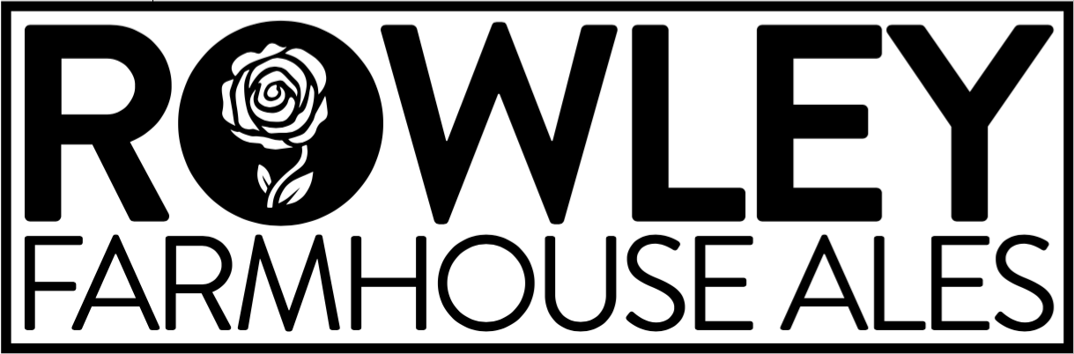

Packaging Assistant
Have you always wanted to work at a real brewery, but aren’t quite ready to give up your day job? Do you want to learn commercial brewing techniques to advance your beer knowledge and improve your homebrewing skills? Do you want to have access every shift to the Head Brewer and see how the pros do it? Or are you already in the brewing industry and looking to work somewhere new with great beer and clear expectations? At Rowley Farmhouse Ales, the 2019 GABF Small Brewpub of the Year, we brew everything from live sour Berliner weisse, to saison, to IPA, to mixed culture fermentation beer barrel aged on real fruit. And we need YOUR help to package that beer into cans, bottles, and kegs so we can get it out of our tanks and into our customers’ hands.

We are currently hiring Packaging Assistants whose primary responsibility will be to can beer for 2-3 shifts during the Monday-Friday work week under the supervision of the Head Brewer. You will be guided through our standard operating procedures and have access to written instructions at all times in order to help guarantee the quality of our finished products. We take our beer seriously while also providing an environment where you can listen to music, chat about your interests, and wear jeans to work for every shift!

Our current Head Brewer has successfully trained multiple entry-level employees who are now the head brewers of large, successful breweries in their own right. Opportunities for training and education are practically endless for those who show interest, enthusiasm, and follow through. There will also be opportunities for advancement for employees who are able to follow instructions and accept feedback, and prove themselves to be reliable, trustworthy, mature, as well as forward-thinking, analytical problem solvers.

If you want to work at an established, nationally recognized brewery that is still small with room and plans for growth, send a resume and a 1-2 paragraph statement explaining why you are interested in this opportunity to Mike Donovan at mdonovan@rowleyfarmhouse.com. See below for full job description and compensation.

PRIMary responsibility: PACKAGING
- Follow established SOPs in canning, bottling, and kegging finished beer under the supervision and at the direction of the Head Brewer
- Package draft batches according to requested package amounts by type as written on Brite Tank and Packaging Logs
- Report inability to package beers as requested
- Fill out Brite Tank and Packaging Logs accurately, completely, and legibly
- Assist Head Brewer and Brewer in maintaining cold box organization and cleanliness
- Move kegs, bottles, and can cases between storage areas as directed
- Prepare orders for distribution as directed by the Head Brewer and/or CFO
- Assist with operation of canning line according to canning SOP, including preparation and cleaning of canner, labeling, and ensuring overall quality of beers in cans
- Report any issues with canning to Head Brewer (e.g. slow runs, foamy beer, or anything out of the ordinary)
- Keep canning line equipment and area clean and tidy
- Assist in operation of bottling line according to bottling SOP, as scheduled and directed by the Head Brewer and/or Brewer

ADDITIONAL RESPONSIBILITIES and requirements
- Help keep brewery area clean, including taking trash out to the dumpster, wiping down surfaces, sweeping, squeegeeing, mopping, and other cleaning tasks as assigned by the Head Brewer
- Maintain a professional manner while at and/or representing the brewery both in your language and your actions
- Accept feedback from the Brewmaster, CFO, Head Brewer, and Brewer when given and work to improve in areas identified as opportunities for improvement
- Occasionally lift up to 55 pounds and work in loud, hot, cold, and/or wet environments
- Work occasional nights and weekends as scheduled by the Head Brewer
- Follow all safety instructions
- Arrive to work on time, ready to work, in appropriate attire
- Other tasks as assigned

Opportunities for additional responsibilities and advancement
- Transfer beers as scheduled and directed by Head Brewer using relevant SOPs
- Inform Head Brewer of any transfer issues as they occur, and make adjustments as directed
- Finalize Fermentation Logs and file them in the appropriate binder, and establish Brite Tank and Packaging Logs
- Perform CIP cycles on cellar tanks according to SOPs as scheduled by the Head Brewer

COMPENSATION $13 per hour (20 hours per week expected on average)

