NIGERIAN CARDIOVASCULAR SYMPOSIUM 2016

Presents the third Annual Nigerian Cardiovascular Symposium
NIGERIAN CARDIOVASCULAR SYMPOSIUM 2016
September 17 and 18, 2016
Lagos Sheraton Hotel
Ikeja, Lagos State, Nigeria

Course Directors

Dr. Obi Emerole
Dr. Felix Sogade
Professor Jane Ajuluchukwu

Co-Sponsored by
Department of Cardiology, College of Medicine University of Lagos
Department of Cardiology
Ben Carson School of Medicine, Babcock University

COURSE OVERVIEW/STATEMENT OF NEED

This course is designed to provide a comprehensive review of current concepts in the management of cardiovascular disease for practicing physicians and other healthcare providers. It provides a forum where health care providers can gather together to learn from each other and develop better strategies to combat the growing threat of cardiovascular disease.

Cardiovascular disease remains the leading cause of mortality globally with majority of the deaths occurring in the lower and middle income countries. In sub-Saharan Africa, while communicable diseases are still more prevalent, the incidence and prevalence of cardiovascular disease is rising more rapidly and it is expected to overtake communicable diseases as a cause of mortality in the near future. One of the major challenges in the fight against cardiovascular disease in this region is a shortage of educational resources and cardiovascular disease specialists. This program hopes to bring world class cardiovascular education to the region so that it can be accessible to health care professionals who may not have access to similar programs which are often held in other parts of the world.

Topics to be covered include Heart failure, Cardiac Arrhythmias, Cardiovascular Imaging, Valvular Heart Disease, Coronary Artery Disease and Cardiovascular Disease Prevention.

COURSE OBJECTIVES

The goal of the course is to provide attendees with knowledge of the most recent advances in the diagnosis and management of cardiovascular disease which can be used to improve the care provided to their patients.

At the end of the course, the attendees should be able to do the following:

Recognize and treat the most common forms of heart failure appropriately.

Implement the most effective strategies for evaluation and treatment of chest pain.

Recognize the most common types of heart valve disorders and implement the most effective management strategies.

Understand the most current concepts in cardiovascular disease prevention.

TARGET AUDIENCE
This course is intended for cardiovascular disease specialists, primary care physicians, nurses and other allied medical personnel interested in the field of cardiology.

ACCREDITATION
The course is approved for 10 CPD units by the University of Lagos Medical.

REGISTRATION
Registration fee is 25,000.00 Naira or 100.00 U.S dollars. You can register online at www.cardiovasculareducationfoundation.com.

INQUIRIES
In USA call Ms. Olivia Lamar at +1 (478) 7389443.

In Nigeria call Ms. Uchechi Esinna at 234(814)4155012

Or send an email to info@cardiovasculareducationfoundation.com.

ACCOMMODATION
Rooms are available at the following hotels:

Sheraton Hotel, Ikeja, www.sheratonlagos.com Telephone No 234(1)2800100

Ibis Hotel Ikeja Lagos. www.ibis.com Telephone 234(805) 6959997

For assistance with hotel reservations and to get the best rates send an email to info@bookinglagos.com or contact Ms. Ihuoma Onungwa at 234(803)6767760

A pre-symposium workshop will be held at Babcock University Hospital, Ilisan Remo, Ogun State on September 14 and 15.

The workshop will include a pacemaker implantation and interrogation course, and cardiac catheterization and interventional cardiology case presentations and demonstration.

Agenda for the Pre-Symposium Workshop

Wednesday, September 14

9.30 A.M.–12.00 P.M.: Pacemaker Implantation and Interrogation Workshop.
Moderators: Dr. Michael Sanusi, Dr. Olu Ajijola, Dr. Felix Sogade, Dr. Joseph Poku.

12.00 P.M.–1.00 P.M.: Lunch Break.

1.00 P.M.–3.30 P.M.: EKG Interpretation Workshop
Moderators: Dr. Olu Ajijola, Dr. Amir Schricker, Dr. Ijeoma Ananaba Ekeruo.

3.30P.M.: Program Adjourns.

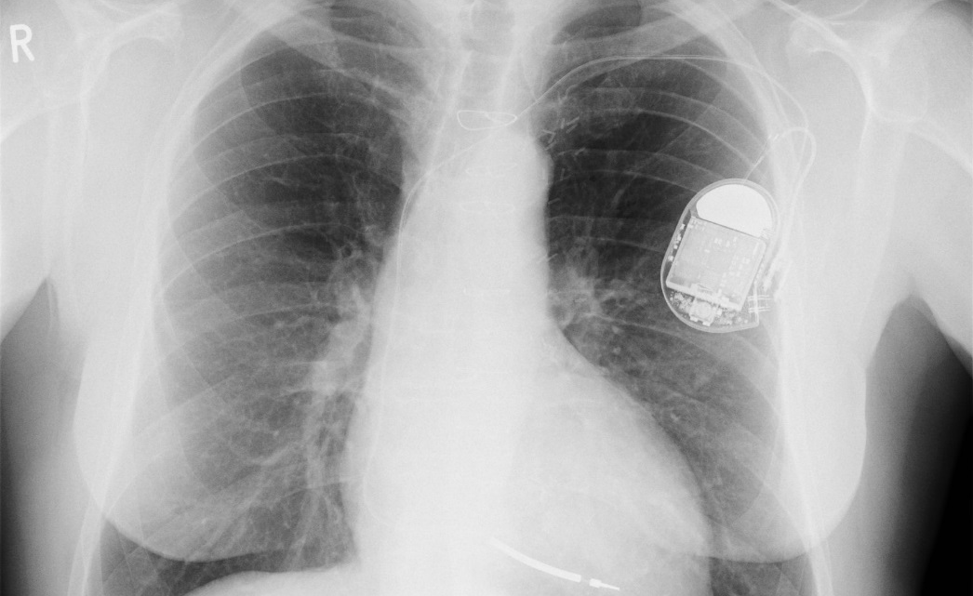

Agenda for the Pre-Symposium Workshop

Thursday, September 15

9.30 A.M.-12.00 P.M.: Cardiac catheterization and Interventional Cardiology presentations and demonstration.
Moderators: Professor Kamar Adeleke, Dr. Tosin Majekodunmi, Dr. Oladipupo Olafiranye, Dr. Tayo Addo.

12.00 P.M.-1.00 P.M.: Lunch Break.

1.00 P.M.–3.30 P.M.: EKG Interpretation Workshop.
Moderators: Dr. Olu Ajijola, Dr. Amir Schricker, Dr. Ijeoma Ananaba Ekeruo, Dr. Ogundu Ngwu.

3.30 P.M.: Pre-symposium workshop ends.

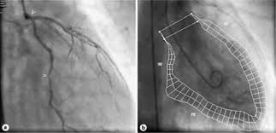

PROGRAM AGENDA

Friday, September 16th

8:45 A.M.: Opening Remarks
Dr. Tayo Addo
9:00 A.M.: History and Physical Examination in the Era of Hi-tech Cardiology
Professor Jane Ajuluchukwu
9:30 A.M.: Advances in the Management of Heart Failure with Reduced Ejection Fraction.
Dr. Obi Emerole
10:00 A.M.: Evaluation and Management of Heart Failure with Preserved Ejection Fraction.
Dr. Ijeoma Ananaba Ekeruo
10:30 A.M.: Break
11:00 A.M.: Evaluation and Management of Pulmonary Hypertension and Right Heart Disorders
Dr. Tayo Addo
11:30 A.M.: Hypertensive Heart Disease:What is it and how do we treat it
Dr. Okechukwu Ogah
12:00 noon: Congenital Heart Disease in Adults
Dr. Tosin Majekodunmi
12:30 P.M.: Lunch Break
1:30 P.M.: Mitral Valve Disorders
Dr. Michael Sanusi
2:00 P.M. Aortic Valve Disorders
Dr. Oladipupo Olafiranye
2:30 P.M.: Echocardiography Case Reviews
Dr. Kofo Ogunyakin
3:30 P.M.: Clinical and Case Presentations
Dr. Amir Schricker
4:3 0 P.M.: Panel Discussion, The Basics of Cardiovascular Research
Professor Jane Ajuluchukwu, Dr. Okechukwu Ogah, Dr. Tayo Addo, Dr. Henry Okafor
5:00 P.M.: Program Adjourns

Saturday, September 17th

8:45 A.M.: Opening Remarks
Dr. Olu Ajijola
9:00 A.M.: Evaluation and Management of Syncope
Dr. Henry Okafor
9:30 A.M.: Bradyarrhythmias and Conduction System Disease
Dr. Ogudu Ngwu
10:00 A.M.: Supraventricular Tachycardia.
Dr. Ijeoma Ananaba Ederuo
10:30 A.M.: Break
11:00 A.M.: Atrial Fibrillation and Flutter
Dr. Felix Sogade
11:30 A.M.: Ventricular Tachycardia and Sudden Cardiac Death
Dr. Joseph Poku
12:00 noon: Channelopathies and Hereditary Sudden Death Syndromes
Dr. Amir Schricker
12:30 P.M.: Lunch Break
1:30 P.M.: Evaluation of Chest Pain
Dr. Obi Emerole
2:00 P.M.: Management of Stable Ischemic Heart Disease
Dr. Chima Nwaukwa
2:30 P.M.: Management of Non ST Elevation Acute Coronary Syndromes
Dr. Oladipupo Olafiranye
3:00 P.M.: Management of ST Elevation Myocardial Infraction
Dr. Tayo Addo
3:30 P.M.: Advances in the Management of Pulmonary Embolism
Dr. Obiorah Ajuluchukwu
4:00 P.M.: Clinical Case Presentation
Dr. Onye Achilihy, Profesor Ibrabeem Katihi, Profesor Basil Okeahialgm
5:00 P.M.: Closing Remarks, Program Ends
Dr. Felix Sogade
Program Ends

“Program is subject to change without notice
if unforeseen circumstances arise”

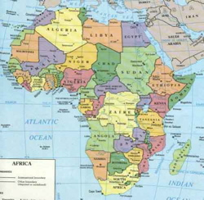
ABOUT CARDIOVASCULAR EDUCATION FOUNDATION

Cardiovascular Education Foundation is a nonprofit organization dedicated to the goal of promoting cardiovascular education, research and patient care in underserved communities especially in sub-Saharan Africa.
Sub-Saharan Africa is currently undergoing and epidemiologic transition characterized by a rapid increase in the prevalence of non-communicable diseases especially cardiovascular disease. One of the major barriers to optimal cardiovascular care in the region is a shortage of healthcare professionals with advanced training in the specialty. This shortage is compounded by the outmigration of physicians and other healthcare professionals from Africa to Europe and America for economic reasons.
Cardiovascular Education Foundation hopes to contribute to the advancement of cardiovascular education, research and patient care in sub-Saharan Africa and worldwide by promoting world class cardiovascular education within the region. It is our hope that some of the physicians and other healthcare professionals who are not able to attend similar programs which usually take place in other parts of the world would benefit from this conference.

FACULTY

Onye Godfrey Achilihu, MBBS, FACC.-Interventional Cardiologist, Echo-Scan Health Services. Abuja, Nigeria.

Tayo Addo, MD., FACC.-Director: Interventional Cardiology Training Program. University of Texas, South West Medical Center, Dallas, Texas

Kamar Adeleke, MD, FACC.-Professor of Medicine and Chief of Cardiology. Benjamin Carson School of Medicine, Babcock University, Llisan Remo, Nigeria.

Olu Ajijola, MD., PhD.-Electrophysiologist, Assistant Professor, UCLA, Los Angeles, California

Jane Ajuluchukwu, MBBS, FMCP.-Professor of Medicine and Chief of Cardiology, Lagos University Teaching Hospital, Lagos, Nigeria.

Obiora Ajuluchukwu, MBBS, FMCR-Interventional Radiologist. Lago University Teaching Hospital, Lagos, Nigeria.

Ijeoma Ananaba Ekeruo, MD.-Electrophysiologist, University of Texas Medical Center, Houston, Texas,U.S.A.

Obi Emerole, MBBS, FACC.-Interventional Cardiologist, Georgia Heart Physicians LLC., Macon, Georgia, U.S.A.

Ibraheem Katibi, MBBS, FWACP.-Professor of Medicine and Consultant Cardiologist, university of Ilorin Teaching Hospital, Ilorin, Kwara State, Nigeria.

Tosin Majekodunmi, MBBS, FRCP.-Interventional Cardiologist, Tristate Cardiovascular Associates, Babcock University Hospital, Ilisan Remo, Ogun State, Nigeria.

Ogundu Ngwu, MBBS, FACC. - Electrophysiologist, Kaiser Permanente Health System, Washington DC. U.S.A.

Chima Nwaukwa, MBBS, FACC.-Interventional Cardiologist, Metropolitan Cardiology, Beaumont, Texas, U.S.A.

Okechukwu Ogah, MBBS, FACC. - Consultant Cardiologist, Department of Medicine, University College Hospital, Ibadan, Oyo State, Nigeria.

Joseph Poku, MD, FACC.-Electrophysiologist, Georgia Arrhythmia Consultants and Research Institute, Macon, Georgia, U.S.A.

Michael Sanusi, MBBS, FACS.-Cardiothoracic Surgeon, Tristate Cardiovascular Associates, Babcock University Hospital, Ilisan Remo, Ogun State, Nigeria.

Felix Sogade, MBBS, FACC.,-Electrophysiologist, Georgia Arrhythmia Consultants and Research Institute, Macon, Georgia, U.S.A.

Amir Schricker, MD.-Electrophysiologist, University of California Health System, San Diego, California.

Kofo Ogunyankin, MBBS. FACC.,-Cosultant Cardiologist, First Cardiology Consultant, Lagos, Lagos State, Nigeria.

Henry Okafar, MBBS. FACC.,-Electrophysiologist, Vanderbilt University Hospital, Nashville, Tennessee, U.S.A.

Basil Okeahialam, MBBS, FWACP.,-Professor of Medicine and Cardiology Consultants, Jos University Teaching Hospital, Jos, Plateau State, Nigeria.

Oloidipupo Olafiranye, MBBS, FACC.,-Assistant Professor Interventional Cardiology, University of Pittsburgh Medical Center, Pittsburgh, Pennsylvania, U.S.A.

Abrodun Olatidoye, MBBS, FACC.,-Consultant Cardiologist, Emory University Health System, Atlanta, Georgia, U.S.A.

