Fleet 301 & the Malletts Bay Boat Club
Cordially invite you to the
2019 Fleet 301 Lightning Spring Regatta
AND
New England District Championship

On

June 29-30, 2019

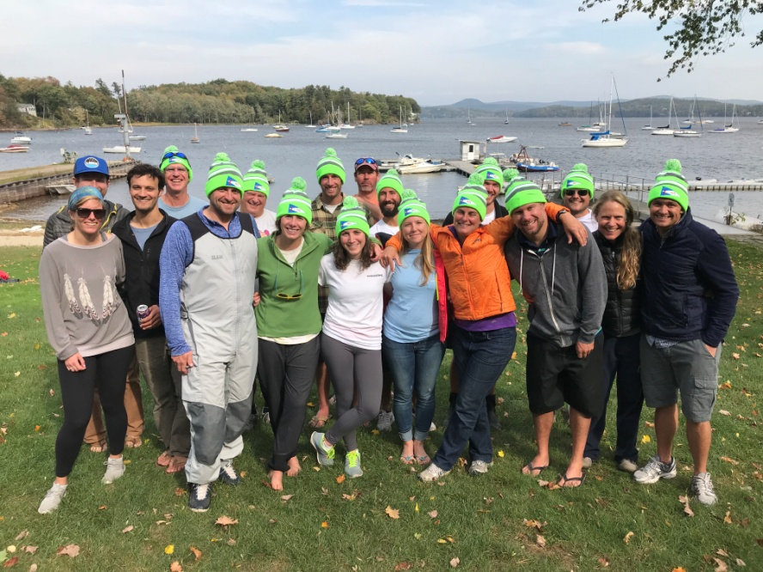

This season, Fleet 301, the Malletts Bay Boat Club and the New England Lightning District are hosting an exciting combined event that will culminate our always exciting and eventful annual Spring Regatta with the historic New England District Lightning Class Championship. This event will feature world class racing on the historic Outer Malletts Bay waters, top notch race committee and our always high energy, spirited and memorable parties at the Malletts Bay Boat Club.

Entry Fee is $100 ($95 for US Sailing Members) (Free for all Junior Teams!!)
Entry fee includes:
- Coffee/Bagels Saturday and Sunday AM
- Dinner for three on Saturday night (extra dinners $10 per person)
- Hors d’oeuvres after racing
- Trophies for the top 3 boats.

Please RSVP via email if you are coming: Bretton Gardner – Bretton.Gardner@gmail.com
Schedule:
Saturday 6/29
0800 - 0930 Registration
0930 Skippers meeting
1000 Harbor Start
1115 Start Race One, races to follow
1700 Hors d’oeuvres
1800 Dinner
Sunday 6/4
0930 Harbor Start
1045 Racing begins Day two
Trophies on lawn after sailing. No races will start after 1400 on Sunday.
There is limited housing available. Please contact Bretton Gardner.
For additional information our fleet contacts:
Bretton Gardner Bretton.Gardner@gmail.com 802-598-9952
Bill Fastiggi bill@vtsailing.com 802-655-SAIL
http://www.mbbc-vt.org/fleet301/
Directions to MBBC
*From South:* I-89 to Exit 16. Right onto Route 7 (North). Follow approx. 2 miles. Left at light onto Blakely Road. Follow to intersection at Lake. Straight onto Lakeshore Dr. Club 0.7 mi. on Right.
*From North:* I-89 to exit 17. Left at end of exit ramp. Right on Route 7 for about 3 miles. Turn right towards Malletts Bay on Bay Rd opposite Mobil station. Follow around bay until traffic light. Right on Lakeshore Dr. Club 0.7 mi. on Right.
MBBC phone # 802-658-3959
Join us also for:

Leaf Peeper Regatta October 12-13, 2019

