NORWOOD

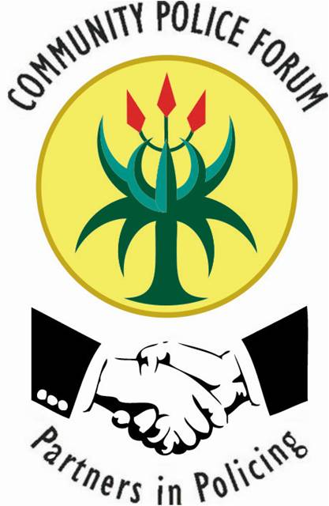

12 Paterson Rd
Norwood
2192

Cell: +27 78 014 2387
Fax - 086 638 4230
E-mail:secretary@ncpf.co.za
www.ncpf.co.za
Twitter - @NorwoodCPF
Facebook - Norwood Community Police Forum

NCPF MONTHLY COMMUNITY MEETING
VENUE: NORWOOD POLICE STATION BLUE ROOM
13TH MARCH 2019 @ 18H00

AGENDA
- WELCOME AND OPENING REMARKS BY NCPF CHAIRPERSON: Mr Wandile Yani
- PRESENTATION BY SADMON PROJECTS : Ms Charity Mokwane
- PRESENTATION OF SECTOR 4 EXECUTIVE AND LAUNCH OF SECTOR CRIME FORUMS: Ms Mbali Langeni
- STATE OF NORWOOD POLICE STATION AND REPORTS BY STATION COMMANDER: Colonel Sithole
- NCPF POA FOR 2019: Ms Nomcebiso Ngqinambi

- REPORTS
  - JMPD
  - Sector Managers
  - Victim Support Team and Programmes

- VOTE OF THANKS BY SECTOR 4 CHAIRPERSON: Ms Angelina Nyatyoba
- CLOSURE! CLOSURE! CLOSURE! CLOSURE! CLOSURE!

