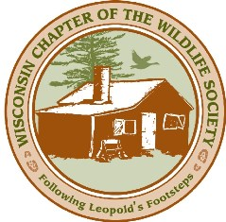
First Call for Abstracts

Wisconsin Chapter of The Wildlife Society Winter Meeting 2020

WCTWS is looking for interesting presentations and posters for our annual winter meeting being held February 25-27th, 2020 at the Mead Hotel and Convention Center in Wisconsin Rapids. The theme of this year’s meeting will be “Building Strength From Within”.

The conference agenda includes a plenary sessions, the WCTWS business meeting, committee meetings, a banquet, fundraiser, and plenty of time to network with your fellow wildlife professionals and students.

There will be several concurrent sessions for you and your colleagues to give 20-minute presentations or share your work in a poster session. We are seeking submissions on a variety of topics including research, policy, education, management, professional development, or partnerships.

The deadline for abstracts is December 15th, 2019. When submitting, please include the following information in a Word document or PDF:

1. Title of Presentation:

2. I would this to be considered for a
___ poster
___ presentation
___ either

3. Your name:
Affiliation:
e-mail:
phone number:

4. Abstract (200 words or less):

Questions or Submissions can be emailed to __________at _________________

