2
Model
In this chapter
- Representing user interface concepts in code
- The responsibility of the presentation model
- Codifying user input
- Scaling the model to handle complex scenarios
A model is a representation of something meaningful. Not necessarily something physical, but something real: a concept or a business or an API that's difficult to work with.
When we write object oriented software, we create classes that make up this representation. We can create our representation so that when we use it we are working in our natural human language, like English or Spanish or business jargon, instead of in mere programming language constructs like booleans, meaningless strings and integers.
When working with a UI framework like ASP.NET MVC the meaningful thing we have, the complex problem we manage, is the UI. It's the data in a window, a form submission from a user, the options in a select list. The model represents the screen.
2.1 The M in MVC
Consider a screen that shows a table to the user:
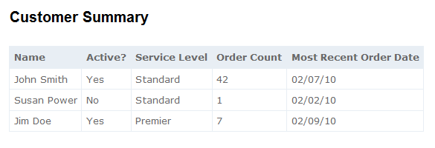
Figure 2.1 A table in our user interface
This table in Figure 2.1 is the product of our software development. It deserves to exist as a first-class object in our system. This will allow us to intentionally create it and to maintain it after its initial development. A first-class object representing this table, or rather, representing each row, will also allow our view an unencumbered mechanism to display the table itself. In Listing 2.1 we look at a simple model class for the table in Figure 2.1.
Listing 2.1 CustomerSummary.cs
public class CustomerSummary
{
public string Name { get; set; } |#1
public bool Active { get; set; } |#1
public string ServiceLevel { get; set; } |#1
public string OrderCount { get; set;} |#1
public string MostRecentOrderDate { get; set; } |#1
}
#1: Each property represents a column
It's simple on purpose. Our model consists mostly of strings. That's what we're representing, after all: text on a page. The logic that displays the data in this object will be straightforward; the view will only output it. The presentation model is designed to minimize decision making in the view.
The model for the entire table is of type IEnumerable<CustomerSummary>. With a simple model like that, the view only has to iterate through it, writing a row for each CustomerSummary. In the next section we'll discuss the programmatic creation of the model.
2.2 Delivering the presentation model
Somewhere in our application we'll build this presentation model. It may be hydrated with the results of a simple database query, like a flat report. Or it may be calculated and projected from another set of interesting data. It's common to have a class whose sole responsibility is to formulate the presentation model. Doing the work of building a presentation model in application code is better than doing that work in the view. The view is convoluted enough as it is, and focused on HTML and style. A separate class that creates the presentation model can be easily tested, programmed and maintained.
It's also best to not perform this work in the controller. The controller is busy deciding which view the render and coordinating these other efforts. From the controller's perspective, there's nothing to it. A simplistic look at how a controller might send the presentation model to the view is offered in Listing 2.2.
Listing 2.2: A controller action preparing the presentation model
public ViewResult Index()
{
IEnumerable<CustomerSummary> summaries = |#1
_customerSummaries.GetAll(); |#1

return View(summaries); #2
}
#1 Preparing the presentation model
#2 Presentation model transferred to view
Once the model is ready, the controller passes them into the View() method, transfering them to the view (2). There's a special mechanism for sharing the model in ASP.NET MVC 2, and we'll cover it in the next section.
2.3 ViewData.Model
The controller and view share an object of type ViewDataDictionary named ViewData. ViewData is a regular dictionary, with string keys and object values, but it also features a Model property. Conveniently, ViewData.Model is where we put our model. And the Model property is strongly typed, so our view knows exactly what to expect and developers can take advantage of IDE features like IntelliSense and support for renaming variables.
Listing 2.3 shows how a view can describe its model type in the Page directive.
Listing 2.3 Defining the model in the Page directive
<%@ Page Language="C#" MasterPageFile="~/Views/Shared/Site.Master"
Inherits="System.Web.Mvc.ViewPage<IEnumerable<CustomerSummary>>" %>
The Inherits tag in Listing 2.3 specifies that the view's model (the ViewData.Model property) is of type IEnumerable<CustomerSummary>. Because we designed our model to work with our screen, it's easy to mark up with HTML.
Listing 2.4 Using the model in the view
<table>
<tr>
<th>Name</th>
<th>Active?</th>
<th>Service Level</th>
<th>Order Count</th>
<th>Most Recent Order Date</th>
</tr>
<% foreach (var summary in Model) { %> #1
<tr>
<td><%= summary.Name %></td> |#2
<td><%= summary.Active ? "Yes" : "No" %></td> |#2
<td><%= summary.ServiceLevel %></td> |#2
<td><%= summary.OrderCount %></td> |#2
<td><%= summary.MostRecentOrderDate %></td> |#2
</tr>
<% } %>
</table>
#1 Model is IEnumeable<CustomerSummary>
#2 Working with the model
The markup in Listing 2.4 renders our table. Instead of relying on "magic string" keys and complex logic, we're free to work directly with a strong, clear model. By constructing the model elsewhere and designing it to represent the screen, the developer's job here is easy.
Some screens are more complex than a single table. They may feature multiple tables and additional fields of other data: images, headings, subtotals, graphs, charts, and a million other things that complicate a view. The presentation model solution scales to handle them all. Developers can confidently maintain even the gnarliest screens as long as the presentation model is designed well. If a screen does contain multiple complex elements, a presentation model can be a wrapper, composing them all and relieving the markup file of much complexity. A good presentation model does not hide this complexity - it represents it accurately and as simply as possible, and separates the data on a screen from the display.
Another complex, real thing that a web application must process is user input. We'll cover modeling user input in the next section.
2.4 Representing user input
Just like we crafted a presentation model to represent a display, we craft a model to represent the data coming into our application. And just like a strong presentation model made it easy to work with our data in the view, a strong input model makes it easy to work with user input in our application. Instead of working with error-prone string keys and inspecting request values that hopefully match input element names, we can levage ASP.NET MVC 2 features to work with a strong input model.
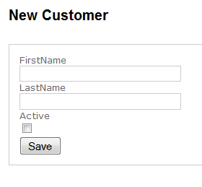
Figure 2.2 A form for user input
2.4.1 Designing the model
This simple form in Figure 2.2. has two text boxes and a check box. As a feature of our application, it's also worthy of a formal, codified representation, a class. Designing the class to represent this form is easy: it's two strings and a boolean value.
Listing 2.5 The input model
public class NewCustomerInput
{
public string FirstName { get; set; } #1
public string LastName { get; set; } #2
public bool Active { get; set; } #3
}
#1 A property represents a textbox
#2 Represents input in second textbox
#3 Represents the checkbox
The input model in Listing 2.5 is a simple class with a focused job. It is the surface area of user input - nothing more, nothing less.
2.4.2 Presenting the input model in a view
Views can be configured with the input model as the ViewData.Model type. We craft the HTML form using the input model. ASP.NET MVC 2 ships with several helpers that ease this and allow for strong associations between form element names and model property names. These helpers will be covered in depth later, but it's important to see how they're superficially used.
Listing 2.6 A view using the input model
<%@ Page Language="C#"
Inherits="System.Web.Mvc.ViewPage<NewCustomerInput>" %> #1
<%@ Import Namespace="InputModel.Models"%>

<asp:Content ID="indexContent" ContentPlaceHolderID="MainContent"
runat="server">
<h2>New Customer</h2>
<form action="<%= Url.Action("Save") %>" method="post">
<fieldset>
<div>
<%= Html.LabelFor(x => x.FirstName) %> #2
<%= Html.TextBoxFor(x => x.FirstName) %> #3
</div>
<div>
<%= Html.LabelFor(x => x.LastName) %>
<%= Html.TextBoxFor(x => x.LastName) %>
</div>
<div>
<%= Html.LabelFor(x => x.Active) %>
<%= Html.CheckBoxFor(x => x.Active) %> #4
<div>
<button name="save">Save</button></div>
</fieldset>
</form>
</asp:Content>
#1 Again, specifying the model
#2 A helper for the label
#3 A helper for textboxes
#4 A helper for checkboxes

This form in Listing 2.6 is built with our input model, NewCustomerInput from Listing 2.5. Note the special HTML Helpers that take a lambda parameter (2). These helpers render HTML form elements with the name attribute set to the name of the property expressed in the lambda. When working with HTML forms, work must be done to ensure that the software is looking for values in the known location.
Lambda expressions aid in refactoring
Don’t underestimate the value of lambda expressions in your views. These are compiled along with the rest of your code, so if you rename an action, for example, this code will break at compile time. Contrast this with code in your ASPX that references classes and methods with strings. You won’t find those errors until runtime. Having strongly typed view data references also aids in refactoring. Using a tool like JetBrains ReSharper (http://www.jetbrains.com/resharper) will allow you to refactor code and have it reach out to all of the views that use it as well. Very powerful, indeed.
Before strongly-typed helpers, we relied on magic strings and there was effort to ensure consistency between the input form and the processing logic. With strongly-typed helpers like we use in Listing 2.6, ASP.NET MVC 2 handles this coordination for the developer, so renaming a property won't cause our screen to malfunction. We cover these helpers in depth in Chapter 3.
2.4.3 Working with the submitted input
The form in Listing 2.6 posts to the Save action, and ASP.NET MVC 2 offers a convenient way to translate the values in the HTTP request to our model. This process is called model binding, and while it's explored later, we'll take a quick look at it now in Listing 2.7.
Listing 2.7 Model binding form values to the input model
public ViewResult Save(NewCustomerInput input) #1
{
return View(input); #2
}
By declaring the action's parameter as a NewCustomerInput object, the value is wired-up by ASP.NET MVC 2's DefaultModelBinder and delivered properly (1). This is the default behavior in ASP.NET MVC 2.
Our action works with our strong input model object, not a dictionary of key value pairs (2). In this case it's not doing much (just sending it as the model of a different view, so in the example we can inspect the "saved" values), but in a real action we'd have the opportunity to work with it like any other class: persist it or pass it along to collaborating classes for further processing.
Many views are not just displays or input forms, but combine elements of both to achieve a rich user experience. In the next section we'll apply the concepts we've already learned in this chapter to a more complex view.
2.5 More complex models for combined operations
Here's a table that has a list of customer summaries as well as an input element for each row. The end user can see a list of customer summaries, but they may also modify the status of the customer, checking the box is the user should be activated.
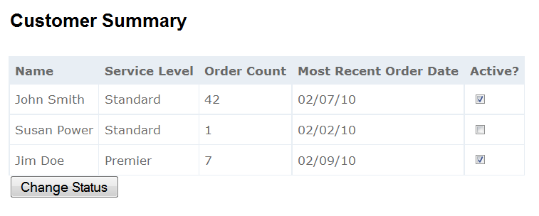
Figure 2.3 A combined display and input form
2.5.1 Designing the model
This is familiar now, but it's important enough to reiterate: the presentation model we design represents the screen and the input model represents user input. Both are as simple as possible, with C# properties reflecting the reality of the user interface. Listing 2.8 shows the code for a model that represents the table in Figure 2.3.
Listing 2.8 A combined model
public class CustomerSummary
{
public string Name { get; set; }
public string ServiceLevel { get; set; }
public string OrderCount { get; set; }
public string MostRecentOrderDate { get; set; }

public CustomerSummaryInput Input { get; set; } #1

public class CustomerSummaryInput |#2
{ |#2
public int Number { get; set; } |#2 #3
public bool Active { get; set; } |#2
} |#2
}
#1 The input model is a property
#2 The input model itself
It makes sense to model the input model as a nested class (2). After all, in the user interface the input elements are nested inside the display. The Input property is the input model for each item (1). Keeping it as part of the presentation model ensures that it will be easy to maintain: there's only one class that represents this screen. Note the Number property in CustomerSummaryInput (3) - it's the "id" of each customer, and exists to distinguish the inputs. We don't want our users to intend to activate Jim Doe and our application to actually activate Susan Power. On this screen it's important that our application has a logical connection to a specific customer.
2.5.2 Working with the input model
Model binding works the same. We still must be specifc in our action signature about which type we intend to model bind. It's slightly different because we are editing mulitple customers. In Listing 2.9 we model bind to a list.
Listing 2.9 Working with the input model
public ViewResult Save
(List<CustomerSummary.CustomerSummaryInput> input) #1
{
return View(input);
}
We direct the model binder to collect all the inputs by accepting a List<CustomerSummar.CustomerSummaryInput> (1). This works out of the box.
2.6 Summary
The main concept in this chapter is how to design a presentation model by crafting it to represent the user interface. We saw how a presentation model designed to support a screen makes the corresponding view easy to work with. By representing user input with a codified model, we can leverage ASP.NET MVC 2 model binding to work with objects. We saw how representing a complex screen with a focused model can make it easier to manage.
With strong presentation models comes an avalanche of simplicity that enables maintainability and rapid construction velocity. Refactoring, renaming, adding fields and changing behaviors is returned to the world of programming. Freed from the shackles of the designer and a constant effort to maintain consistency across a myriad of magic strings that may or may not make sense, developers can focus on one thing at a time. The model is the axis of power in Model-View-Controller.
There are other types of models. Like presentation models represent the user interface, domain models typically represent a part of a business or conceptual problem, and we cover the domain model in Chapter 8. Many simple applications will share a domain model and a presentation model - the UI and core of the application will use the same classes. But these are only the most trivial of applications, and even then it's advisable to segregate these duties.
In Chapter 3, we'll more closely examine MVC views, exploring in depth many of the topics we superficially mentioned in this chapter.

