Chromatic “Look” on a Diatonic Staff

The goal of WYSIWYP is to make reading sheet music as simple and intuitive as possible while still providing all of the functionality of Traditional Notation (TN), and thus to make it suitable for musicians of all levels of experience. To get a quick overview of the original design see Footnote 1 at the end.

A different approach to the display of sharps and flats
The original design of WYSIWYP identifies sharps and flats with different notehead shapes.
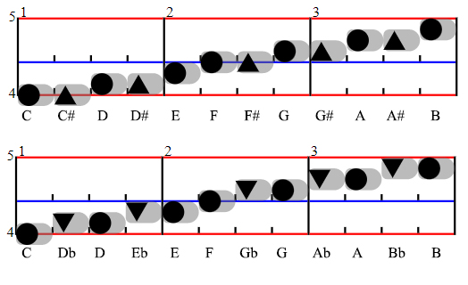
The new design is an additional user preference option for sharp and flat presentation in the WYSIWYP notation’s device display app (SNapp). This new option allows the musician to replace separate sharp and flat noteheads that represent the same tone (e.g., C# and Db) with a single combination sharp/flat notehead. Noteheads of adjacent naturals still overlap by 50% on the diatonic scale staff as before. But now a combination notehead occupies the overlap space between the adjacent naturals. Thus, it is half the height of a natural notehead (see Footnote 2).
The rectangular combination notehead looks a lot like a horizontal black key on the keyboard, reflecting the idea that, on the keyboard, a black key is in fact what is played. The following example has white key naturals (circles) along with the combination noteheads. It demonstrates how this makes it possible to see a chromatic scale on a diatonic staff where every notehead center point has its own unique vertical position:
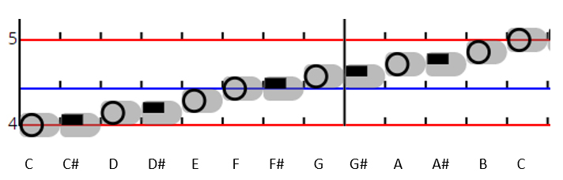
Although the notehead is the same for a given sharp/flat combination, the notetails (grey stripes indicating duration) are positioned differently. For example, the C# notetail is on the same vertical space as the C natural and has the same vertical height as shown in the figure above. The Db notetail is on the same space as the D natural as shown in the figure below. But in both cases, the combination noteheads themselves (the rectangles) are in the same position, only the notetails are different. Thus, the ability to identify the note as sharp or flat is still available (although more subtle).
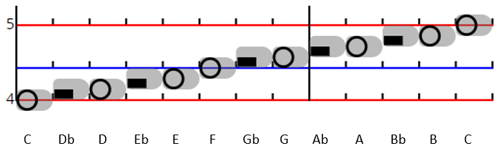

This approach to sharp/flat presentation further enhances the concept of “What You See Is What You Play.” This is because now there is no mental translation of a natural up or down based on seeing a sharp or a flat notehead symbol as with the original design. The new notehead staff position makes it easy to recognize the flat/sharp combo with respect to the red and blue lines of the WYSIWYP octave. And then it can be visually and directly mapped to the associated black key on the keyboard.

In the next figure, the sharps are all stacked up on a single time position on the left of the staff in order to emphasize the keyboard mapping. On the right, there’s an octave’s worth spread out to clearly show their individual relationships to the red and blue staff lines:
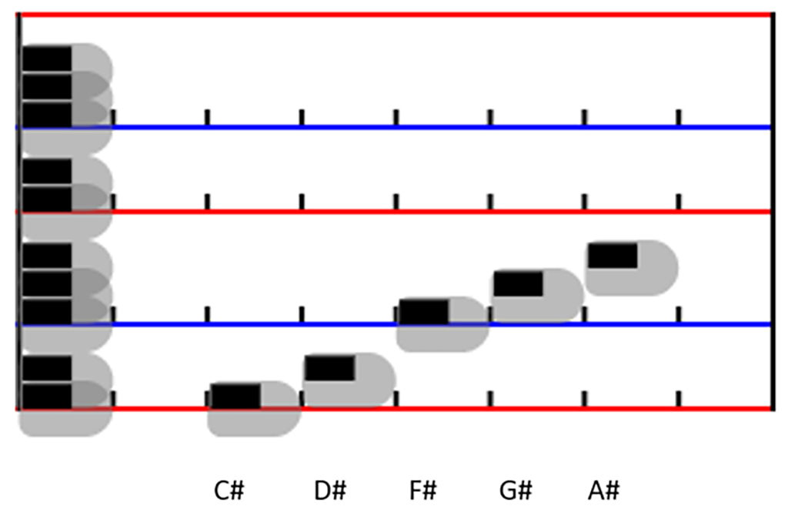

Here is the same display with notetails for flats instead of sharps. Observe that the black noteheads don’t move, only the notetails:
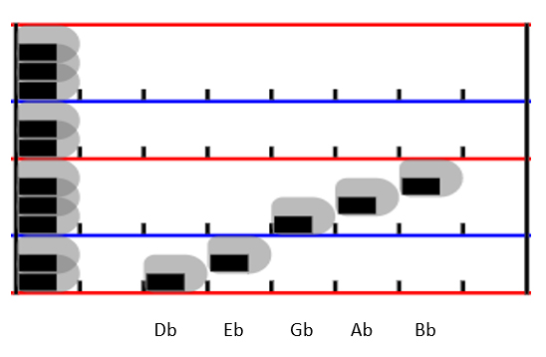

With this new feature, all twelve chromatic notes map directly to their corresponding keys on the keyboard octave. The net result is a design that is not only full function like TN (see Footnote 3) but also serves as a piano keyboard tablature (see Footnote 4). And in addition, like chromatic staff designs, there is a notehead position dedicated to all twelve degrees in the chromatic scale.
Therefore, overall, there is an intuitive visual mapping from sheet music to keyboard for all twelve chromatic degrees. Here is a two-octave example with all the sharps stacked up on the left and all of the naturals spread out on the right:

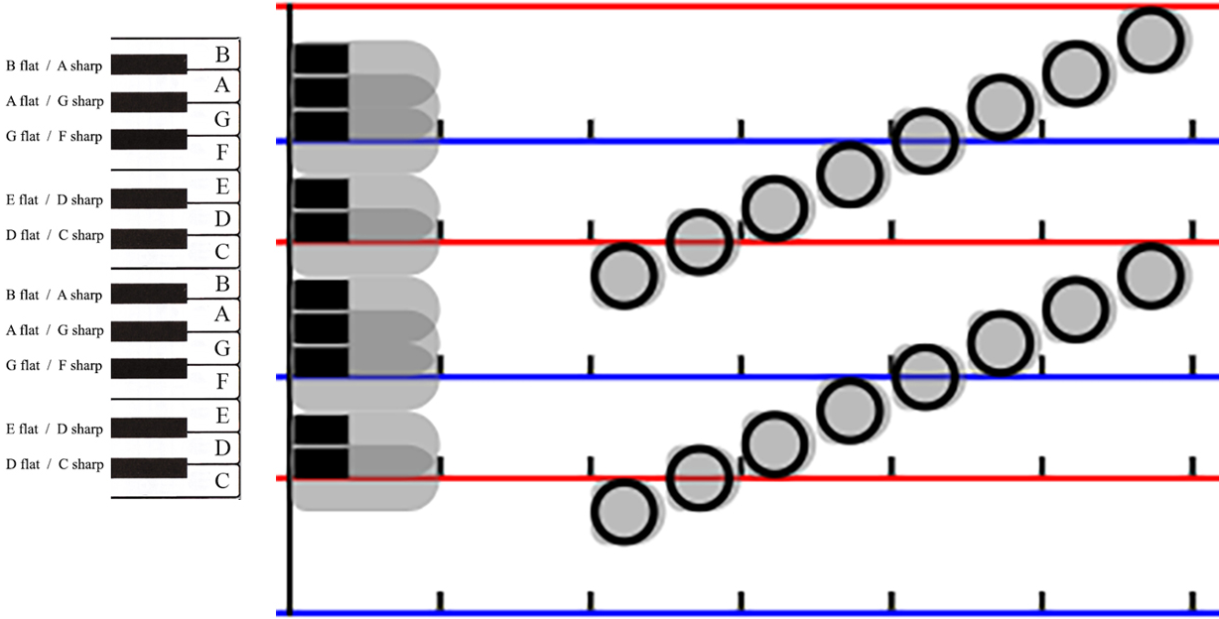

Example score snippets

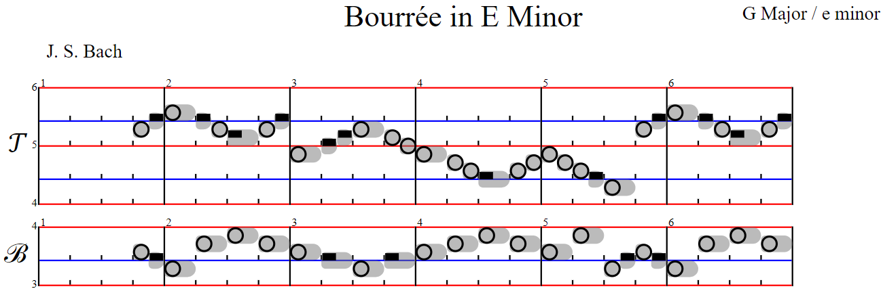

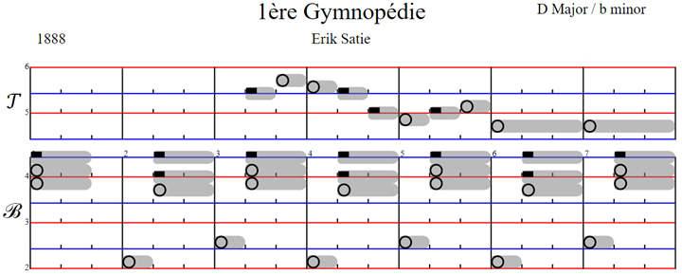

Triads
Major triads:
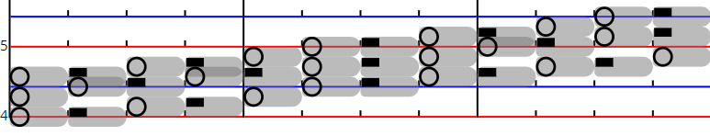

Minor triads:
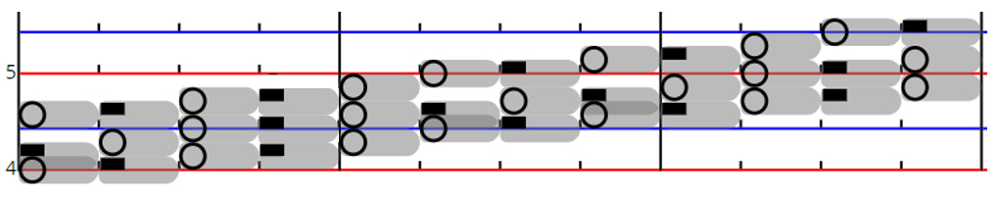

It’s the player’s choice
Even though WYSIWYP serves as a keyboard tablature, it does not prevent players of other instruments from using it. In these cases, the player reads a note’s degree and octave position in the same way as any notation (recognizing staff position and sometimes along with notehead appearance). But there is no visual mapping to non-keyboard instruments. But for whatever reasons, players of all instruments may prefer to use the original WYSIWYP design of distinct sharp and flat noteheads. (Note that even with the new design, one can differentiate between sharp and flat according to the position of the notetail, but this provides less emphasis than with the unique noteheads.) The original design remains available as a user preference option in SNapp.
Another reason to use the original design (separate noteheads for sharps and flats) is for those who fully intend to learn TN later and want to maintain a similar reading/playing technique of altering a natural up or down (as is required by TN according to key signatures and accidental symbols).

In summary: chromatic vs WYSIWYP diatonic staff designs
The great advantage of chromatic staff designs is that all twelve degrees have equal standing on the staff. With all degrees explicit, key signatures are no longer needed. And in addition, they permit intervals between notes in a chord to be consistent no matter the chord position on the staff. The price is the extra real estate needed on the sheet music page to display twelve positions instead of seven (an increase of 12/7, or 70%). For most of them, like TN, adjacent natural noteheads overlap by 50%. There are some compact designs that eliminate the extra space by using a 75% overlap, but then some musicians may find it difficult to discern a Major third from a minor third by staff distance alone. However, having different notehead shapes for adjacent degrees helps to make the distinction.
Because of the twelve degree range of the chromatic scale, staff designs employ ledger lines and full lines that logically segment the octave in order to make it easier to identify individual notes. Most often this is accomplished by a fixed interval between full lines (see Footnote 5). These designs generally range from four to six total lines (ledger plus full) per octave. A few “7-5” designs provide a map to the standard keyboard by mapping the lines to either the white keys or the black keys. These have either seven or five total lines as you would expect. Players of isomorphic keyboards may prefer a “6-6” chromatic designs because there is a more logical mapping to those keyboards.

The WYSIWYP diatonic design uses the same vertical space as TN wherein the seven natural noteheads overlap by 50%. Explicit noteheads for naturals, sharps, and flats replace the need for key signatures. However, as with TN, recognizing intervals between notes in a chord is more difficult due to the black key “gaps” at B-C and E-F. Crossing or not crossing a gap can cause chords that have the same appearance to have different intervals.
One of the simplicities of the WYSIWYP octave is that the staff lines represent the B-C and E-F gaps on the keyboard and thus provide a direct visual mapping from the notation. Another is that only two staff lines are needed to uniquely and easily identify the seven diatonic degrees. Focusing the design on the naturals supports the cognitive psychology research that says that the number of objects an average human can hold in short-term memory is 7 ± 2 (see “Weblinks” list below). These simplifying factors may be helpful to beginning students of music.
Explicit noteheads for naturals, sharps, and flats plus the staff line mapping to the keyboard make WYSIWYP a true keyboard tablature and therefore simple and intuitive to read (see Footnote 6).

In conclusion
As always, it must be said that there is not a “one size fits all” solution for notation. Advanced musicians, composers, and musicologists may prefer the more analytic format of chromatic designs. At the opposite end of the skill spectrum, beginners may prefer more graphic and visually intuitive designs and tablatures like Klavarskribo and WYSIWYP (note that the former has thousands of users that are not beginners). There’s no (logical) reason why a player should not be able to select a notation that suits the score, the genre, and the player’s skill level.

Weblinks:
Gallery page on the MNMA website: https://musicnotation.org/systems/gallery/
The Magic Number Seven, Plus or Minus 2: https://en.wikipedia.org/wiki/The_Magical_Number_Seven,_Plus_or_Minus_Two
WYSIWYP prototype website: https://www.wysiwyp.org/
SNapp screen device prototype app: https://snapp.wysiwyp.org/
Original WYSIWYP MNP forum post from 2019: https://groups.google.com/g/musicnotation/c/YqkC63nLKYU/m/3g-DowdxCgAJ

-------------------------------
Footnote 1: WYSIWYP – a quick review of the original design
WYSIWYP is based on a diatonic staff. Every octave has a red line on C and a blue line on F. Circles represent naturals.
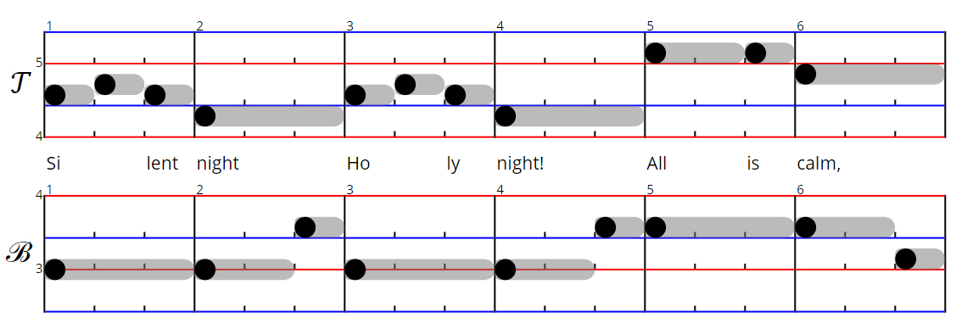
The grey background stripe, AKA a notetail, indicates the note duration with respect to the beat “ticks” on the red and blue lines. Any notehead on the diatonic staff overlaps with its adjacent neighbors by 50% just like TN. Each of the naturals have a unique relationship to the red and blue staff lines. With respect to the red line, notes B C D are touching it from below, over, and above. The same relationships exist with E F G and the blue line. Not touching any line is A. Octave numbers display to the left of the red line.
In the original design of WYSIWYP, a sharp is explicitly defined by an upward pointing triangle notehead, while the flat is a downward pointing one. With explicit notation, a key signature is not required to know how to play a given notehead.
The musician selects the display of either sharps or flats with a User Preference option in SNapp, the WYSIWYP Simplified Notation display app. However, the choice makes a big difference in how the very same note is presented. For example, a notehead for C# is displayed on the C degree position, while the notehead for a Db is displayed on the D position. Same tone, same keyboard key, but different “looks” (appearance) on the page due to notehead shape and vertical position on the staff.

Footnote 2: The combination notehead appearance is pretty much identical to that of TN rests for whole and half note durations. Since WYSIWYP has no symbols whatsoever for rests, there should be no confusion.
Footnote 3: While WYSIWYP is full function in design, its sheet music display app, SNapp, is still a protype in development. Thus, it does not yet implement full functionality. However, it must be noted that this is a huge undertaking when one considers the large range of notational elements available in TN to be implemented (just take a look at MuseScore). However, all the major changes to TN by WYSIWYP (staves, noteheads, tempo) are implemented so that the app is sufficient for evaluation and for most beginning students of music.
Footnote 4: Musical tablatures allow a musician to map notation directly to fingers on the instrument without having to be aware of the notes themselves (i.e., their scale degree and octave number). Guitar tablature visually shows where to press the strings on a diagram of the strings and frets. Other tablatures exist for other instruments. And don’t forget Synthesia video “tablatures” on YouTube. Klavarskribo is a keyboard tablature where lines are black keys and white spaces are naturals.
Footnote 5: The “Gallery” page of the Music Notation Modernization Association, MNMA, website list many examples of the latest chromatic staff line designs by its members. See “Weblinks” list above.
Footnote 6: WYSIWYP also implements a graphic notation for tempo instead of symbolic notation. This makes reading note durations intuitive as well as showing time relationships across staves. It’s also helpful in decoding complex rhythms and syncopation.

