Testing Motus tower detection with UAV-mounted tags.
Scott Jennings and David Lumpkin
Cypress Grove Research Center, Audubon Canyon Ranch, CA, USA

Introduction
Audubon Canyon Ranch has installed 2 Motus (motus.org) towers at our preserves on Tomales Bay, California, USA for a study of shorebird migration timing and overwinter movements. We wanted to test tag detections by the towers to determine two answer two questions:
1. To what extent to does the signal strength received by Motus towers reflect the distance between the tag and tower? and
2. To what extent is the probability a tag is detected determined by the distance from tag to tower and the difference in angle between tag-tower bearing and the direction each antenna is oriented?
Methods
Towers - Each tower consisted of a WADE Antenna 30-foot pop-up telescoping mast secured by a 10-foot tripod and 9 guywires in sets of 3 spaced each 10 feet from the top and anchored to the ground with rebar. A CTT SensorStation 2.0 mounted to each tripod was connected by LMR400 coaxial cable to each of 4 Laird YS4306 6-element yagis mounted at the following heights and bearings:
Cypress Grove Tower |  | Toms Point Tower
Height (m) | Bearing | Height (m) | Bearing
9.0 | 305 | 8.8 | 111
8.5 | 196 | 8.34 | 192
7.9 | 112 | 7.8 | 285
7.3 | 31 | 7.3 | 34

Tag - We used a single 1 gram CTT Power Tag with a 15 second nominal signal transmission interval for testing. We attached the tag in a vertical orientation to one of the UAV landing gear struts. We oriented the tag with the antenna pointing downward and used electrical tape around the tag body and at 1-2 points along the tag’s antenna.
UAV flights - We used DJI Matrise 100 UAVs for all test flights and for all flights we collected UAV location data at ≥ 1 Hz. We flew at three locations along Tomales Bay: at the Cypress Grove and Toms Point Motus towers (Figure 1) we programmed the UAV’s to fly a creeping line or parallel pattern, covering a 1 km radius circle centered at each tower. We programmed the parallel paths to be spaced 400 m apart, and the UAV to fly at 5 m/s and 50 m above the surface. We also flew 1-3 manual flights at ~ 10 m above the surface over specific areas of interest for our study at two locations: Cypress Grove and Walker Creek. The flights at Walker Creek were intentionally out of the line of sight for both towers.

Figure 1. Location of Motus towers and paths of UAV test flights flown in Sept 2021 at Tomales Bay, CA.
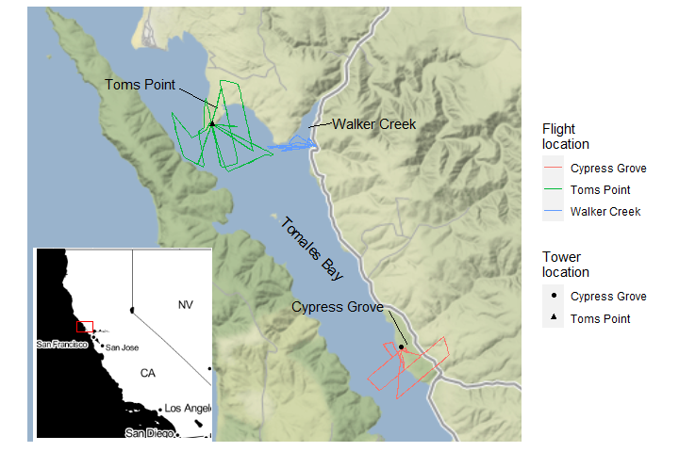
Data processing - To estimate tag detection probability, we needed to identify any instances where a tag signal was expected but not detected and add these interpolated signals back into the dataset. We interpolated missed signals as occurring on a 14.8 sec interval, which was the average interval of detected signals in our data once we filtered to intervals 13 < x < 16 sec. This interpolation process was repeated for each antenna on each tower. Full details and code for our interpolation methods can be found in Appendix A: Data processing.
Once missed signals were interpolated, we attributed each signal to the appropriate UAV location. We then calculated the distance and bearing between tag and tower for each signal (see Appendix A Data processing for further detail). Finally, we calculated the tag bearing off the axis of each antenna as the difference between the bearing of the antenna axis and the tag-tower bearing. We assumed that there would be no difference in signal detectability to the left vs right of the antenna axis, so we converted the tag bearing off antenna axis to the scale 0-180 degrees.
Analysis and visualization - We first visually examined patterns in signal strength and detected/missed signal in the raw data by plotting tag signals as a function of distance and bearing off antenna axis.
To generalize our results, we also fitted simple linear models and generalized linear models to estimate mean signal strength and detection probability, respectively, as a function of distance and bearing off antenna axis. We only used data from the programmed-route flights done around each tower (excluding low altitude, manual flights at Cypress Grove and Walker Creek). Both towers detected tag signals from flights at both places, so the detection data had a large gap with no data in the middle of our observed distance range (Figure 2). Thus, we separated the data into “close” and “far” subsets and analyzed these subsets separately. For each distance subset and each response variable (signal strength and detection probability) we fitted a model with the additive effects of distance and tag bearing off antenna axis. We centered and scaled distance and bearing off antenna axis predictors by subtracting the mean then dividing by the standard deviation. We pooled detections across all antennae, and thus did not attempt to account for differences in detectability between antennae. For each model we extracted coefficient estimates and 95% Confidence Intervals to judge coefficient importance and strength in predicting response variables. We also fitted the models to the unscaled predictor variables and used the resulting estimated coefficients to create estimated signal strength and detection probability surfaces across the distances and angles in our data. All code and data for these tests and analysis can be found at https://github.com/scottfjennings/Motus_tower_testing_report
Results and Discussion
Summarize and visualize raw data - We conducted a total of eight programmed-route flights and four ad hoc flights between 0900-1300 hours on 14 and 15 Sept. 2021, totaling 119.7 minutes for programmed flights and 53.5 minutes for manual flights. During these flights we detected a total of 3175 transmitted signals, and we interpolated another 1237 missed signals.
Signal strength was greatest close the tower and along bearings nearer the axis of the antenna (Figure 2). When the UAV was flying within approximately 1,800 m of a tower, most tag signals were detected and there was little effect of bearing off antenna axis at these distances. However, at distances between approximately 5,200-7,800 m, the bearing off antenna axis had a stronger effect on detectability. This effect of bearing off antenna axis was somewhat more apparent for antennae mounted on the Cypress Grove tower; whereas detectability was more constant across bearings for Toms Point antennae.
During the Walker Creek flights, we observed relatively good detection during by most antennae on the Toms Point tower, approximately 2,000 m away. Some signals were even detected by the two Cypress Grove antennae that are pointed toward Walker Creek, despite the substantial distance and blocking topography. Recall that these flights were intentionally done at a low elevation, with the line of sight blocked by one (Toms Point tower) or several (Cypress Grove) ridges. Walker Creek is one of the main areas on Tomales Bay that shorebirds use, so we are pleased with these detections.
Figure 2. Raw detections collected during UAV testing of Motus receivers on Tomales Bay, CA, 2021. Shown are detected and interpolated signals by a UAV-mounted tag flown in a series of flights at three locations. Signals are separated by the distance range of detections, and flights at Walker Creek are shown separately (see Figure 1). The blue scale indicates signal strength, and red indicates interpolated signals. Note different scales on y axes.

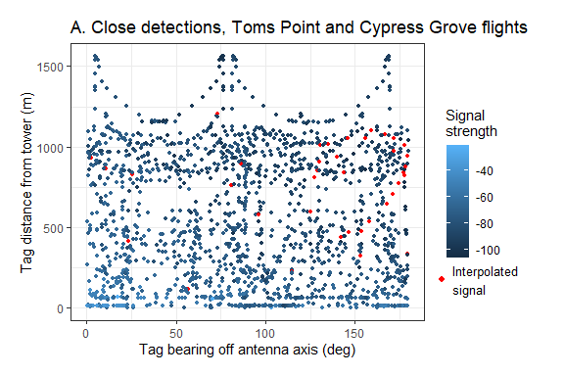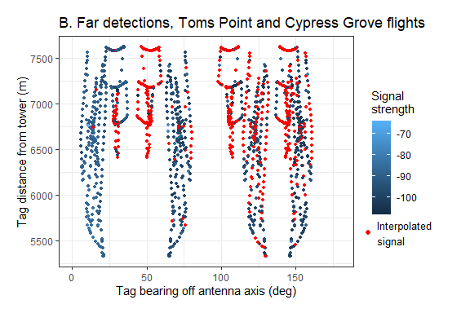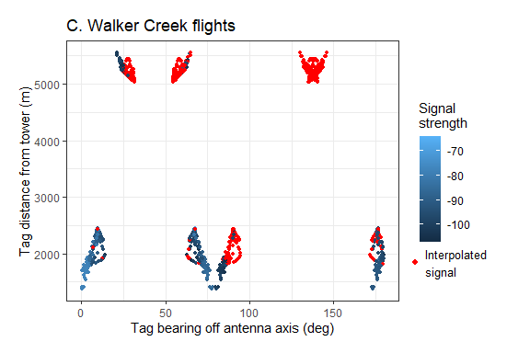

Models - The estimates and 95% confidence intervals for coefficients for the models fit to each data subset, and the predicted detection surfaces derived from those models, generally support our qualitative conclusions drawn from the plotted raw data. In general, we found a negative relationship between distance from tower and bearing off antenna axis and both signal strength and detection probability (Table 2, Figure 3). However, distance appeared to have a stronger effect on detectability than did bearing because the estimated distance coefficient was an order of magnitude greater than the bearing coefficient for all data subsets except signal strength, far (Table 2).
Table 2. Coefficient estimates for the best supported models predicting Motus receiver detection rates on Tomales Bay, CA, 2021. Models were fitted to each of four data subsets, indicated by the subheadings, based on response variable (Signal strength or Detection Probability) and distance between tag and tower (close: 0-1200m or far: 5300-7600m).
 |  |  | 95% Confidence Interval
Data subset | Coefficient | Estimate | lower | upper
Signal strength, close | Distance | -60.78 | -63.72 | -57.84
 | Bearing | -5.26 | -5.67 | -4.86
Signal strength, far | Distance | -3.28 | -4.78 | -1.78
 | Bearing | -3.16 | -3.43 | -2.88
Detection probability, close | Distance | 2.33 | 0.71 | 4.05
 | Bearing | -0.36 | -0.59 | -0.15
Detection probability, far | Distance | -3.68 | -4.36 | -3.03
 | Bearing | -0.60 | -0.71 | -0.50

Particularly when the tag was 0-1200m from the tower, distance was a strong predictor of signal strength. This suggests that Motus towers configured as ours may be useful in determining some coarse location information when detections from multiple antennae on the same tower or multiple towers are considered together. This may also be the case for distances greater than 1200m. However, once distances of our “far” data subset are reached, it appears the changes in signal strength are relatively small and these relationships may be too weak to determine tagged animal location.
At close distances (≤1200m), detection probability was lowest when the tag was directly behind and close to the tower (Figure 3). Our flight heights were above the towers, so this is likely due to the tag being above the horizontal plane of the antennae, so that when the tag was close to the towers it had a large bearing off the antenna axis on the plane perpendicular to the one we measured.
Figure 3. Predicted Motus receiver detection rates on Tomales Bay, CA, 2021. Predictions are from models fitted to each of four data subsets, indicated by the subheadings, based on response variable (Signal strength or Detection Probability) and distance between tag and tower (close: 0-1200m or far: 5300-7600m).
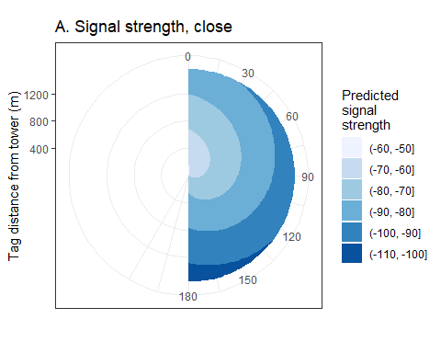
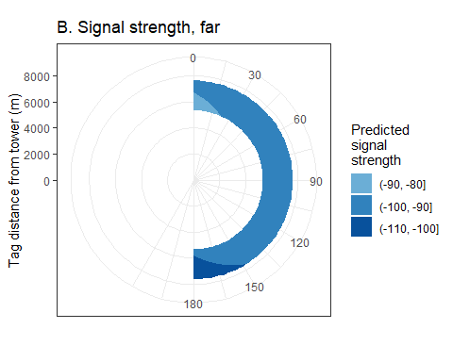
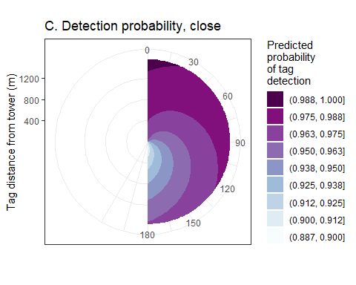
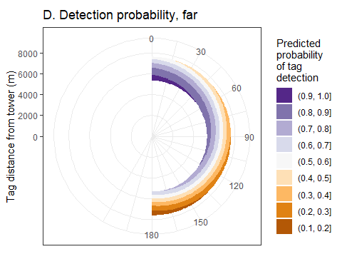

Conclusions
Overall, our test flights revealed encouraging results for the use of 1-3 Motus towers to detect and monitor tagged animal activity in a habitat feature the size and shape of Tomales Bay. We found that tag detection probability was somewhat strongly affected by bearing off the antenna axis at distances between approximately 5.3-7.6 km. However, towers with 4-5 antennae set at equal bearings will effectively eliminate the zones of poorer detection behind individual antennae. Our results suggest that if a tagged animal flies within 6 km (approximately median of our “far” distances) of one of the towers we’ve placed on Tomales Bay (where the maximum angle between antennae is ~55 degrees), there is = 73% chance that each signal will be detected. At distances greater than 7.5 km (near our maximum “far” distances), this figure falls to 33%. Thus, if one in three transmitted signals are detected at these larger distances, and with signal transmission frequency around 15 hz, we might expect hypothetical tagged animals passing within 7.5 km for = 60 seconds (yielding = 3 transmitted signals) to be detected most of the time.
We also found possibly encouraging results regarding the relationships between signal strength and distance from tag to antenna (while accounting for bearing off antenna axis). The data we collected were somewhat limited in diversity of motus tower configurations and range of distances between tag and tower. However, our results suggest it may be possible to derive rough estimates of animal location from signal strength as detected by multiple antennae on a single tower or multiple towers.
The data we collected are not sufficient to fully evaluate tag detections across the full range of distances we evaluated, nor were we able to establish the farthest distance a tag might be detected by our towers. Furthermore, our test flights were mostly at 50m above the surface. We did not thoroughly test detectability at other heights. For future testing, we suggest additional flights across a broader range of distances and heights, as well as tests specific to the behaviors of prospective study animals for particular research questions.

Acknowledgments
We thank Annie Schmidt, Megan Elrod, Suzie Winquist and Danny Khor of Point Blue Conservation Science for providing and piloting the UAVs.

