App Concept

The goal ist o make a companion App for all the provisioning recipes and craft building plans where you can randomly find in the online Game «The Elder Scrolls Online».

Screen 1 Main Menu
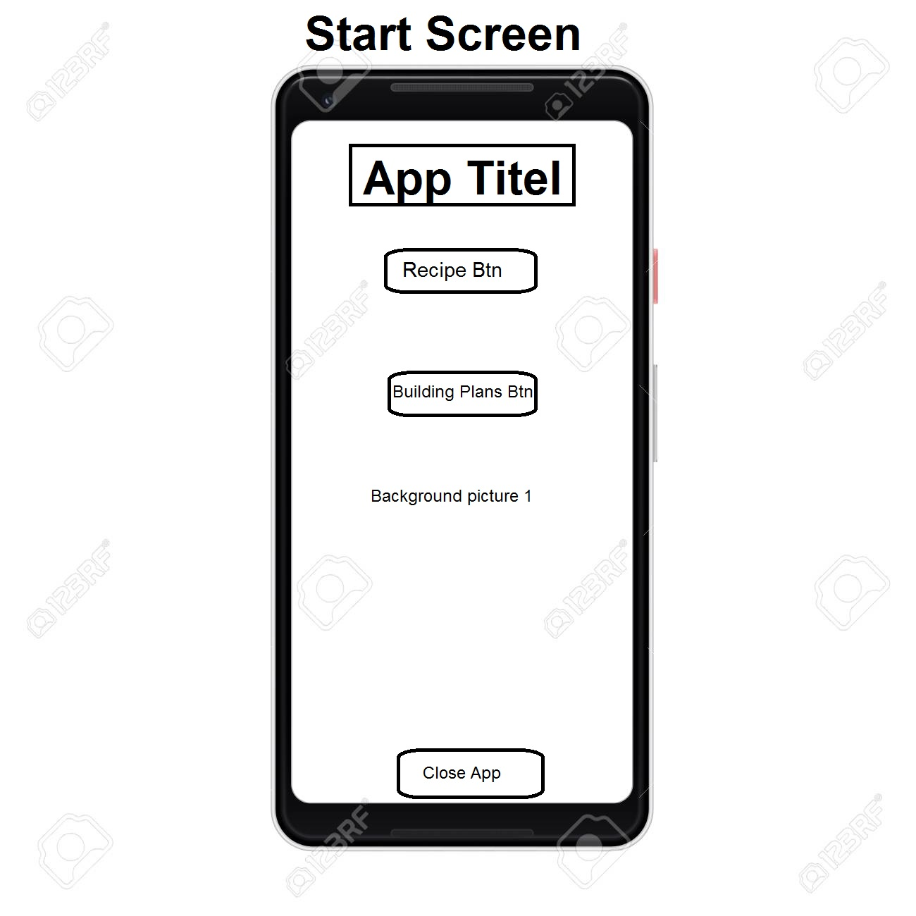
This ist he First screen if you open the app. Now you can choose if you wnat to go tot he recipes or the building plans oversight.

Screen 2 Recipes Oversight
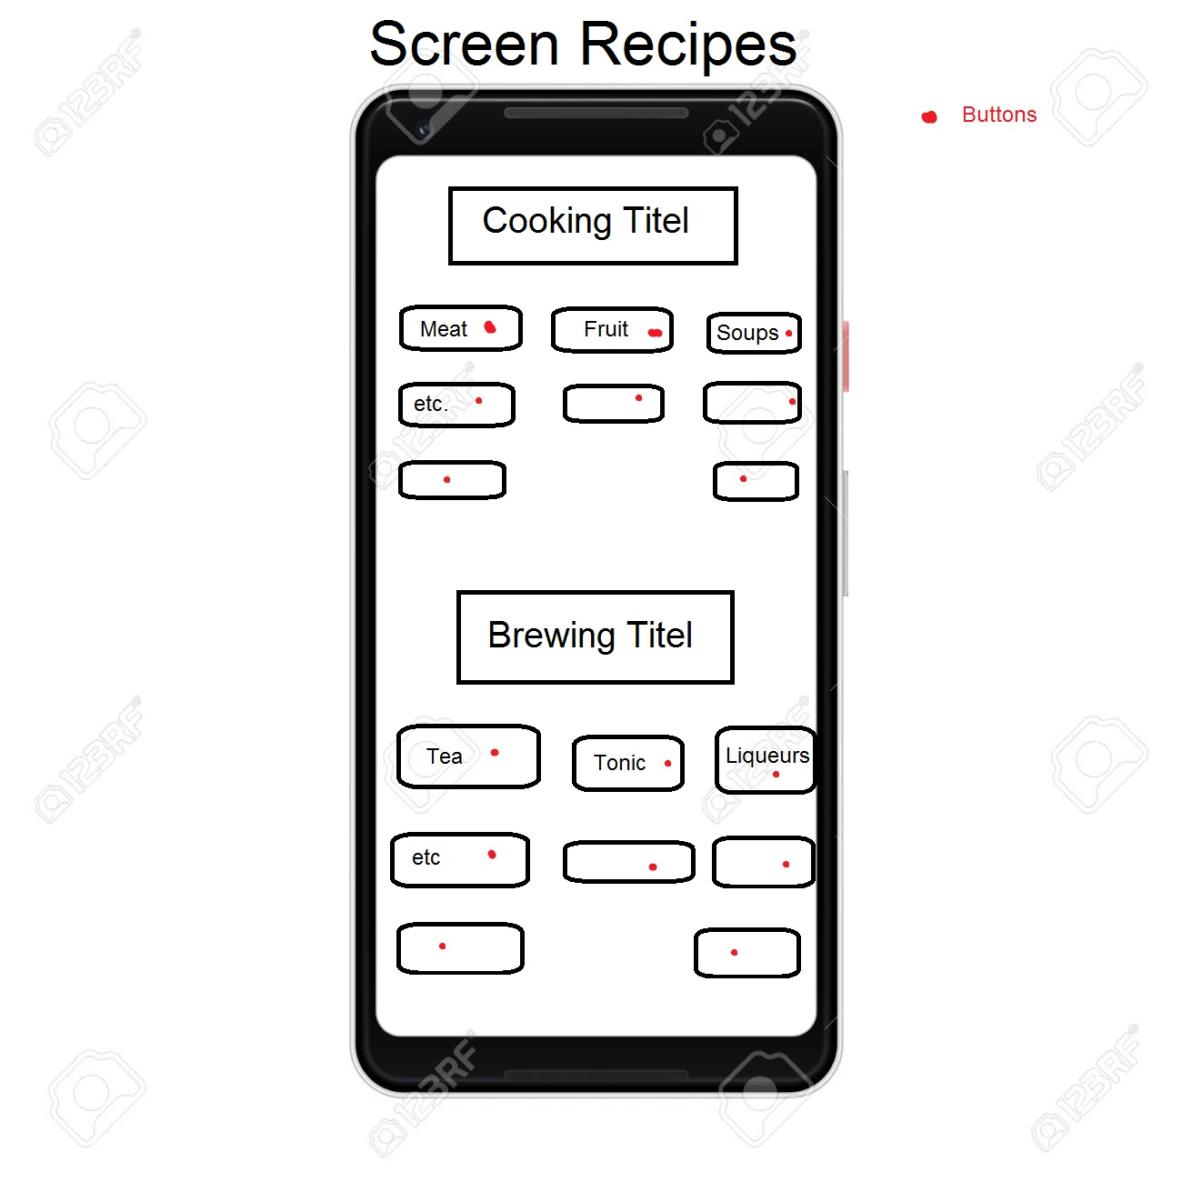
Background picture
Back Btn
Now you can find all the different categories and you can choose with the buttons which one to have a look in. The list with the recipes is hidden in this screen too and will just activate/be visible with the right recipes if a button is touched.

Screen 2.1 Meat Dishes
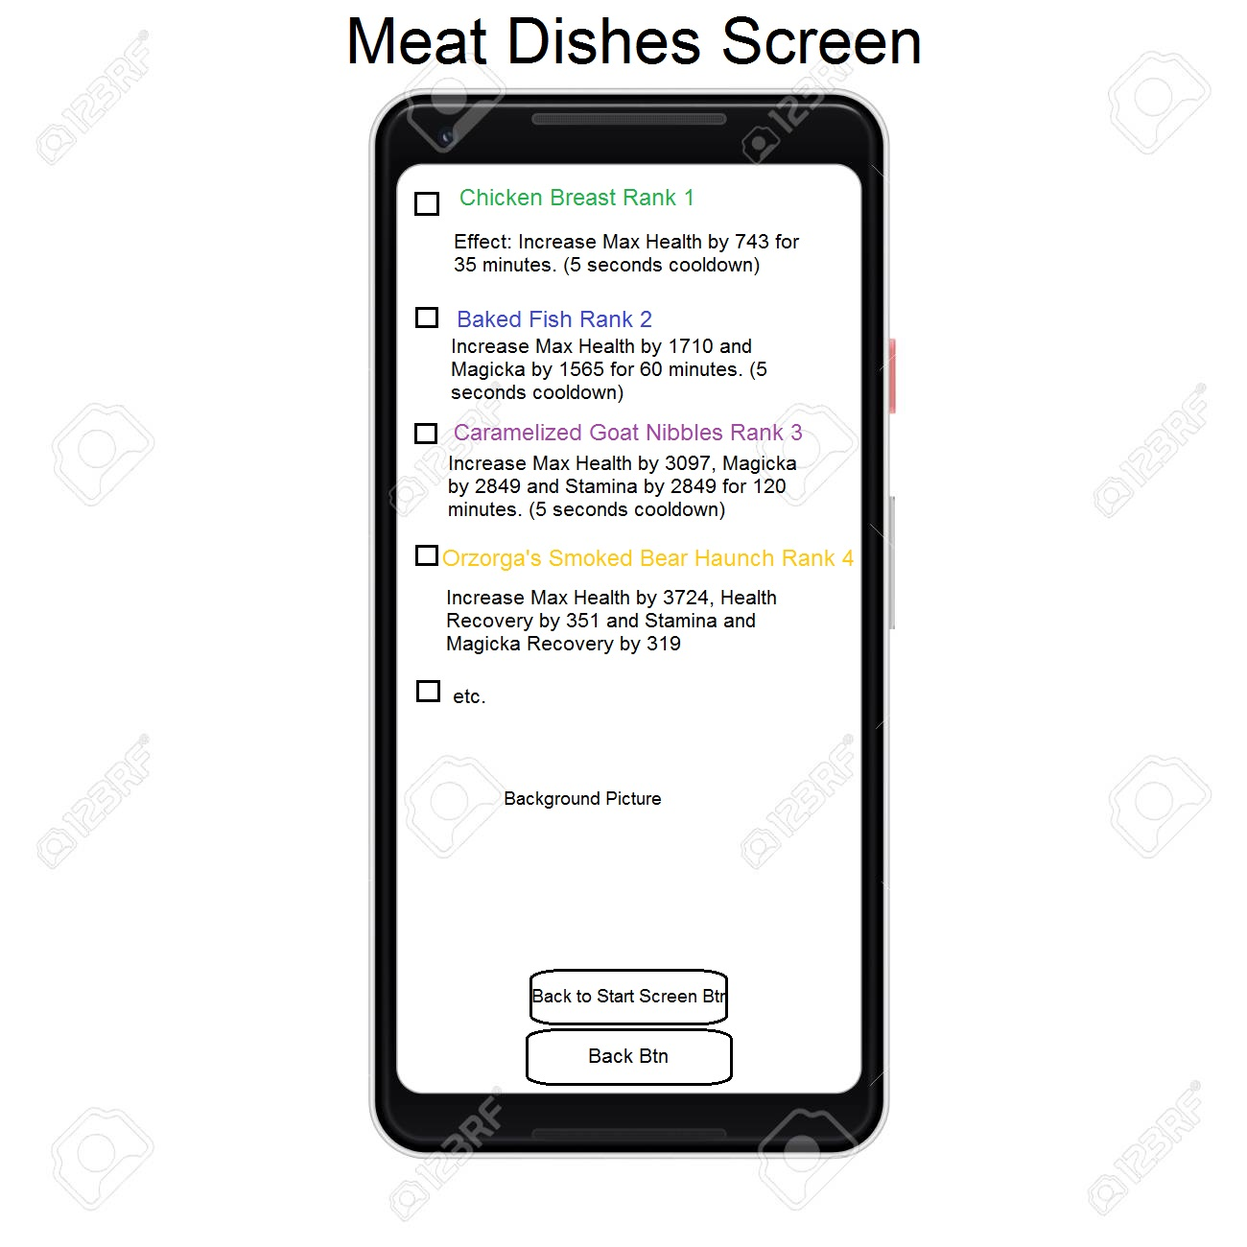
Here you can see all the recipes (or building plans of course) with the Effects in a list where you also can mark the ones you already have. Optimally you would also see which quality the recipe is based on the colour of the recipe text (Quality 1 / 2 / 3 / 4 / 5).

