**MECHANICAL ENGINEERING DESIGN 2**

**MIO220S**

**2013 SEM.2**

**PROJECT BRIEF**

You are required to design an automatic hydro-pneumatic assembly station of press fitting bearings into housings. The system must have minimum operator interventions, practically only limited to the feeding of bearings and housings into their respective gravity feeders. Finished parts must be dropped on a conveyor that takes them to packaging.

The bearing type is a single row radial ball bearing with external diameter D = 52 mm; bore diameter d = 25 mm; the width B = 15 mm; and the fillet radius r = 1 mm, as showed on Fig. 1. The bearing must be press fitted into 4-botls square pillow housing by means of an hydraulic cylinder (up to 20 ton of force), illustrated by the operation 1A1 on Fig. 3. After fitting, the press must maintain the housing in place for the drilling of the lubrication orifice to be executed, (operation 1A2 on Fig. 3), before the press arm retracting.

 

**Fig**. 1 Ball bearing dimensions and type of guides during press fitting.

All positioning of components on the station jigs and the ejection of finished parts must be excecuted by pneumatic cylinders.

Lubrication orifice

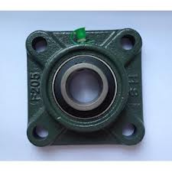

80mm

120mm

14 mm

**Fig**.2 4-Bolts Square Pillow Bearing Housing.

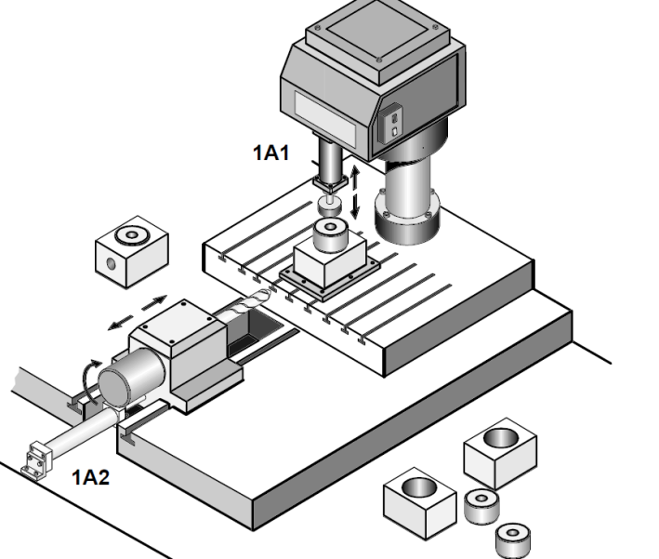

**Fig**. 3 Illustration of the station arrangement.

Design a system with two feeders (Gravity feeders), one for the bearings and the other for the housings. Sequences for positioning should be controlled by pneumatic cylinders, fitting and drilling powered by hydraulic actuators.

Specific tasks:

1. Design the bearings and housings feeders to the station and their sequences. **[10]**
2. Design the station setup: base plates, mountings actuators and sensors involve and the steps sequences **[40]**
3. Design the control system to automate the station. **[20]**
4. Design the conveyor (3 m long) for evacuation of finished parts (size, structure, speed and power system and control). **[20]**
5. Conduct necessary evaluations (calculations) of all components and draw required drawings that go along with your concepts.
6. Present your findings in an appropriate report format. **[10]**