DIY guide – miniscope commutator

These can be made for about $30 each. We have been using these commutators for a while now with great results. Imaging sessions have been stable for up to an hour, and with an armored cable large animals can be left completely unattended without having to worry about cables twisting or animals eating the cable.

Evan Hart and Matt Gardner

Items needed:

-Standard heat shrink
https://www.mcmaster.com/7856K44/

-standard miniscope coax cable. CW2040-3650SR from cooner wire works
https://www.coonerwire.com/mini-coax/

-coax connectorizing PCBs. These are the standard ones from OSH that Daniel made. You probably have them on hand
https://oshpark.com/shared_projects/xtQGQ32E

-coax SMA female jacks. From digikey CON-SMA-EDGE-S-ND
https://www.digikey.com/en/products/detail/rf-solutions/CON-SMA-EDGE-S/5845767

-coax SMA male plug connectors. You probably already have these on hand: CONSMA013.062-ND
https://www.digikey.com/en/products/detail/CONSMA013.062/CONSMA013.062-ND/1577228

-fast setting epoxy. I prefer hardman extra fast setting. Number 04001
https://www.theepoxysource.com/On-Line-orders.htm

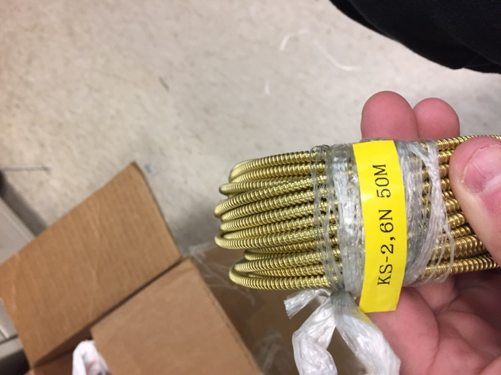
-metal sleeving. I have been using brass (see attached photo), but I could not find a source for this particular one since I just found it lying around in lab. but anything metal and flexible enough would work, such as this steel corrugated sleeving from mcmaster carr: https://www.mcmaster.com/54885K11/

-slip ring from adafruit: https://www.adafruit.com/product/1196

PART 1 – the commutator

- Prepare 2 coax SMA connectors. For each of them, solder the coax PCB to the coax SMA connector (CONSMA013.062-ND). Make sure to connect each ground pad, including the 2 on the back (exactly as you would for making a miniscope).
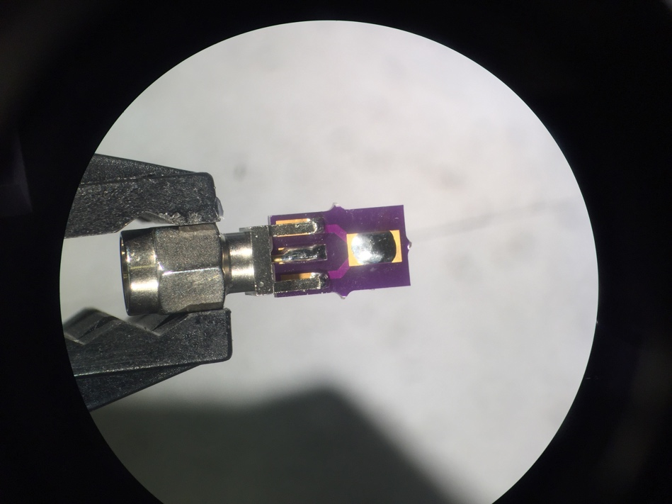

- To deal with the extra wires you can either bundle them up and tape them aside (as pictured below) or just cut them off altogether. I kept them in case something breaks, I have backups to use.
- Prepare the slip ring – on the top side (the side that does not have the moving part), trim 2 of the wires to about 2 cm. does not matter which wires. I have been using red for signal, white for ground. The goal is to get them as short as possible, while leaving enough slack to solder them to the PCB, which is now attached to the SMA connector.
- Once the top has the signal and ground soldered, fix the connector in place with hot glue.
- On the bottom of the slip ring (with the moving part), find the same 2 wires (by color), and trim them to about 2 cm. Once they are trimmed, solder them to your other coax PCB. Try to strip and solder them such that you can attach the connector as close to perfectly straight as possible.

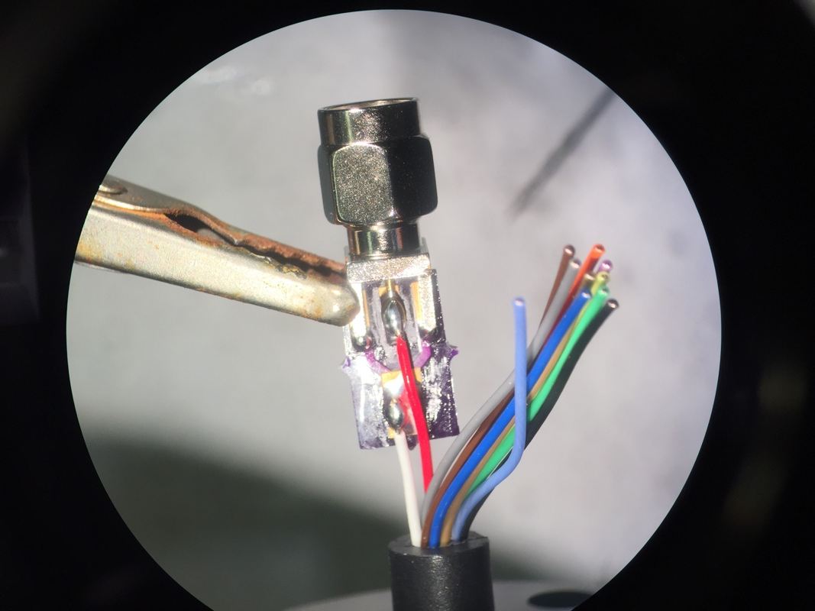

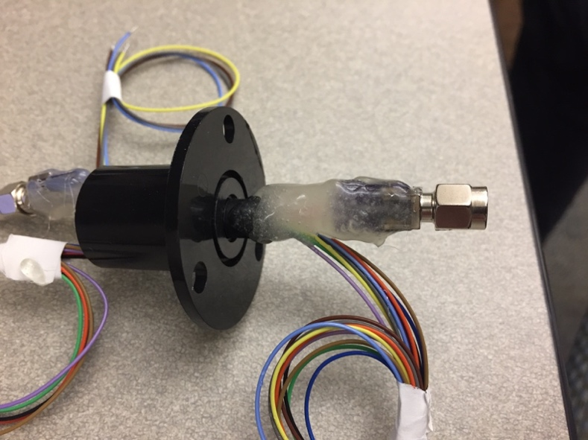
- Once the bottom connector is soldered, fix it in place with epoxy. Make sure to get a good ring of epoxy around the moving part of the slip ring (without getting in the mechanism!) and around the PCB/connector.
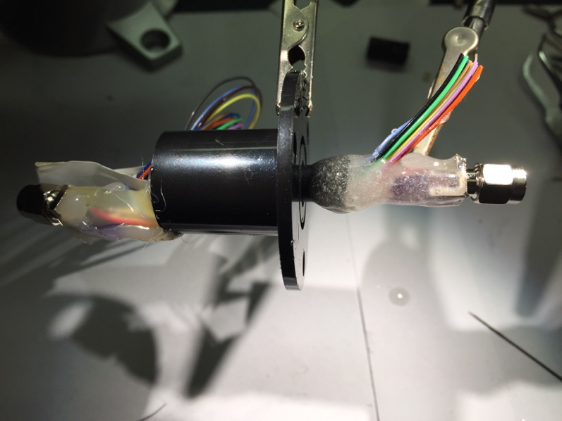

PART 2 – the armored cable – this is made to plug into a miniscope that has been permanently affixed to the rat’s head (we get super consistent imaging this way!). An alternative if you do not want to permanently affix your scopes is to cut the coax cables attached to your miniscopes to the approximate length that would be needed to get from the rat’s head to the commutator. Then just slip the metal shielding over the cable, and solder on a coax connector.

- Cut a length of metal sleeve appropriate for your box/behavior. Cut this same length of coax cable, plus ~3cm on each side.
- Prepare 2 coax jacks with PCBs. Solder the coax PCB to the jack (CON-SMA-EDGE-S-ND)
- Solder one end of the coax cable to one of your jacks – both ground and signal
- Feed the coax cable through your metal sleeve. Put heat shrink over the coax cable where it could contact sharp edges of the metal sleeve. This is to avoid the metal sleeve cutting the insulation around your coax cable. (do this on both ends). Secure this end with hot glue. Epoxy also works, but hot glue is just easier to remove if you ever want to reuse parts
- Solder the other end to your other jack, both ground and signal. Secure and fix this side with hot glue or epoxy.

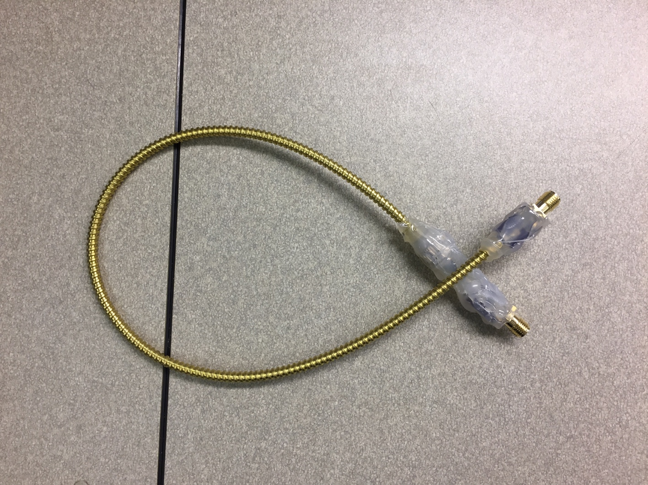

Part 3 – one more cable

Make a coax cable for connecting the commutator to your daq. Male end on one side, female on the other.

