Mifos generated loan repayment schedule
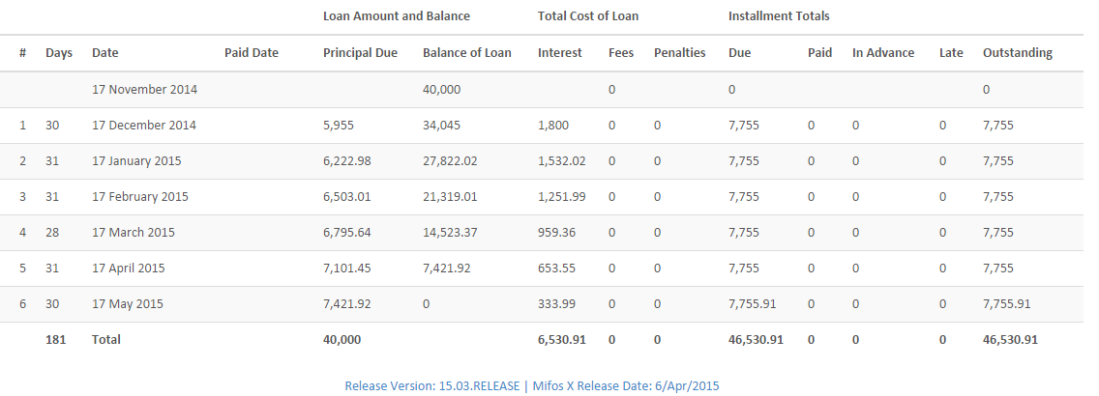

loan setup

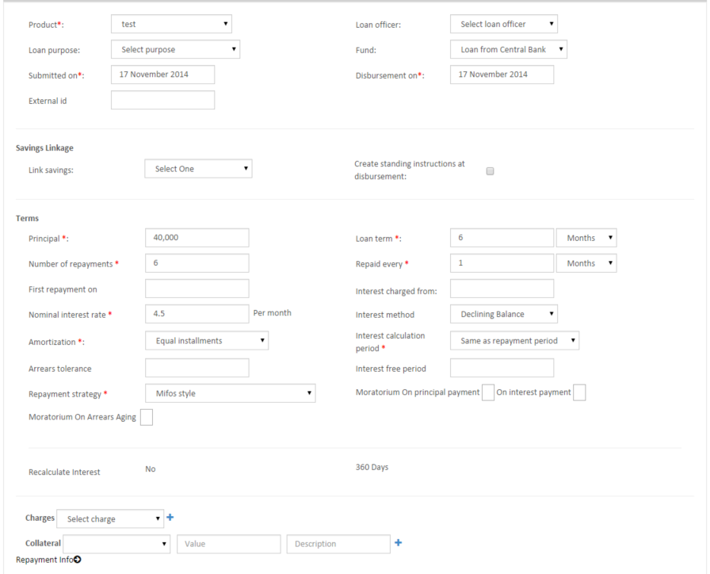

Product setup:
Equal principal payment,
Mifos style
360 days
Days in month: actual

Mifos emi shown is 7755
Using the emi formula manually expected emi must be 7755.136
Should it be rounded up to 7755.14?

