Non-stretchy integral (looks good):
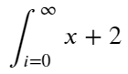

Stretchy integral (quite upright):
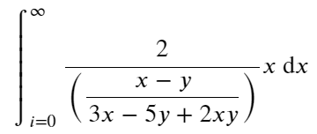

Stretchy integral variants (double, triple, and bounded integrals) (don’t stretch):
