Knowing Mario: For the First Time

Emilio Iodice
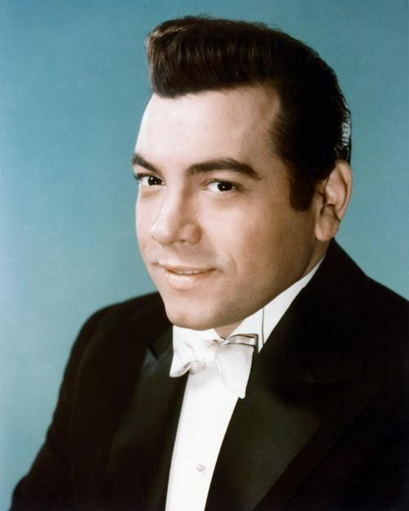
My fascination with Mario Lanza started on October 7th, 1959. Our family, like other Italian immigrants, was large and extended. Three cousins lived with us in our duplex in New York. One was a brilliant carpenter. He studied history, art and music. Gaetano loved opera.
That day, he came home early from work. I had just arrived from school. As I passed his room, I heard crying. It was deep and sorrowful. I sensed a heart-rending event. I imagined the loss of a close family member or friend. I drew all the courage I had to knock on his door. He opened it slowly. I sat next to him on his bed. He looked at me with eyes swollen with tears. “He’s dead,” he said. His voice was muffled and deep. I was speechless.
I expected he would tell me it was his father, mother or brother or someone so close to merit such suffering. I could tell that chills were running through him. He was trembling. “Mario Lanza is dead,” he said. I was confused. Who was this friend, this person, this name? “He was the greatest voice and the greatest entertainer of all time,” he said, choking back an endless quantity of tears.
“He was a singer,” I said? “He was more than that. He was the most wonderful tenor you have ever heard. He could sing popular songs, record spectacular LPs, do magnificent concerts, have a radio program, be on television and also make movies,” he exclaimed. “There was no one like him. He surpassed Caruso, Gigli and all the others because he crossed over to do what other tenors only dreamed about,” said Gaetano. He was inconsolable.
His room had a record player and a stack of Italian recordings. On top was “The Great Caruso.” A handsome young man, dressed in a tuxedo and standing on a stage with an orchestra was on the cover. Gaetano took the album from the pile and held it to his chest. It seemed like it was a relic of sacred value. With care, he took out the disc and gingerly laid it on the turn table. He started the machine and put the needle on the record.
Out poured music I never heard before. They were violins and a cornucopia of strings. Suddenly, a voice filled the room. It seemed like the orchestra was playing to it. It was thrilling. It was strong, young and powerful. It was melodic, overflowing with a smooth musicality that reminded me of waves rolling over the sea with rhythm, strength, softness and perfection. It was the first time I heard Mario Lanza. It was “La Donna e Mobile” from “The Great Caruso.” Goose bumps covered my arms and legs. My face turned flush with wonder. For the next two hours, Gaetano and I listened to one record after another.
It was hard to believe that the same person who sang “Celeste Aida,” and “O Sole Mio” with such emotion could now drift into the world of the “Student Prince” with “Deep in My Heart Dear” and “Serenade” and sail into the sphere of love with amazing songs like “Love is the Sweetest Thing,” “My Romance,” “If I Loved You,” and “Danny Boy.”
I understood how Gaetano felt. The world had lost something special. It was a rich talent that gave immense pleasure and joy. Lanza had an inspirational voice. It was warm yet powerful. It was clear and, if perfection existed, it was as close to being perfect that any human could achieve.
I was struck with an immediate fascination. I had to learn more. In a theatre near my house was playing “For the First Time.” Gaetano and I went to see it. Throughout the motion picture I heard people crying. The movie was joyful and Mario was at his best. I could not believe that shortly after the film was finished he died at 38. It was incredible.
From that day forward I became a fan of Mario Lanza. Nine months after his passing, I finished elementary school. I graduated with high honors. My father said I could choose any reasonable gift I wanted. He expected a bicycle or an encyclopedia, which were both things I longed for. Instead, I asked if we could visit the record shop in Little Italy in Manhattan.
It was on Mulberry Street. The store was filled with thousands of recordings. Most prominent were works of Mario Lanza. They were everywhere. As my gift I wanted to hear Mario and Caruso. We left the store an hour later. I had 6 Lanza albums that ranged from opera to pop to religious to Christmas. A special Caruso compilation included 3 LPs with nearly 100 of his best performances. I was in heaven.
For the next month I devoured arias and songs with 2 voices that electrified me. Caruso was luxurious, deep and wide. It was oceanic. Mario Lanza was something else. I could identify with this first generation Italian American. He had perfect English diction and his Italian seemed impeccable. His voice was young, energetic, filled with power. I could see images when he sang. They were of cascading falls, sea gulls and eagles flying, angels with harps and performers with violins. I could feel emotion. I understood love by delving into the sensations from his voice caressing the words of poets who had sent pieces of their hearts as lyrics to give life to music. It was amazing.
As I entered my high school years, I studied Mario, Caruso and every tenor since the start of recordings. I read voraciously about their lives and careers. Each week I consumed the latest issue of “Opera News.” I could never afford a ticket to the Metropolitan but listened to the live Saturday radio broadcasts. I was enthralled by what I heard and could see in my mind’s eye. I imagined the scenery, the settings, and the story and was captured again and again by the voices and the flights of emotion that only opera can provide.
By the time I finished my university education, I had listened too and studied every Italian opera and heard nearly every performer who had set their voice to discs since the start of the 20th century. Each was unique. Some were incomparable. I had examined, in my own personal way, every artist. I was a true lover of “grand voices.” Finally, I set a benchmark. Enrico Caruso, as Lanza often said, was by far, the richest and broadest of tenors. He soared with pure power and energy. He was the opera king and would remain so until the dawn of Luciano Pavarotti.
Mario Lanza was something else. His flair for opera was more direct and resolute. He was not burdened with hours on the stage, reciting and acting. He focused on arias that were popular, intense yet concentrated with sentiment. His passion was the key. He brought excitement to each performance and sang as if it was his last. Lanza’s fervor and enthusiasm was unmatched. His versatility set him apart for everyone else. His recordings of popular songs became solo hits that only he could perform. Whenever I needed to feel creative and stimulated, I turned to listen to Mario. I never grew tired. I heard “Long Ago and Far Away,” a dozen times, yet each seemed new and different. No other singer had such an impact on me.
As the years turned into decades, I continued to search for performers who could match Mario in all his creativity and talent. I found the specialists like the splendid tenors of the majestic opera houses who the world knew and loved. They devoted their lives of lyric opera. No one could go beyond those boundaries and venture into other areas of entertainment with the same success as Mario Lanza.
When I met and got to know Placido Domingo, I was struck by his devotion to Lanza. He told me of how “a kid from Philadelphia” inspired him and so many others to venture into the world of opera. He made a documentary in the 1980s, “The American Caruso,” which was a homage to Mario. It demonstrated his contribution to so many marvelous performers who wanted to be like him.
I was inspired by Placido to write about Lanza. I learned of the British Mario Lanza Society from my family in London. Pam Latham was kind enough to accept some essays about Mario for “Golden Days,” the lovely newsletter of the Society. Eventually, a number of people who read them asked that I publish them in a book.
Several fine biographies had been written and I was not interested in preparing another. I wrote as a fan, writing for fans. I wanted to render honor to Mario Lanza by depicting who he was and how he was to those of us whose lives were changed by his voice and by his life.
I hope I have done so in “A Kid from Philadelphia, Mario Lanza, the Voice of the Poets.” The work is a series of essays in English and Italian. They start with a “Letter to Mario.” I wrote it as if he could read it from that celestial place where he now sings with the angels. It captures the feelings from the heart that only Mario Lanza could provide. The essays range from a brief depiction of his extraordinary life to his passing on October 7th, 1959:

Letter to Mario

An Extraordinary Life

Listen to Mario

The Lanza Essays

A Kid from Philadelphia

Once Upon a Time there was a Boy with the

Grandest and Sweetest of Voices
Mario Lanza: The Man and the Myth
The Lanza Legacy: The Voice of Poets

The Great Lanza: The Spiritual Dimension
October Seventh

Each essay is a work of love and gratitude. As I note in the Introduction: “They are personal reflections, not scholarly works. They leap from the heart. They paint a picture of a performer who gave us joy and inspiration. It is a tribute to him and those who venture into the realm of entertainment. May they live long and happy lives. They give us pleasure and help dismiss thoughts of challenging moments and difficult days. Mario Lanza was such a person.”

----------------------------------------------

“A Kid from Philadelphia, Mario Lanza, the Voice of the Poets,” can be ordered from this Amazon.com web site:

http://www.amazon.com/Kid-From-Philadelphia-Mario-Lanza/dp/1470062917

