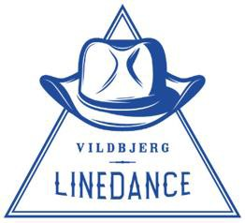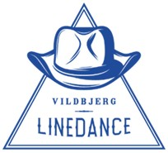Vildbjerg Linedance
Livlig lørdag
1. oktober 2022

 | Dans | Alternativ
1 | Wait a minute
2 | Until the dawn
3 | Adalaida | Cut a Rug
4 | Top of the World | Tennessee Waltz Surprise
5 | Reunited!
6 | Fields of Athenry | Skinny genes
7 | ’Til you can’t | This and That
8 | Workshop 1
9 | I’m on my way
10 | Dance before you leave me | Come dance with me
11 | Over drinkin’
12 | Irish Pub song
13 | When you smile
14 | Mighty fine
15 | Bottom of the Bottle
16 | Dim the Lights | Why did it have to be me
17 | Into the Dark Night | Mamma Maria
18 | Workshop 2
19 | Wrong Direction | Ice Breaker
20 | Sweet Ireland | Hearts and Flowers
21 | Knock Off | Things
22 | In Heaven
23 | Storm and Stone
24 | Make It | Thanks a Lot
25 | I cross my Heart | I’ve been waiting for you
26 | Recap 1
27 | Recap 2
28 | Gypsy Queen | Sweet Sweet Smile
29 | Champagne Promise | Broken Heart
30 | Hey Boy
31 | Walk Back to Me | I close my eyes
32 | Sunset road

TAK FOR I DAG 😊

