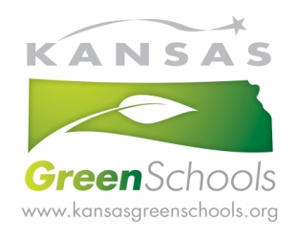
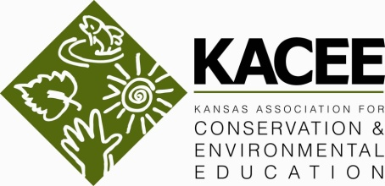
For immediate release 14 September, 2016
For more information, contact Jolene Amtower
jamtower@kacee.org or 785-532-1902
or visit www.kacee.org

Kansas Green Schools & Environmental Education Conference
Tell Your Story!
November 4-5, 2016 at Baker Wetlands Discovery Center in Lawrence KS

Lawrence, KS - The 17th Annual Kansas Environmental Education Conference will offer Kansas educators the very best in conservation and environmental education professional development, networking, and exploring the outdoors November 4-5 at the new Baker Wetlands Discovery Center. The 2016 conference theme, Tell Your Story, is an exploration of the power of story to engage learners and inspire action. This conference will be a fun and educational experience for both school-based and non-formal/community-based educators alike. All who work to expand opportunities for children and adults to learn about and experience nature are invited to register.
On Friday, November 4, conference attendees have the option of participating in an afternoon pre-conference wetlands adventure as part of their regular conference registration, or registering for a full day pre-conference workshop. The pre-conference workshop will provide a wealth of activities and tools for educators to incorporate environmental education and the Kansas College and Career Ready Standards into their classrooms and programs while exploring the connections between wetlands and wildlife. Educators participating in both the conference and pre-conference workshop will have the option to earn a graduate credit. “We are thrilled to host this year’s conference at the beautiful new Baker Wetlands Discovery Center, and include a unique opportunity to explore wetland wildlife with the center’s founder, Dr. Roger Boyd, as well as a workshop that will inspire educators to incorporate wetland studies into their classrooms and programs” said Melissa Arthur, KACEE’s Director of Operations.
The conference will kick off Friday evening with a “Taste of EE” event that will showcase a wide variety of field-tested hands-on activities developed and presented by experienced teachers and environmental educators. The evening’s entertainment will include an EE Story Slam, celebrating the heartwarming and hilarious adventures unique to the environmental education field while demonstrating the power of story to bring people together around shared values.
The conference program for Saturday, November 5, will include a variety of concurrent sessions and roundtable discussions presented by leaders in the environmental education field, as well as a keynote address by Andy Goodman, writer, producer, orator, and founder of the Goodman Center. Goodman will illustrate why storytelling is the single most powerful communication tool we possess, and he will offer specific techniques for using stories to advance our missions.
Arthur summed up the conference experience by saying, “Conference participants can expect a fun and unique learning experience, including meals, evening entertainment and top-notch professional development for a very affordable registration fee. KACEE looks forward to our 17th year of convening this inspiring, hard-working and fun-loving group of professionals and welcoming new faces to join us in celebrating and strengthening environmental education in Kansas.” For more information and to register, go to www.kacee.org or contact Jolene Amtower jamtower@kacee.org or 785-532-1902.
###

