8:15 Registration opens
9:00 Opening remarks

The field school includes expert presentations,
In-the-field activities, goal setting, networking & great conversations.

Sacred Heart Parish Hall - 101 Cottonwood - Emporia, KS 66801

Lodging: www.VisitEmporia.com/ 35/Stay

Registration
Limited to first 150 paid
Check payable to Gail Fuller, or PayPal: https://greencoverseed.wufoo.com/forms/2018-fuller-field-school/
Gail Fuller
1862 Road M
Emporia, Ks. 66801
Please email me before sending your check to make sure there is still room.

RATES:
Early bird: $200/person or $300/couple
April 1 $275/person
$375/couple
Noon meals & snacks will be provided.

Evening meal in the field on the 18th for an additional $20

QUESTIONS? CONTACT:
Gail Fuller
fullerfarms@hotmail.com
(620)344-3363

Don’t forget our farm design workshop April 20!
Soil Is Life
REJUVENATING SOIL. GROWING HEALTHY, NUTRIENT-DENSE FOOD.
MANAGING WATER EFFECTIVELY. ATTRACTING ABUNDANT WILDLIFE.
BUILDING RESILIENCE FOR FUTURE GENERATIONS.
2018 FULLER
FIELD SCHOOL
April 18-19
Walter Jehne
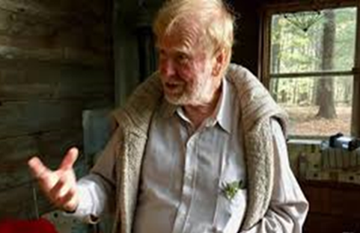
Walter Jehne is an internationally recognized climate scientist, soil microbiologist and innovation strategist. He has immense field and research experience in forest, grasslands, agriculture and soils at national (CSIRO) and international (UN) level. Walter has a remarkable ability to explain complex science and economic paths forward in easy to understand ways. Walter’s primary scientific focus is soil biology.

Judith D. Schwartz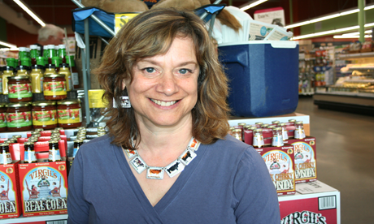
Judith D. Schwartz is a widely published journalist and the author of Cows Save the Planet and Other Improbably Ways of Restoring Soil to Heal the Earth and Water In Plain Sight: Hope for a Thirsty World. She has a B.A. from Brown University, an M.S.J. from the Columbia University Graduate School of Journalism, and an M.A. in Counseling from Northwestern. She speaks nationally and internationally about soil-water-climate connections and solutions, most recently in Mexico, France, Norway and Switzerland.

