

April 20

8:00-3:30

Sacred Heart Parish Hall - 101 Cottonwood - Emporia, KS 66801

Cost: Early bird $75 (if you attended the “Soil Is Life” School prior) otherwise, $100

After March 31 $100 for school attendees and $150 for others

PayPal (link below) or check to: Gail Fuller

https://greencoverseed.wufoo.com/forms/2018-fuller-field-school/

Questions? Contact Gail

(620)344-3363 or [fullerfarms@hotmail.com](mailto:fullerfarms@hotmail.com)

1862 Road M, Emporia Ks. 66801

Lunch Provided

Fuller Field School Part 2:

Farm Design

Designing For The Future

Come learn how to design your operation to be more efficient in use of time while maximizing energy flow. Walter has vast knowledge of how to design systems to work in sync with nature.

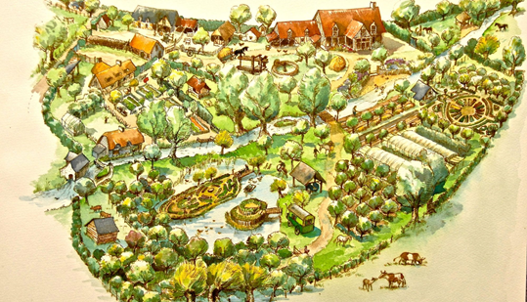Walter will also share ideas on different designs of “tools” he has to make life easier, and more efficient!

