- Top problem
  - 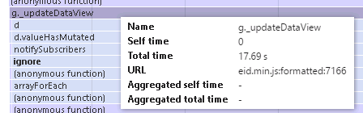

g._updateDataView = function(b) {
g.IsArray() && !a.isArray(b) && (b = [b]),
g._sortData(b),
g.Mode() === "Append" && a.isArray(b) && (b = a.merge(g.DataView() || [], b)),
g.BeforeUpdate.notifySubscribers(b),
g.Data(b),
g.DataView(b),
g.AfterUpdate.notifySubscribers(g.DataView())
}
,

- 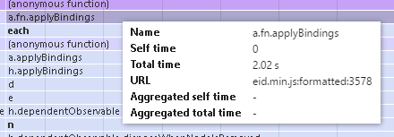

if (a)
b.mapping.fromJS(a, f.Rows, e.Rows).extend({
throttle: 400
});
else {
var d = e.DataSource.DataView();
c.isNull(d) && (d = []),
b.mapping.fromJS({
Pager: {
TotalCount: e.DataSource.Paging.TotalCount()
}
}, e),
b.mapping.fromJS(d, f.Rows, e.Rows).extend({
throttle: 400
})
}
o()
}
- 