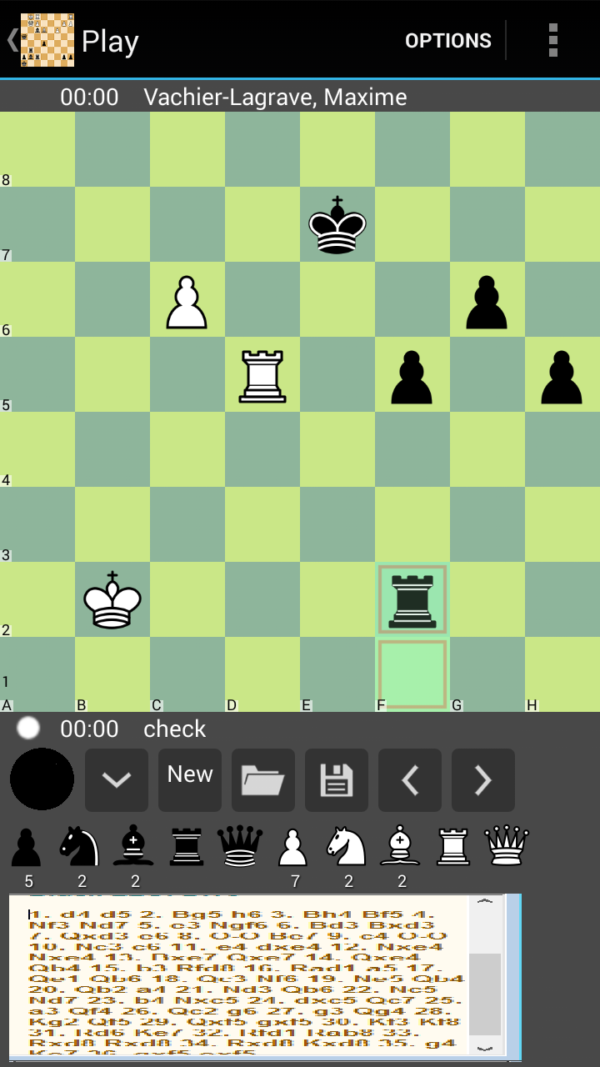
This is the first idea. In the original image, do not have the box of movements of the game. In the Image above is not exactly supposed to be, it's an example how can be. Exactly like the current. But in this case, the game movements shows on the screen. Using the same method of course. Coloring the current move with the red color, or another color you wish. And letting on the screen the captured chess pieces. Like in the image.
The black circle represents the color of chess pieces. If you touch in there, you can change the pieces side of the game. Like is done when you touch in the screen and slides to change the position game. I think it's more direct and objective. Another change is about the online game. Instead of having a command line, put the same movements box, not necessary the movements box, but the line of the moves. And the pieces of chess game, like the picture above shows. And using the same idea of ​​the command line, you can use a command line to change what you would like. Example. When you open the online game, you begin with the command line, but when you are playing with another player, changes to the screen like the picture above, with the pieces and the moves line of the game. When the game over, appears the box like a box of the normal game, where have the options to review the game. To save your game, and give the chance to move your pieces to analysis of the game. Or even copy to the clip board.
That is it. I hope to help a little with this ideas and changes. And I hope you read and think about the changes. Thank you so much to the attention!

