To share your printer
- Open Printers and Faxes. Click Start, click Control Panel, click Printers and Other Hardware, and then click Printers and Faxes.
- Right-click the printer you want to share, and then click Sharing.
- On the Sharing tab, click Share this printer and then type a share name for the shared printer.
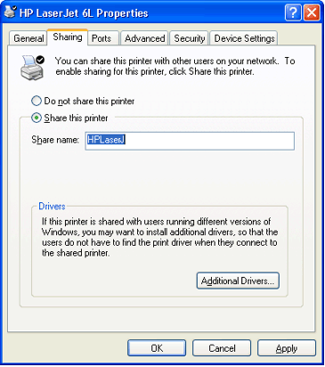
- If you share the printer with others using different hardware or different operating systems, click Additional Drivers. Click the Environment and operating system for the other computers, and then click OK to install the additional drivers.
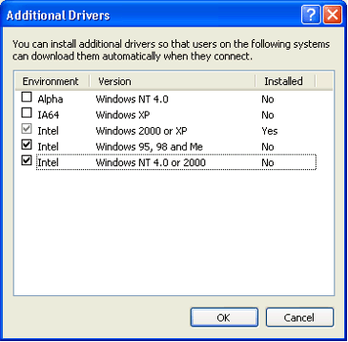
Note Drivers for users running other versions of Windows (Windows 95, Windows 98, or Windows NT 4.0) are located on the Support CD. Printer drivers for Windows NT 3.1 and Windows NT 3.5 are not included.
- Click OK, or, if you have installed additional drivers, click Close.
Note When you publish a printer in Active Directory, other users logged on to the Windows domain will be able to search for the printer based on its location and features, such as how many pages it prints per minute and whether color printing is supported.
To stop sharing your printer
- Open Printers and Faxes. Click Start, click Control Panel, click Printers and Other Hardware, and then click Printers and Faxes.
- Right-click the printer you want to stop sharing, and then click Sharing.
- On the Sharing tab, click Do Not share this printer.
To connect to a printer on a network
- Open Printers and Faxes. Click Start, click Control Panel, click Printers and Other Hardware, and then click Printers and Faxes.
- Under Printer Tasks, click Add a printer to open the Add Printer Wizard, and then click Next.
- Click A network printer, or a printer attached to another computer, and then click Next.
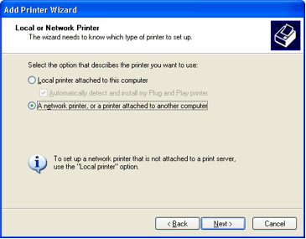
Top of page

Three Ways to Connect to a Printer on a Network
To search for a printer in Active Directory
- Click Find a printer in the directory, and then click Next.
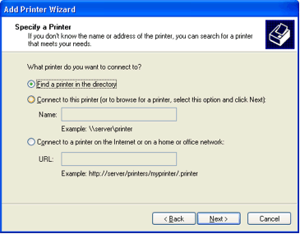
- Click the Browse button to the right of Location, click the printer location, and then click OK.
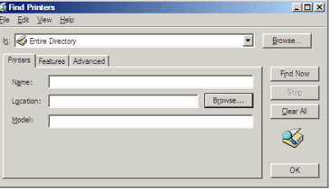
- Click Find Now.
- Click the printer you want to connect to, and then click OK.
To locate a printer by typing the printer name or browsing for it
- Click Connect to this printer.
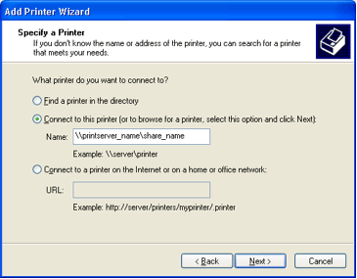
- Do one of the following:
- Type the printer name using the following format:
\\printserver_name\share_name
- Browse for it on the network. Click Next, click the printer in Shared printers.
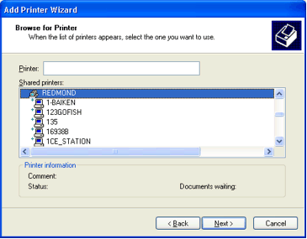
- Click Next.
To connect to an Internet or intranet printer
- Click Connect to a printer on the Internet or on a home or office network.
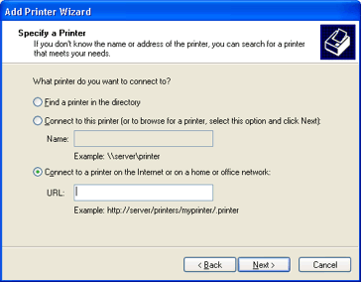
- Type the URL to the printer using the following format:
http://printserver_name/Printers/share_name/.printer.
- Follow the instructions on the screen to finish connecting to the network printer.
Top of page

Setting or Removing Permissions for a Printer
To change the permission settings for a printer, you must have the Manage Printers permission, which is one of several printer permissions.
To set up new permissions for a printer
- Open Printers and Faxes.
- Right-click the printer for which you want to set permissions, click Properties, and then click the Security tab.
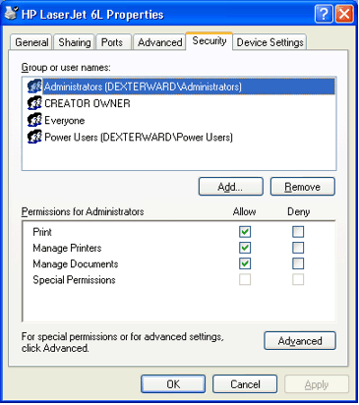
- Click Add.
- Click Look For, select the types of users you want to add, and then click OK.
- Click Look In, browse for the location you want to search, and then click OK.
- In the Name box, type the name of the user or group you want to set permissions for, separating each name with a semicolon ( ; ).
- To ensure the names are recognized by the directory, click Check Names.
- Once all the names you want are listed in the Name box, click OK.
- In Permissions, click the Allow or Deny check box for each permission you want to allow or deny.
- To view or change the underlying printer permissions that make up Print, Manage Printers, and Manage Documents, click Advanced.
To change or remove permissions for a printer
- Open Printers and Faxes.
- Right-click the printer for which you want to change or remove permissions, click Properties, and then click the Security tab.
- Click the name of the user or group whose permissions you want to change or remove.
- In Permissions, click the Allow or Deny check box for each permission you want to allow or deny, if necessary. Or, to remove the user or group from the permissions list, click Remove.
- To view or change the underlying permissions that make up Print, Manage Printers, and Manage Documents, click Advanced.

