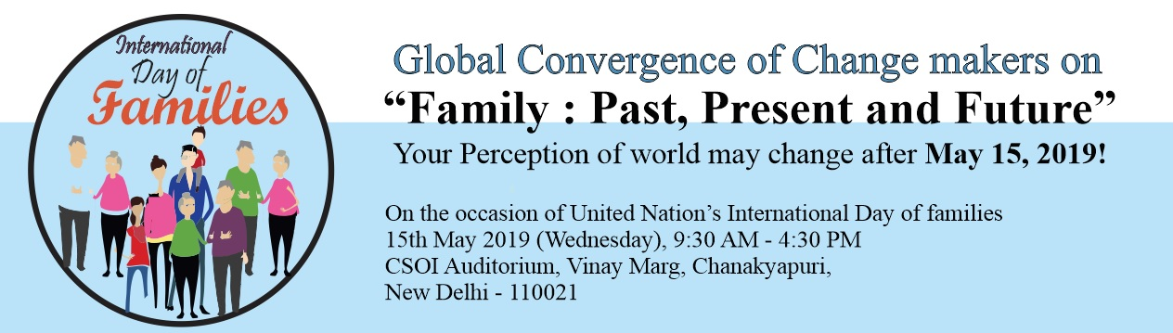
15 May | International Day of Families TOPICS | Program Structure  SUB TOPICS
10:00 - 10:45 | Inauguration, Key note address etc.
10:45 - 11:30  SESSION – 1 | Relevance of Family :Emotional, economic, social, cultural, educational aspects. | - Family forms as an institution / school across Geography and History  - Role of family : Nurturing and Character building of future citizens, Preserving culture and tradition  - Financial support structure to fall back upon when needed, Permanent source of Emotional fulfillment  - Family as the foundation for Building a happy, good and Prosperous civil society
11:30 - 12:15 SESSION – 2 | Family : Challenges and directions, Forces impacting strength and stability of the institution called family) | - Clash of Values : Formal Education Vs. Family Education ,  - Developments/ Civilizational shift (Notions of Ownership of property and Inheritance and its impact on the institution of family)  - Heterogeneous family forms : Genesis and future  - Family Vs Individual (Freedom Vs. Support, Rights Vs. Obligations, Role of members of family towards each other.
12:15 - 01:00 SESSION - 3 | Impact of constitutions across the world on institution of family. | - Indian constitution and family  - Personal laws and family  - International Pvt law vis-a-vis family  - Can constitutions be family centric ?
01:00 - 02:00
LUNCH
02:00 - 02:45 SESSION – 4 | Experience Sharing, different religions, different Regions : | “Challenges and Benefits” of  - Person managing single household  - Person from Nuclear Family  - Person from Joint family  - Person from Very large family
02:45 - 03:30 SESSION – 5 | Facilitating Journey from “Family to global Family” | Opportunities for a number of Organizations to make (3-5 minutes) presentations elaborating their activities, vision, Roadmap.
03:30 - 04:00 | Valediction, Resolutions and Vote of Thanks, Completion

4:00 – 5:00 PM Discussion Over Tea

