Clip/cropping photograph:

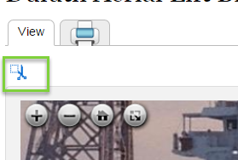

Results in:

Is it possible to do this with the individual page of the Book SP? For example, a newspaper page.
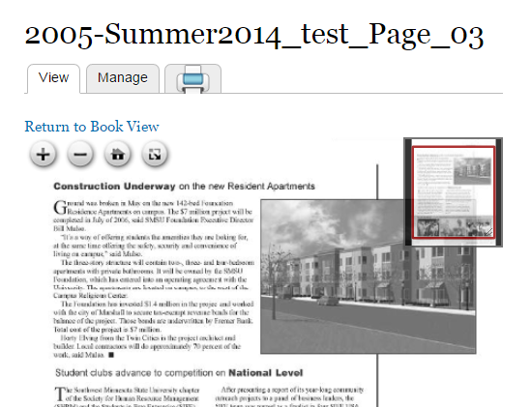

We don’t see the “clip/crop image” function…

