Facet setting mods_physicalDescription_form_ms
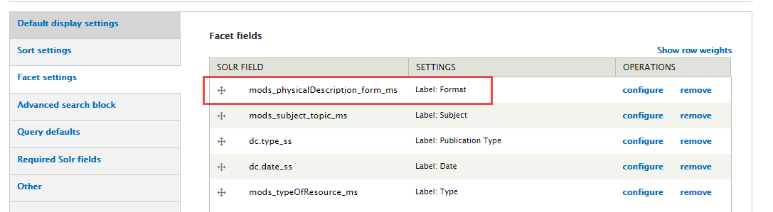

We have Newspapers under MODS physicalDescription form
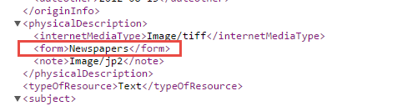
Works for search
Mankato State Normal School
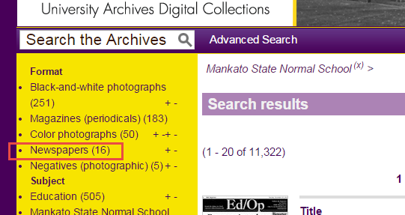

But not for Minnesota Vikings
