Dave Perry - Rules Quiz
March 15, 2023, 7:00 to 9:30, St Francis Yacht Club, Starting Line Room
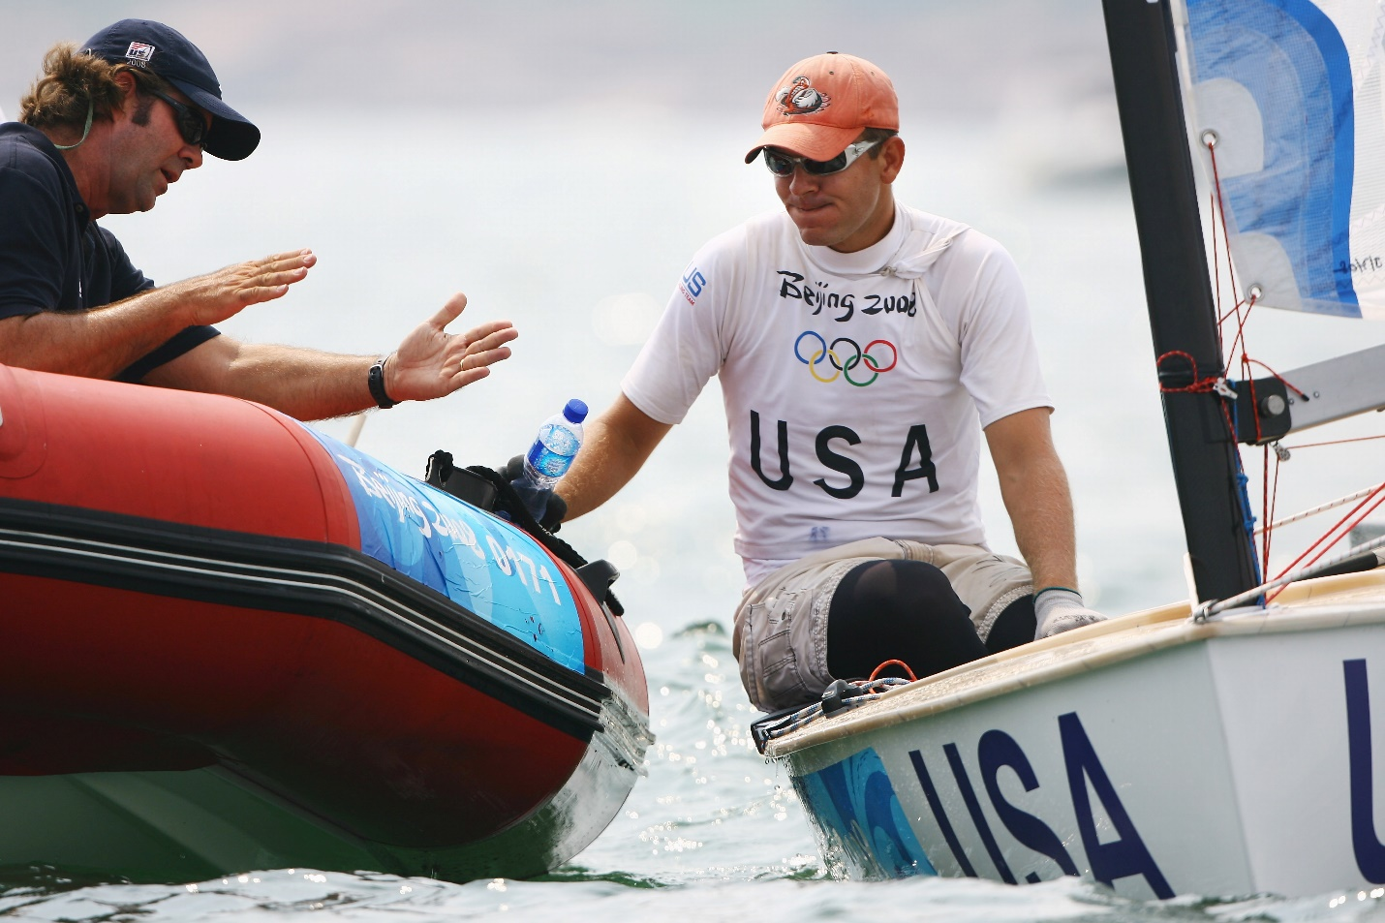

Rules Quiz! - This is an entertaining and informative look at situations around the race course where it helps to know the rules. Dave discusses the rules and tactics in each situation with a look to how to maximize confidence and winning tactics with an increased rules knowledge. This presentation is particularly useful for crews to help them understand better what will happen next and what information the skipper needs to know. Dave will answer all your rules questions as well.

Dave grew up on Long Island Sound in Connecticut, racing Blue Jays and Lightnings. He received his undergraduate degree at Yale University, and has received an honorary Doctorate of Education from Piedmont College. He is Chairman of the US SAILING Appeals Committee and a National Judge.

He was a two-time All American sailor and Intercollegiate Dinghy National Champion at Yale University, 5th place finisher at the 1979 Laser Worlds, two-time Congressional Cup winner (1983 & 84), Bronze Medalist in the 1983 Pan Am Games, Silver Medalist in the 1983 Soling Pre-Olympic regatta, 2003 Ideal 18 North American champion, and a five-time winner of the U.S. Match Racing Championship for the Prince of Wales Trophy.

Dave will have copies of his two books on the rules, Understanding the Racing Rules of Sailing and Dave Perry’s 100 Best Racing Rules Quizzes available for sale and signing (cash, check or Venmo).”

