REDISCOVERY OF OLAX NANA WALL. EX BENTH. (OLACACEAE) FROM GUJARAT, INDIA, AFTER A CENTURY.
Olax nana Wall. ex Benth. is reported to occur in North-Western Himalayas, Punjab, Nepal, Bihar, North Bengal, Assam, Burma, West Bengal and Odisha (Biswas, 1971; Panda et. al. 2013). The plant was reported before a century from Porbander district, Gujarat (Thaker, 1910), i.e. before 104 years. During our recent exploration of endemic and threatened angiosperms of Gujarat with Biodiversity Management Committee (BMC), Olax nana (Figure 1) was collected from Lathedi of Abdasa taluka, Kachchh district, Gujarat (Map 1).
Olax nana Wall. ex Benth. in Trans. Linn. Soc. 18: 678. 1838 - 1841; FBI 1: 576; c 1: 235; WI 7: 91; S&J 15.
A low under shrubs with a root; stock woody, twiggy, diffuse branched at base, branches are yellowish-green and smooth. Leaves alternate, arrange with sub zigzag pattern, 2.7-7 x 0.6-1.8 cm, oblong-lanceolate, glabrous, obtuse, base acute, midrib strong, margins are yellowish, subsessile exstipulate. Inflorescence axillary solitary, flowers white, 0.6-0.75 cm long, complete, actinomorphic, hermaphrodite, polygamo-dioecious or dioecious, perigynous; pedicel 0.6-1.25 cm long, slender. Sepals 3, polysepalous, minute, cup shaped, truncate or obscurely lobed, much enlarged in fruit enclosing the drupe, accrescent, valvate. Petals 3, free or more less connate, dirty white in color, valvate, oblong-obovate, apex rounded, tips reflexed, cohering about half way up but readily separable. Stamens 3, one in center of each petal, epipetalous (a little more than half the length of the petal and adnate to it about half way up); filaments free; anther yellow, adnate to the filaments, oblong, 2-celled, dehiscing longitudinally. Carpels 3; ovary free, 3-celled, ovoid, usually surrounded by a cup shaped hypogynous disk; ovules 3, linear, pendulous from the apex of central plancenta, one in each locule on pendulous placentation; style simple, shorter than stamen, simple; stigma 3-lobed. Drupe 0.5-0.7 cm across, globose, deep-yellow when ripe, covered by accrescent calyx, apiculate, stone crustaceous, 1-celled, 1-seeded. Seed spuriously erect, albuminous, embryo minute in the apex of fleshy albumen, radical superior.
Flowering and Fruiting: April-July
Vernacular name: Sudiyo, Himi, Tadholi
Specimens examined: Royal Botanic Garden Kew - K000657931.
Location and Ecology:
During the study period, Olax nana was associated with 5-6 species of plants viz., Lepidogathis, Chrysopogon, Dichanthium, Periploca, Commiphora etc…………… The plant was reported from riverine ecosystem predominantly with undulating open scrub patches. It was found mostly on gentle slope of riverside with sparse grass cover and sandy loamy soil on a gravelly substrate. The plant species though recorded from riverine habitat close to human settlements and other developmental activities like roads and check dams construction, no visible threats could be identified. Only threat that could possibly have an impact was the soil erosion and digging for water harvesting structure. Proper monitoring is needed to identify the precise threat faced by the species. This would ensure the long-term survival of the species in the wild.

Note: Critically Endangered (30 individuals found in a small patch of 50 sq. m.). Adequate measures should be taken towards protection of the habitat for natural growth of the still surviving population of this species along with its ex-situ conservation. Mass propagation using modern techniques like tissue culture is also suggested.
Collection of seeds to study its viability, germination and plant growth is very essential to spell out proper strategies to substantiate the wild population. In-depth studies on the micro- and macro-habitats are very crucial, which are essential in propagating the plant in Botanical gardens. In addition, developing nurseries close to such habitats to facilitate the better in-situ
condition would enhance the survival capabilities of this species. Such strategies could also form an important tool for identification of the reintroduction sites in and around the reported locality. In addition to carrying out more intensive habitat-specific surveys in Kachchh, the plant species must be protected with the help of the locals by making them aware of its rarity.
As the local people are unaware about this rare species, conserving this species in its natural habitat through the community participation would provide considerable protection.

ACKNOWLEDGEMENTS
We thank Dr. A.P. Singh, Member Secretary, Gujarat Biodiversity Board, Gandhinagar for providing financial assistance and necessary facilities. Our sincere thank to the members of BMC of Lathedi village for permission to survey reported localities of this plant. We also thank Mr. Vinod Solanki, Sahjeevan for assisting us during field work.

REFERENCES
Biswas M.C. (1971). A note on the occurrence of Olax nana Wall ex Benth. (Olacaceae) in West Bengal, Indian For., Vol. 97, No. 9, Pp. 508.
Panda P.C., Acharya P.K., Sahu D.K., Baboo B. & Mahapatra A.K. (2013). Olax nana Wall ex Benth. (Olacaceae)- A new plant record for Odisha, J. Econ. Taxon. Bot., Vol. 37, No. 1, Pp. 106-107.
Thakar, J.I. (1910). Vanaspati Sastara- Barda Dungarni Jadibuti tani Pariksha anae Upyog. (BOTANY- A complete and Comprehensive Account of the Flora of Barda Mountain (Kathiawad). Gujarati Printing Press, Bombay. (2nd revised edition; edi. B. G. Shah. 1952: Sastu Sahitya Vardhak Karyalaya, Ahmedabad. p.
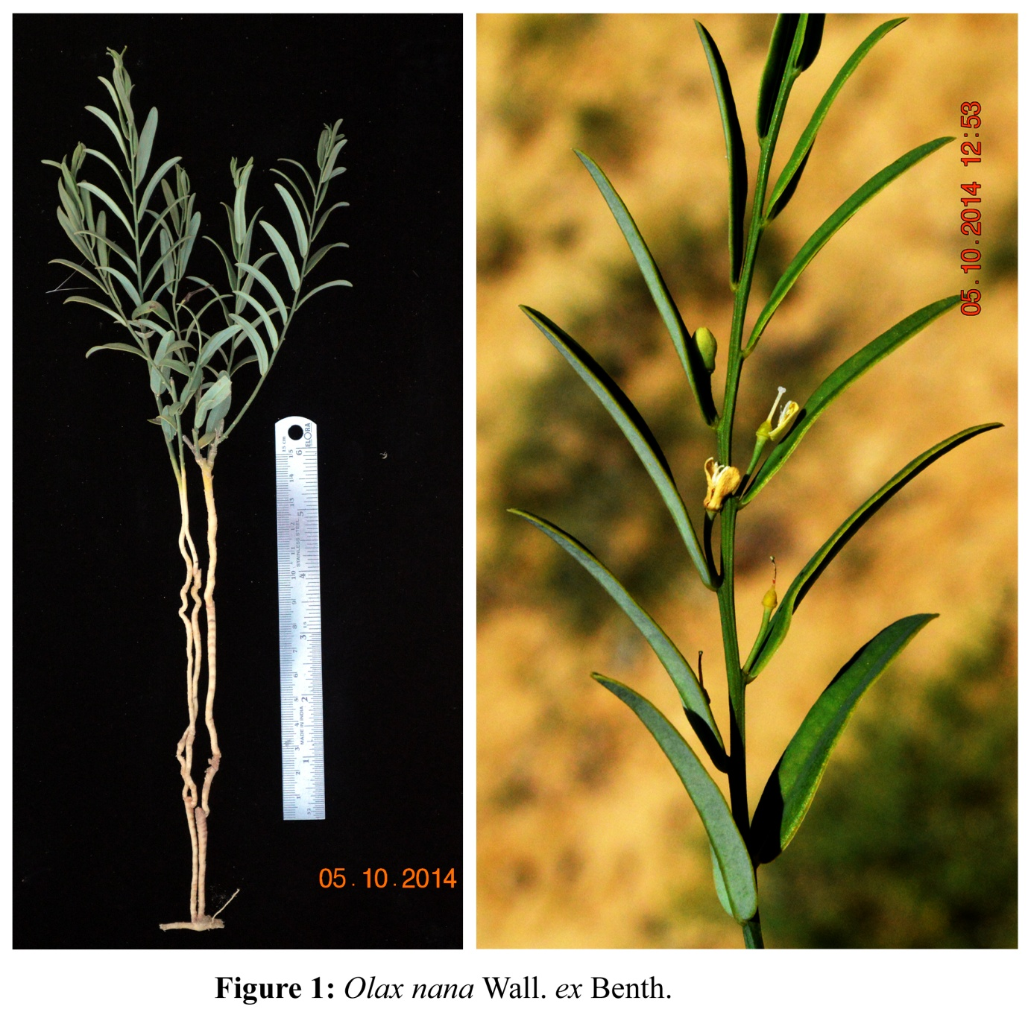

List of Authors:
Ritesh Pokar, Pankaj Joshi, Padamnabhi Nagar, Karan Rana, Sanket Jayswal
Sahjeevan, 175-Jalaram Society, Vijay Nagar, Bhuj, Kachchh, Gujarat 370001, India.
Department of Botany, Faculty of Sciences, The Maharaja Sayajirao University of Baroda, Sayajigunj, Vadodara, Gujarat 390002, India.

