Euphorbiaceae - The Spurge Family

This is a very large family and widely distributed world-wide .
General characteristics: Mostly shrubs or trees but also some herbaceous species are found in this family. Latex is often present. Many of the species grow in dry regions- cactus like in habit., or with branches taking on the form and function of leaves (cladodes) . Leaves are usually simple, alternate. Stipules usually present, sometimes in the form of hairs, glands, or thorns. Inflorescence usually complex and varied. Flowers usually regular, unisexual, the male and female either on the same plants (monoecious) or different plants (dioecious). Sepals usually 5, free, sometimes absent. Petals 5, free, often absent. Stamens 1 to many, free or united. Ovary superior, usually of 3 united carpels, 3-locular. Styles 3, usually 2-lobed. Ovules 1 or 2 in each loculus, pendulous, anatropous; placentation axile. Fruit sometimes a drupe, but more commonly a capsule, which splits into 3 carpels; at the same time each carpel opens along its ventral surface to let the seed escape. Seeds usually with abundant oily endosperm; caruncle is present in some genera.( Ref: Hickey & King: 1997).
- Plants with milky latex.
- Leaves simple, entire or lobed, stipulate.
- Flowers small, unisexual with petaloid bracts.
- Cymose or cyathium inflorescence.
- Stamens 1-∝, ovary superior, 3- celled, styles 3.
- Ovules 1-2 raphe vetural, axil placenta. ( Ref: Sutaria, 1969).
The fascinating flower inflorescence and the widespread prevalence of this family makes this one of the most important angiosperms. I shall dwell a little more on this aspect. In the true spurges (Euphorbia), the female flower is elevated on a stalk called gynophore and is surrounded by several male flowers that each consist of little more than an anther(Ref :Stern: Plant Biology).
Both the female and male flowers are inserted on a cup composed of fused bracts, the cup usually having distinctive glands on the rim. This type of inflorescence is called Cyathium.The following are the examples seen in Christmas flowers and a diagram illustrating the cyathium.
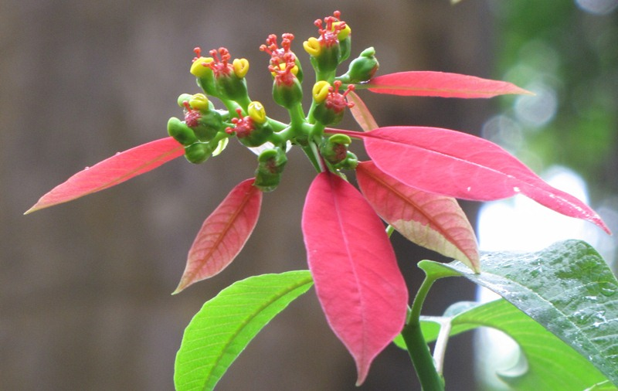  Sagar upavan, Mumbai, Nov 2010. | 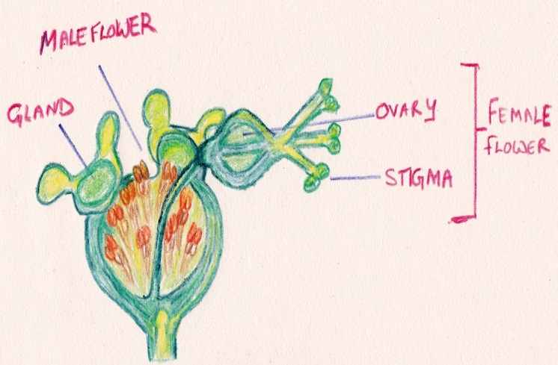
A poinsettia also called Christmas flower–Euphorbia pulcherrima. Several flowers without petals in the centre. Red coloured bracts (modified leaves ) surrounding the true flowers . | An individual cyathium

As per the new Kew Plant List and the one efloraofindia has decided to by and large follow the following is some data of Euphorbiaceae: The website states and I quote “Species of Euphorbiaceae contained within The Plant List belong to 229 plant genera. The Plant list includes 16,849 scientific plant names of species rank for the family Euphorbiaceae, of these 6,511 are accepted species names. The Plant List includes a further 4,394 scientific plant names of infraspecific rank for the family Euphorbiaceae. We do not intend The Plant List to be complete for names of infraspecific rank. These are primarily included because names of species rank are synonym of accepted infraspecific names”.
In our database we have included several genus in Euphorbiaceae which now come under the family Phyllanthaceae as per Kew Plant List. These are as follows: Actephila, Andidesma, Aporosa, Baccaurea, Bridelia, Cleistanthus, Glochidion,Phyllanthus, Sauropus, Securinega.
Regards,
Rashida.

regards,
Rashida.

