INTERNATIONAL CONSULTATION ON
“ECOTECHNOLOGY AND SUSTAINABILITY SCIENCE"
ROLE OF BIODIVERSITY CONSERVATION IN SUSTAINABLE
DEVELOPMENT

29th Feb - 2nd March 2012
ORGANISED BY
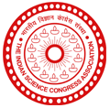
Indian Science Congress Association, Tirupati chapter

Network of Indian Universities on Cultural and Biological Diversity (NIUCBD)
Indian Network on CBD (INCBD) &
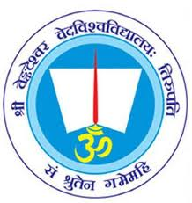
S.V. Vedic University, Tirupati
In collaboration with
S.V.University, Tirupati, Manipal University, Manipal; SRM University, Chennai; Punjab University; Chandigarh, KIITUniversity, Bhubaneswar; Gorakhpur University, Gorakhpur; Bundelkhand University Jhansi; CIFE University, Mumbai; Jiwaji University, Gwalior; Central Agricultural University, Imphal; Foundation for Environment and Economic Development Services(FEEDS)

Dr.R.CHIDAMBARAM, Principal Scientific Advisor to Govt. of India,New Delhi inaugurates
Dr.Balakrishna Pisupati,Chairman,National Biodiversity Authority, Chennai presents Keynote address
VENUE: S. V. Vedic University Auditorium, Tirupati Time:10am

