IHE Releases the International Patient Summary (IPS) Profile

It is with great pleasure that IHE International announces publication of a new IPS Profile, recently released for trial implementation. This profile is the latest in a series of artifacts developed by a collaboration of standards development organizations (SDO’s) to support the global adoption of the International Patient Summary, considered an essential ingredient in managing quality care across any jurisdictional borders.

Interoperability in digital health prescribes that relevant information concerning a patient must be securely available to those who need it, when they need it, and wherever they need it. With an increasingly-mobile population, information also needs to cross jurisdictional borders (local, regional, or national) as well as across a myriad of health systems. Consider a physician in Europe treating an Australian traveler with an unexpected and emergent medical need, or an Olympic athlete who sustains an injury while competing at an event far from home.
Michael Nusbaum, co-Chair, IHE IPS Profile development team

Leading clinical practice demonstrates that an initial overview of relevant clinical information about a presenting patient improves outcomes, while dramatically reducing time-to-treatment and cost. For decades, clinicians have relied on the patient summary to capture demographics, allergies, medical conditions, diagnoses, and essential diagnostic and treatment data, taken at a point in time (such as discharge from a hospital, or when referring a patient to a specialist) … but these documents (on paper or in a computer) were not standardized beyond local use. With the International Patient Summary, clinical data and messaging technology is standardized on a global basis, thereby facilitating the movement of this clinical information anywhere it is needed.

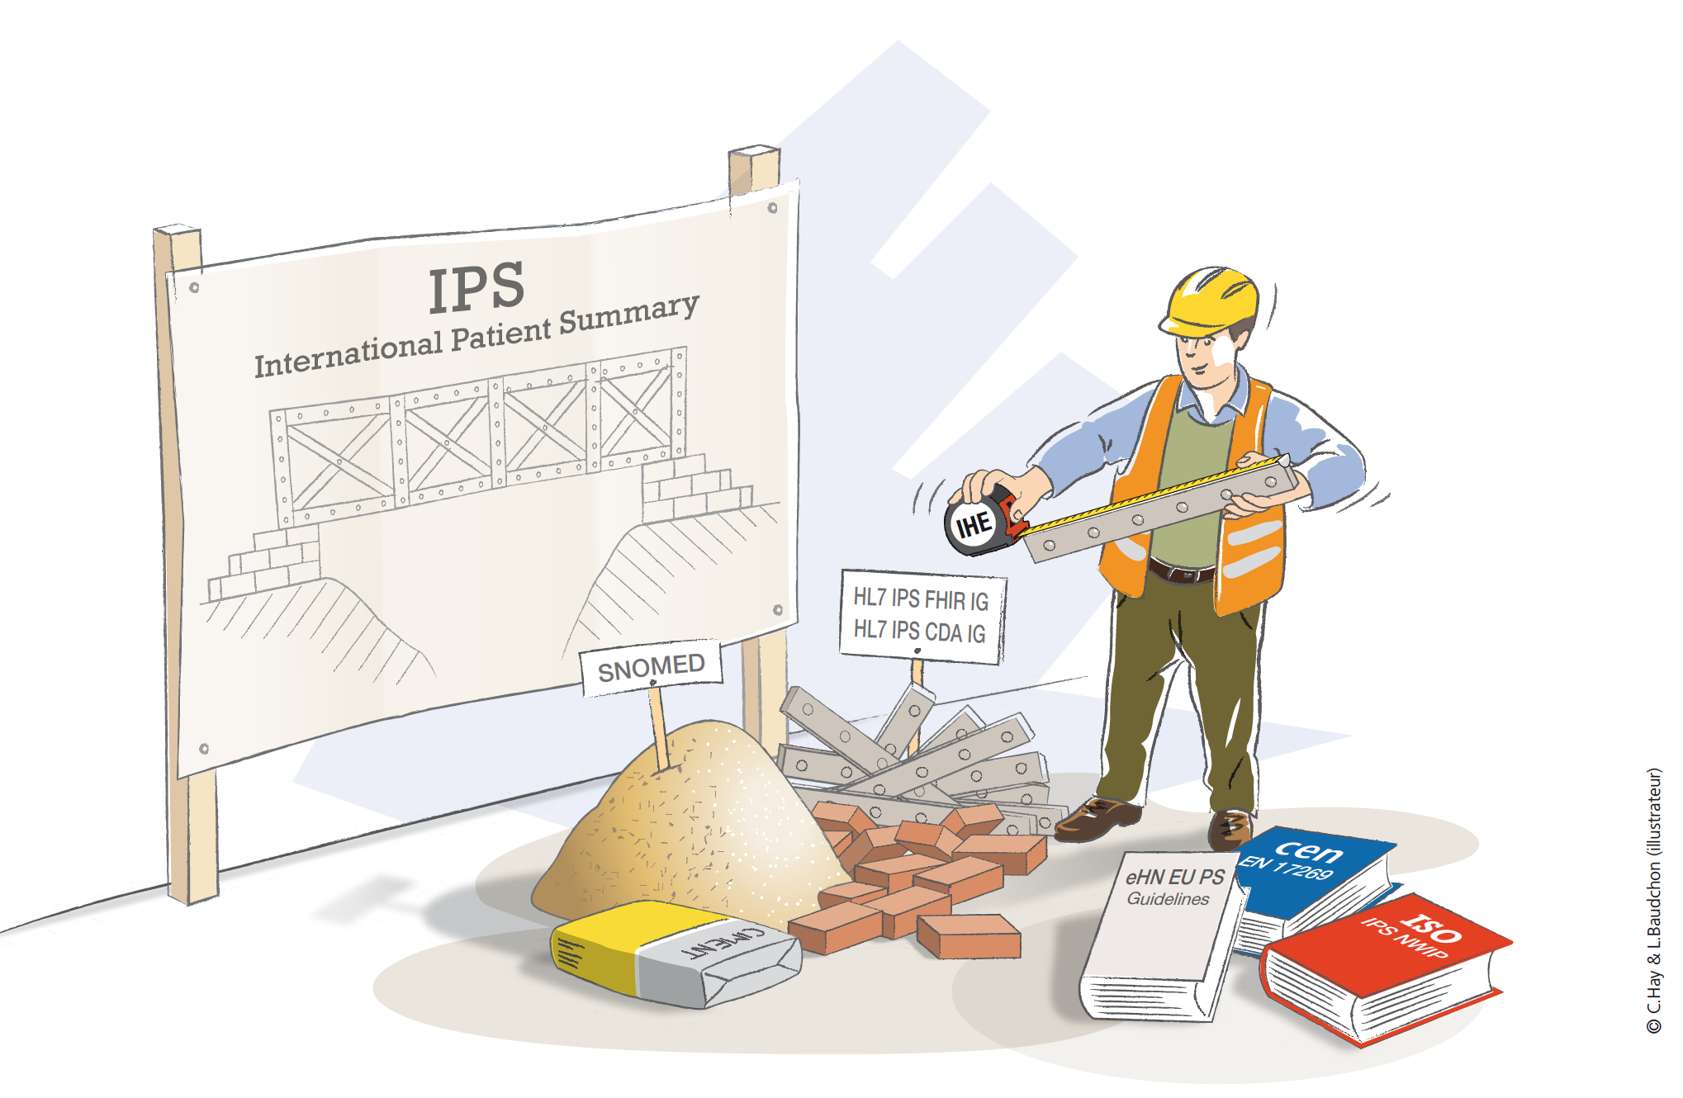
The IPS specifications and implementation guides were originally developed as a joint initiative of the European Standardization Committee (CEN) and HL7 International. This very successful collaboration was further extended to include additional SDO’s, including the International Standards Organization (ISO), IHE International, and SNOMED International. Each of these participating SDO’s has contributed their specific expertise and standards capabilities to evolve a robust specification and a selection of tools to guide implementation and facilitate conformance, all the while maintaining the integrity of the IPS design and use principles.

IHE has added a significant value to the IPS ecosystem by contributing a profile that, while remaining consistent and supportive to artifacts developed by other SDO’s, strengthens conformance and testing attributes as well as extending the IPS’ global reach through IHE’s strong international presence. Even prior to publication, the IPS Profile has already received a great deal of attention from countries and regions around the world. As an example, another IHE profile under development in collaboration with the World Health Organization (WHO) to support Computable Care Guidelines (CCG’s) has adopted the IPS Profile as its basic underpinning, highlighted in this short video.

“IHE has successfully gathered IPS experts from across the Globe, representing multiple SDO’s, to work together in developing the IPS Profile”, explains Michael Nusbaum, IHE Board member and co-Chair of IHE’s IPS Profile project team. “This unprecedented collaboration amongst SDO’s has demonstrated how, when working together, standards can be produced that have broader clinical and industry support, and more global opportunities for implementation.”

In the coming months, the xSDO IPS community will be formulating a strategy that will allow for all IPS artifacts to grow and be maintained in a manner that ensures synchronization across multiple SDO processes and publishing programs, and possibly coordinated by the Joint Initiative Council (JIC).

