Icons are not displayed in mozilla version 41.0. In crhome, Opera and Explorer if deployed.
By firebug out the following
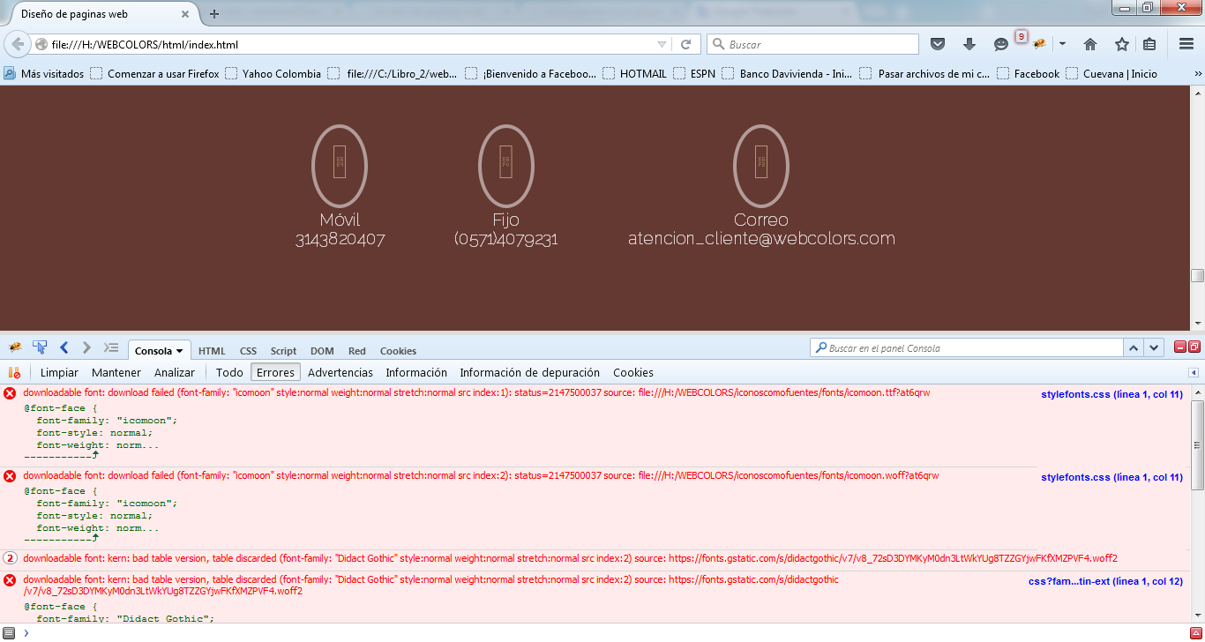
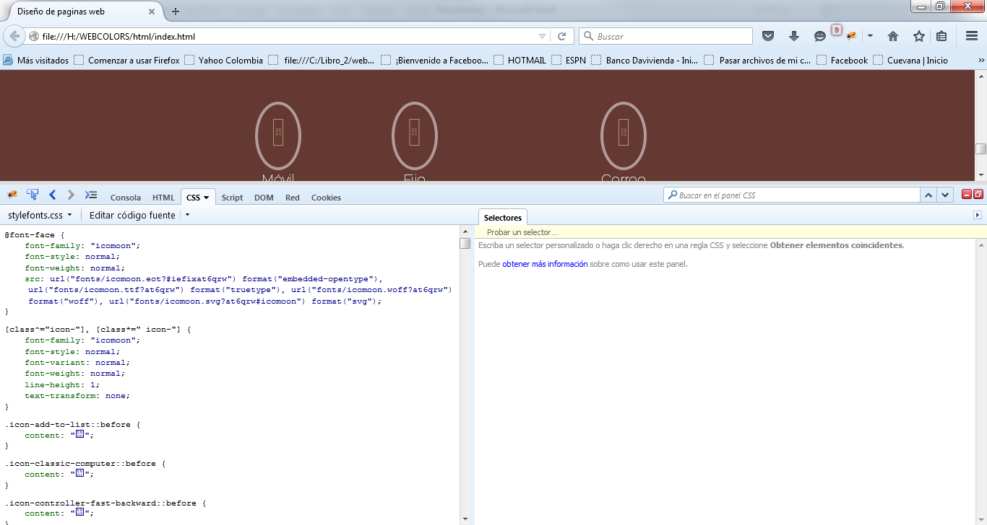

The code in the css file is as follows:
