AKCIÓ: A fűtés olcsó és azonnali megoldása:
Kérem továbbitsák az illetékeseknek!!
Amely lakásnak léghűtése van, ott a léghűtőt azonnal át lehet állitani fűtésre, csak a kompresszoron kell a 3-irányú kiegyenlitő szelep folyásirányyát megforditani (hogy a hőszállitó folyadék folyásiránya megforduljon) és a hőt szállitó foladékot alacsony forráspontúra kicserélni (1-es ábra alább). Ez Németországban már folyamatban van és ha valaki nem kivánja/tudja a meglévő léghűtőjét átállitani, az persze vásárolhat már kész, "két irányú" (hűtő éa fűtő) egységet.
A városokban hol távfűtés van (mint Budapesten), ott az orosz földgáz égetése helyett a talajviz hőtartalmát kell felhasználni úgy, mint Szeged már teszi. Ahol 90°C felett van a vizforrás hőmérséklete ott egyenesen, ahol a viz hőmérséklete ennél alacsonyabb ott hőszivattyúval (2 és 3-as ábra). Az azonnali átállás mikénjét, albb mellékelt cikkem (sajnos ngol nyelvű) ierteti. A cikk Amerikában csak Januárban fog megjelenni, igy annak csak kézirata áll rendelkezésemra, amit alább mellékelek.
Boldog Karácsonyi ünnepeket kivánva,
Lipták Béla
XXXXXXXXXXXXXXXXXXXXXXXXXXXXXXXXXXXXXXXXXXXXXXXXXX
If short on space, Figures 2, 3 or both can be deleted to provide more space for Figure 4, which is important, as it describes a unique and new concept that has never been published!
Putin vs. the Heat Pumps
The new tools of war are drones and energy. Russia is using both, the first against the Ukraine, the second against Europe. The task for the Ukrainians is to expel this aggressor and the challenge for the Europeans is to become energy independent. This is urgent, not only because Europe's oil and gas purchases pay for operating the Russian war machine, but also because their energy storage is running low and the winter is here. Therefore, new energy supplies are quickly needed.
In this column I will show how the heat pumps can help to meet this need and how our process control profession can automate and optimize such a system.
Heat pumps use a working fluid to move heat from a low to a higher temperature level. This working fluid, having a low boiling point, evaporates into a low pressure gas as it picks up heat from the surroundings, that are cold, but warmer the boiling point of the fluid. The gas, - after being compressed -, carries that heat into a condenser, where it releases it into the warm heated surroundings of the heat pump. The air conditioner is such a device as it removes heat from our cooled buildings and rejects it into the relatively warm air outside. If the flow direction of the working fluid is reversed in in the winter, the air conditioner can move the heat contained in the cold outside air into our homes and heat them (Figure 1).
The light blue text in Figure 1 below is hard to read. You can either darken it, or delete.

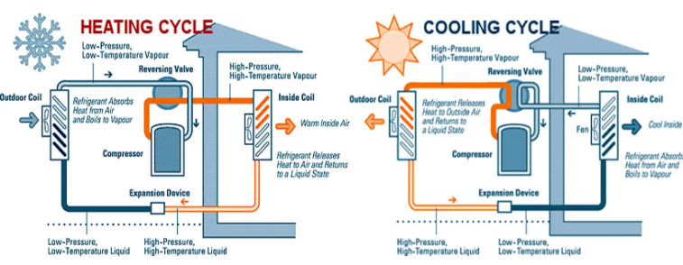
Figure 1: The reversible heat pump

Why do I mention these devices in connection with the present energy war? I do that because they are readily available, they cost much less than furnaces or resistance electric heaters and can quickly be installed, plus they emit no carbon at all if the compressor is operated by green electricity. Naturally it can also transfer heat from air or water. This is an advantage in cold regions, - where the outside air temperature can drop very low, - causing a drop in heat pump efficiency -, while the ground temperature below the surface is relatively constant.
In the US, as we move from north to south, the efficiencies of heat pumps used for heating in the winter increase. In the south, the basis for heat capacity needed per square foot is about 30 BTU (kW/h = 3,410 BTU) and in the north about 60 BTU (in Connecticut it is about 45 BTU/ft²). So, one weapon the EU members can readily use, is to change the working fluid in their A/C units, install a reversing valve around their compressor (or just buy a new 2-directionl A/C unit) and Mr. Putin's blackmailing will be weakened.
Another application of heat pumps is for district heating. In many cities of Europe, the hot (90°C TO 95°C) water for the buildings is centrally generated and is distributed by long pipelines. Compared to using individual furnaces in the served buildings, the cost of centralized district heating is about half regardless of the heat source. On top of that, if the heat source is free, the cost savings further increase. Since in many city districts the distribution network is already in place, these cities can replace the fossil fuel heat sources at the central plant, with any other heat source, including direct of heat pump based geothermal ones. To meet the winter heat load of a heated district, large heat sources are required, which are readily available in the form of geothermal heat, if the ground water temperature is over 90 °C°.(Figure 2).
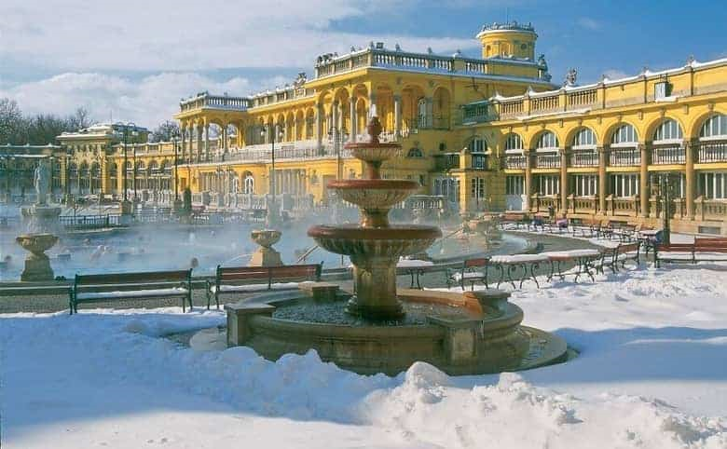
Figure 2: In cities like Budapest the groundwater is warm enough to allow baths to stay open in the winter.
If the ground water temperature is below 90°C, heat pumps are needed. In both direct and heat-pump based district heating systems, the heat source is free and the total system can be carbon emission free, if the pumps and compressors are also operated by geothermal or solar energy. Today, out of the thousands of district heating systems around the world, the heat source of the majority are still fossil fuels and not even 10% use green energy sources, such as geothermal. (Figure 3). If the EU focused on so converting their many district heating systems, they could reduce the effectiveness of by Mr Putin's energy-blackmailing. 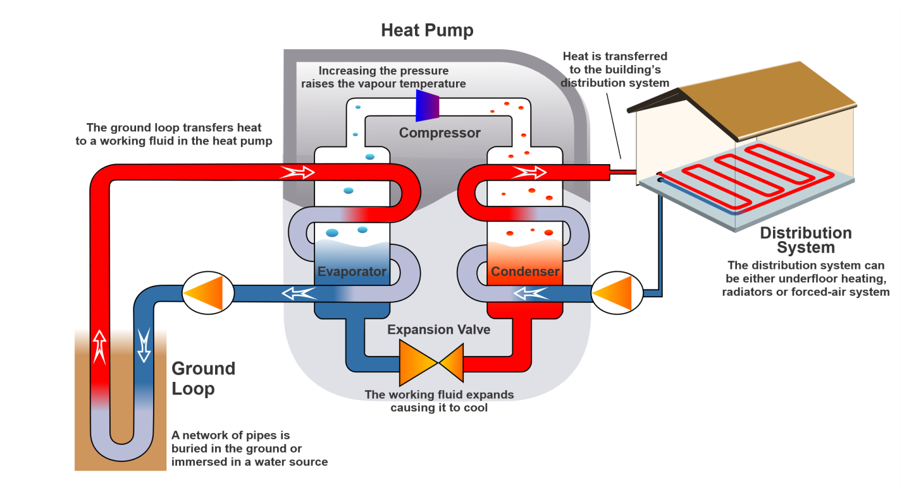
Figur 3: If the ground water temperature is under 90°C, geothermal heat-pumps are used to elevate the water temperature before distribution to the districts.
The total energy needed to oprerate such district heating system, is the sum of three circulation loops (ground, working fluid and district water loops). In older systems, the two pumps and the compressor are often constant speed nd mnually controlled. In a fully automated and optimized system (Figure 4) the throttling of all three loops is by speed variation. In addition the district circulating pump (P2) speed is set so that all supply valves in all buildings are all kept under 90% opening. 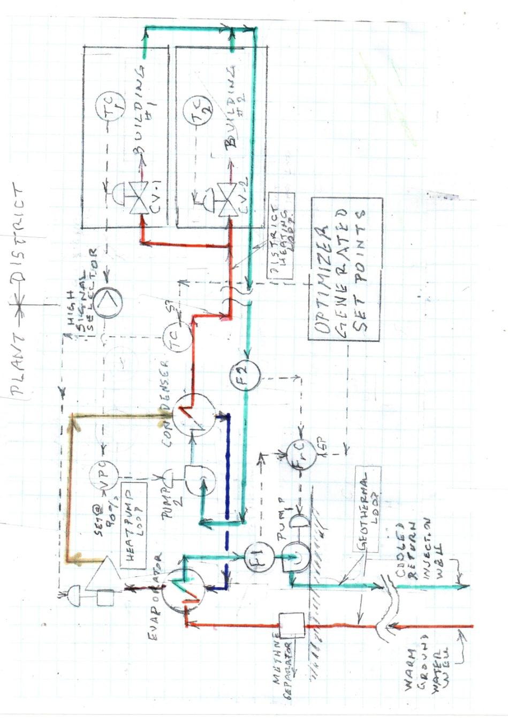Figure 4: The controls of a fully optimized geothermal heating system.
This control is performed by the valve position controller (VPC), which measures the opening of the most open valve from among all the valves served (CV-1, CV-2, etc) and having a set point of 90%, keeps the openings of all under that value. The flow in the district heating loop (F2), - through the flow ratio controller (FrC) -, in turn is adjusting the speed of the geothermal ground loop pump and is thereby keeping the ideal ratio between F1 and F2. Finally, the speed of the compressor is throttled by the district supply temperature controller (TC) having a set point, which is continuously optimized by the overaall system algorithm to keep the total cost of operation at a minimum.

In my mind, It's main advantage is that it can help defeat Russian agression, which I experienced 67 years ago as a capture Hungarian freedomfighter.
An example of a district heating systems is the one in the city of Szeged, providing jobs for 162 employees and supplying heat and domestic hot water to 27,256 apartments (predominantly in 4-10 storey blocks of housing projects) and 433 public buildings (schools, kindergartens, retail units) in Szeged, Hungary – a city of 162,593 inhabitants near the Hungarian-Serbian-Romanian tri-border. The ground water there is about 92°C and they are using 27 wells and 9 pumping centers, distributing some 4 trillion m³ hot water yearly. Presently the returning used 50°C water is sent back into the wells, but the company is looking for low temperature users or considering to remove the low level heat and elevate its temperature by heat pumps before returning into the wells. Another problem, which they are yet to solve the yearly emission of 2 trillion m³ of methane. This they are considering to separate, burn and to generate gray electricity from it. The total cost of building the system was about $75 million, the yearly operating cost is about $10 per GJ (GJ = 277.78 kWh ) of which sum about 1/3 is spent on operating the pumps. Compared to a natural gas based district heating system the operating cost is about one third and the reduction in CO₂ emission is about 90%. The source of the above information is Dr. Kóbor Balázs, director of SZATÁV in Hungary (kobor.balazs@yahoo.com).

