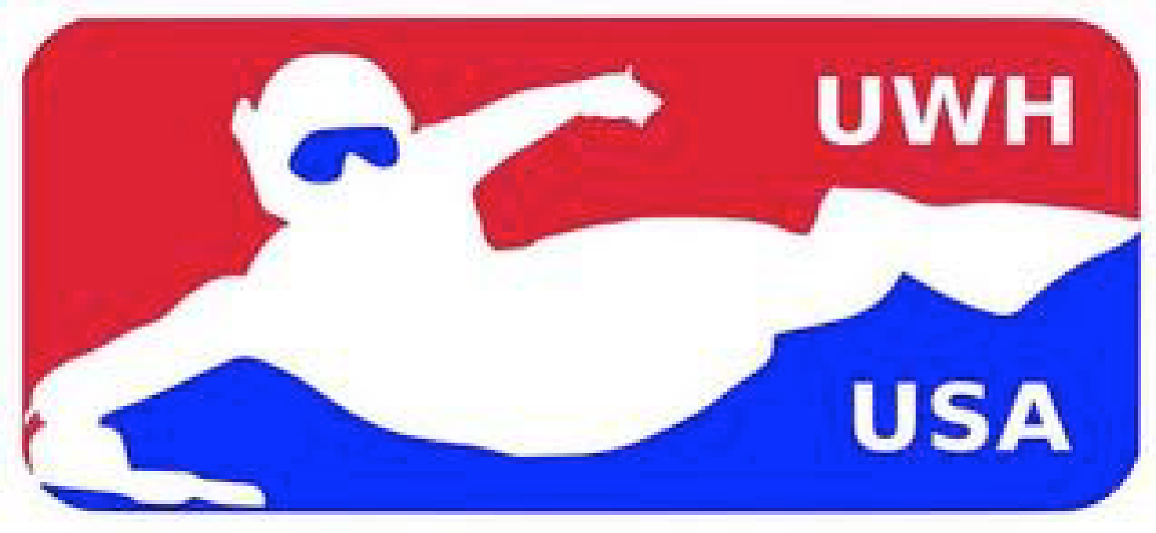
Dear Candidate,

We appreciate your interest in coaching the Team USA Men’s Elite Team. On behalf of the entire team, we would like to thank you for your support.

Well over two years remain between now and the next World Championship.

Based on proposals received in response to this request, the Men’s team will select a Coach to best help us compete for the world title.

The information you’ll find is broken down by section:

Our Goal: The 2018 CMAS World Underwater Hockey Championships
The Current State of Men’s U.S. Underwater Hockey
Coach Requirements
Compensation and Expenses
Deadlines and Selection Process
About the Steering Committee
Questions for Consideration
Application

Please read through each section carefully, and reply back as candidly as possible. If you have any questions during this process, please email the steering committee directly. Applications are due Monday, May 23rd 2016. We intend to introduce the selected coach to Team USA hopefuls at Nationals.

Again, we sincerely thank you for your interest in building Team USA. We realize that this application and the following process for 2018 and beyond will require a significant commitment by both the coach and the prospective athletes. We, as a steering committee, have made the commitment to provide support to the coaching staff to further define the vision, and schedules/programs for the next 3‐5 years. We are committed to putting the time in that it will take to compete for GOLD in 2018, and we are looking for a coach that will join our team with the same drive and objectives that we have.

The US Men’s Team Steering Committee
Matt Blair
Andrew Creedon
Ben Holtzman
Vincent Kiernan
usmuwhsteering@gmail.com

Our Goal: The 2018 CMAS World Underwater Hockey Championships
During the Stellenbosch championships, CMAS voted that the next elite world championship will take place in 2018. Which will be located in Quebec City, Canada [in July].

Sixteen countries have competed in the last two CMAS World Championships we have participated in. They have run anywhere from ten days to two weeks.

More information will be available. We ask that potential coaches have the flexibility to accommodate this scheduling.

The Current State of Men’s US Underwater Hockey
The US Team has taken 10th and 9th place in the last two officially sanctioned CMAS world championships it has competed in.

Fifty people tried out for the 2016 Men’s team. Spread all over the country, metro areas that fielded more than two candidates include Washington DC, San Francisco/Santa Rosa, Los Angeles/San Diego, Denver, Chicago, and Pittsburgh.

There are several school based teams and other high hockey‐dense areas across the country, such as Michigan State, Ohio, and Illinois, where potential US Team candidates can be found and developed.

In the past, the amount of times the US Team has been able to meet together per year has been restricted by the individual cost of travelling to events due geographical spread. Different tactics, primarily cost‐sharing amongst men’s hopefuls, have been used to help mitigate these prohibitive costs.

Several returning members from the 2016 team have announced their commitment to ongoing fitness training between now and the 2018 tryout.

Coaching Requirements
We are looking for the following from our Coach:
- A Two and a Half Year Commitment. Be interested in the position from now until the 2018 WC's, including ability to travel internationally and take time to implement your proposal.
- Select the final team to compete for a medal for 2018 WC, as well as any interim events the team competes in.
- Select and manage coaching staff, if additional personnel are required to meet your development plan.
- Develop, implement, and maintain a team strategy competitive in the current Worlds' environment, with concise documentation (Playbook) made available for team candidates.
- Recruit, develop and motivate team candidates to be fit and prepared.
- Participate in and manage the US Men's team official schedule, including clinics, tryouts, tournaments, recruitment events, or other events necessary to meet goals.
- Manage or delegate financial management, including cost shares and timely collection/dispersals.
- Have a passionate desire to help the Men’s Team go for the gold!

In addition, the ideal candidate has:
- Prior Worlds experience,
- Prior team sports coaching experience, and
- An understanding of how other National Teams compete.

Compensation and Expenses
The Men’s team effort can reimburse the coach’s flight (given that it is of reasonable price) and additional travel expenses for official team events. Reimbursements include airfare and lodging for the World Championship. Other expenses can be considered by the Steering Committee.

In no way does the Steering Committee believe these expenses compensate fully for the Coach’s time. Much like the athletes, the quest for the medal must suffice!

Deadlines and Selection Process
All materials must be submitted by Monday, May 23rd 2016 to usmuwhsteering@gmail.com.

We realize this is a relatively short deadline, but we want to get started as soon as possible. If this deadline is not feasible, please request an extension from the steering committee immediately along with a commitment for date of completion.

The Steering Committee will reply to all applicants. Supplemental information may be required at this time. Ideally, the coach will be informed of his selection by June 1st.

The coach will be introduced to Team USA hopefuls during the Nationals in Colorado.

About the Steering Committee
The US Men’s Team Steering Committee was chosen immediately following the 2016 World Championship. All were voted on by members of that team. New members of the committee will be voted upon following each World Championships by players, in a similar fashion.

The Steering Committee’s primary goal is to facilitate the selection of a coach prior to each world championship and assist potential candidates as needed.

The Committee is currently comprised of:
Matt Blair, Started playing in 2002. Four time USA national team member. Two time National Champion. Two Time National Team Captain. Trained for two years with the Australian National team (including two international competitions and numerous training camps).
Andrew Creedon, through 2018: Introduced to UWH in 2008, and created a competitive team in the Washington D.C. area. After 2 years of creating the team, we won nationals in 2013. I have participated in America’s Cup and CMAS worlds in 2013 and 2016. I have high expectations for the coach and teammates.
Ben Holtzman, Started playing in 2004. USA national team member in 2013 and 2016 World Championships, and America’s Cup 2011. Two time USA National Champion.
Vincent Kiernan, Started playing UWH in 2011. USA national team member in 2016.

Application
For the purpose of selecting our coach, there are specific items that we would like to request from you:
- A Resume, detailing your ‘UWH Story’ up until this point, and
- Your Proposal to meet the Coaching Requirements.

The Resume should include the following:
- Contact information, including Name, Address, Email, and Phone Number
- How long have you been playing underwater hockey?
- How long have you been a team coach?
- Have you ever coached a National team?
- What is your experience as a player and as a coach?
- Do you have any training or coaching certifications?
- Have you played other team oriented sports?
- Have you coached other team oriented sports?

The Proposal should discuss your plan on how to achieve success in 2018. Proposals will be evaluated on their ability to best meet the Coaching Requirements. It is not expected that each and every point will be fully developed; rather, we are more interested in your plan to develop them between now and 2018.

The section ‘Questions For Consideration’ may help clarify what the Steering Committee is looking for in a proposal.

Questions For Consideration:
Below is a list of questions the steering committee might ask a prospective coach.
Though these aren’t meant to be answered individually, a successful proposal will address many or all of these points in some fashion.
- What are the short, middle and long term goals (1, 2 and 3 years) for yourself, for the team, and for players?
- Timeline of events
- What do you expect from the team?
- What do you expect from the steering committee?
- Please layout an ideal organization for your staff. E.g., Head coach, assistants, fitness trainer, chiropractor, referees, event organizers. Detail what they are going to do and what do you expect from them.
- How do you plan to organize our calendar over the next two and a half years? How many clinics, tournament as a team?
  - Consider detailing a rough schedule including number of clinics, tryout dates, and proposed selection dates.
  - How would events such as America’s Cup or other high-level international tournaments fit in with your plan?
  - Dates of ALL training events leading up to worlds.
  - Tournaments that we can play together as a team.
- How do you plan to organize clinics themselves? How many hours in the water and general plan of the day.
  - This could be different for clinics in various stages of the timeline.
- How do you plan on developing team strategy and tactics?
  - What milestones may be required along the way to accomplishing a complete strategy?
  - Playbook and submit it with proposal
    - Defined roles for each position
    - Graphical diagram for different parts of the pool and how the formation plays in each part of the pool
    - Parts of the formation broken down into drills that athletes can do it in swim workouts.
- How are you going to follow players individually? Tracking fitness, skills, and progress.
  - What are your motivational strategies and how would you drive accountability.
- How do you want to recruit new players to the US effort; particularly younger players?
- How important is external fundraising to meeting your proposal?
- Outline proposed selection method for the team. From games, fitness test, etc…
- Outline process for selecting players for clinics.

