Name | Anne Pao
Nickname | SuperPao-wer, EnergizerAnne, Always-On-Anne
Motto | Lean in! Whoop whoop! Lets Party!
Most likely to be…in 10 years | First female president of the US (sorry Hillary)
We will never forget… (100 words on lasting memories about the person, bad habits, work ethic, outstanding achievement for the year, favourite subject etc.) | Most people’s first exposure to Anne was at Orientation week. Whilst wearing a broken ankle cast, she proceeded to kick serious ass playing rugby, soccer, volleyball, nailing the one-legged race and master-classing the wheelbarrow and egg-and-spoon. This was nothing… It is quite astonishing how much Anne has achieved in the space of a year: class co-presidency, multiple clubs, multiple events, part-time consulting, part-time mentoring, start-up planning, marathon running, social butterflying and, oh yes, excelling in her MBA. Anne might seem intimidating with her multitasking energy levels and ferocious email typing during lectures, but underneath the high achiever exterior is a very sweet and caring person. The mother hen in her syndicate group, super-friendly and always keen to defend the needs of classmates, Anne has her heart in the right place. Just don’t ever get in the way of her yoga, her facebook updates and, most importantly, her soft-shell crab addiction.
Attach three high quality photos/drawings of person that best represents them (not a profile pic). Or let me know and the designer will source. | PTO  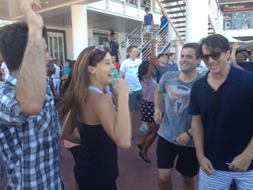  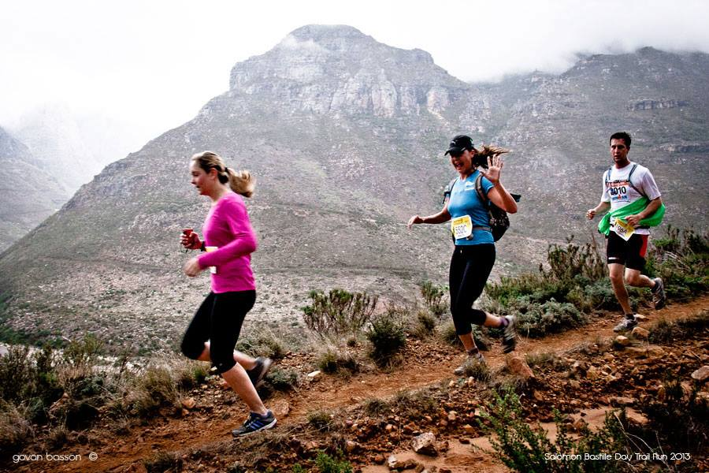  PTO  