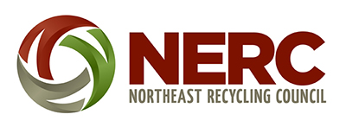
PRESS RELEASE
Contact: Mary Ann Remolador, maryann@nerc.org, 802-254-3636
Date: September 22, 2022

Resources for Promoting & Supporting Municipal Glass Recycling Programs
Over the past two years, the Northeast Recycling Council (NERC) has provided technical assistance to two regional recycling centers in Maine that have started new source separated glass collection programs—Unity Area Recycling Center and NASWA. These two programs have approached glass recycling differently. Unity is collecting clean glass containers and crushing them, while NASWA is collecting clean whole bottles.
As part of the work to support these programs, NERC has developed a variety of resources which are available on its website. These include videos of the glass collection programs, marketing materials (press releases, glass recycling signs and handouts), and glass collection safety posters and safety guides.
Following are links to these resources:

VIDEOS
Unity Area Recycling Center's Glass Collection & Crushing Program
- Part 1
- Part 2
- Part 3
NASWA's Whole Bottle Collection Program
- Part 1
- Part 2
- Part 3

SIGNS
- Unity Glass Recycling 24x36 Sandwich Board Sign
- Unity Glass Recycling Aluminum Sign 12x16
- NASWA Glass Recycling 24x36 Sandwich Board Sign
- NASWA Glass Recycling Aluminum Sign 12x16

MARKETING MATERIALS
- Unity Glass Recycling Handout Letter Size
- Unity Glass Recycling Program Pictures
- Unity Press Release
- NASWA Glass Recycling Handout Letter Size
- NASWA Glass Recycling Program Pictures
- NASWA Press Release

SAFETY POSTERS & GUIDES
- Unity Transfer Station Glass Safety Poster
- Glass Recycling Safety Guide_Unity's Glass Collection & Crushing Program
- NASWA Transfer Station Glass Safety Poster
- Glass Recycling Safety Guide_NASWA's Whole Bottle Collection Program

This project was funded by a USDA Solid Waste Management grant.
#

