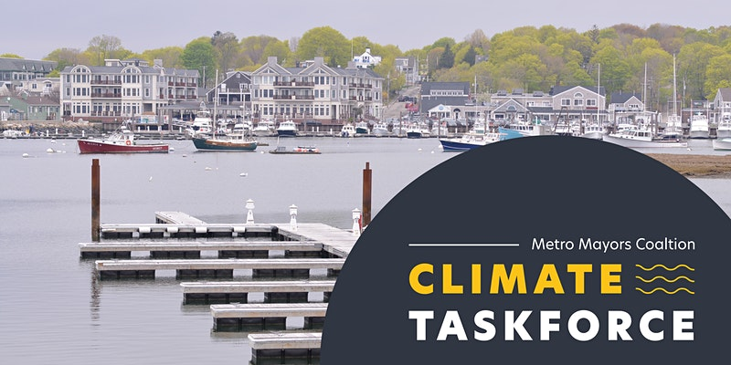
Join Us and the Metro Mayors Coalition for Climate Celebration: Mar 19
Climate change poses serious challenges to Massachusetts and its municipalities. Sea Level Rise, increased precipitation, and more intense and frequent heat waves are already having significant impacts on the health, safety, and economic wellbeing.
In 2015, the Metro Mayors Coalition, representing the urban core of Metro Boston, committed to addressing climate change regionally and formed the Climate Preparedness Taskforce. In 2016, the Metro Mayors committed to becoming a net-zero region by 2050.
At this year’s Climate Celebration on Friday, March 19, from 10:30 to 11:30 AM, we will highlight the accomplishments of the Metro Mayors Coalition and Climate Taskforce over the past six years. We'll also look ahead to recovery and discuss the ways our climate work intersects with public health, equity, and economic goals.
Register for the livestream here.

