Climate change and the olivine concept

Life on Earth (including you!) exists thanks to the weathering of rocks. That process has captured the CO2 that is emitted by volcanoes and stored it as carbonate rocks, before a high concentration in the atmosphere could make life impossible. It works as follows. Minerals like olivine, the most common mineral on Earth react with CO2 and water, resulting in magnesium bicarbonate solutions. These are carried to the sea, where organisms turn it into carbonate rocks, where it is sustainably stored.

Humankind is now causing a spike in CO2 emissions because we burn in a few hundred years the fossil fuels that have taken hundreds of millions of years to form. Weathering cannot cope with this fiftyfold increase in emission, so the CO2 concentrations of the atmosphere rise, leading to climate change and ocean acidification.

A logical answer would be to increase the rate of weathering as well, by mining olivine rocks, mill them and spread the grains over fields and beaches. Small field tests in the Netherlands have shown that this works. Mining wastes of similar crushed rocks also show very high rates of weathering.

Many people prefer complicated technologies to fight climate change, and come with several objections to this simple olivine concept. Allegedly it would be dangerous because olivine rocks contain asbestos (a misleading statement, there are *some* olivine rocks that carry asbestos, but these should be left untouched). There are plenty of asbestos-free olivine rocks.

It would contain high levels of nickel: true, but that doesn’t make them dangerous. There are hundreds of millions of people living on such rocks for many generations, grow their crops on them, graze their animals and drink the water without ANY negative consequences.

An often heard objection is that the process would be too slow. It is a slow process, but it doesn’t matter that it takes a few years before the olivine grains are completely weathered. For the climate that is good enough, and certainly quicker and more effective than all those big international climate meetings together.

Then the more serious objections. Olivine is a silicate, so it releases silica during weathering. It was stated that the process will stop itself when the solubility of quartz (SiO2) is reached. Fortunately, this idea is not valid, because there are many organisms like rice. sugar cane, bamboo and reed that need silica, and so does a very large group of plankton, the so-called diatoms (siliceous algae, fig.1). They gobble up the dissolved silica, so in the real world the solubility of quartz is never reached during olivine weathering.

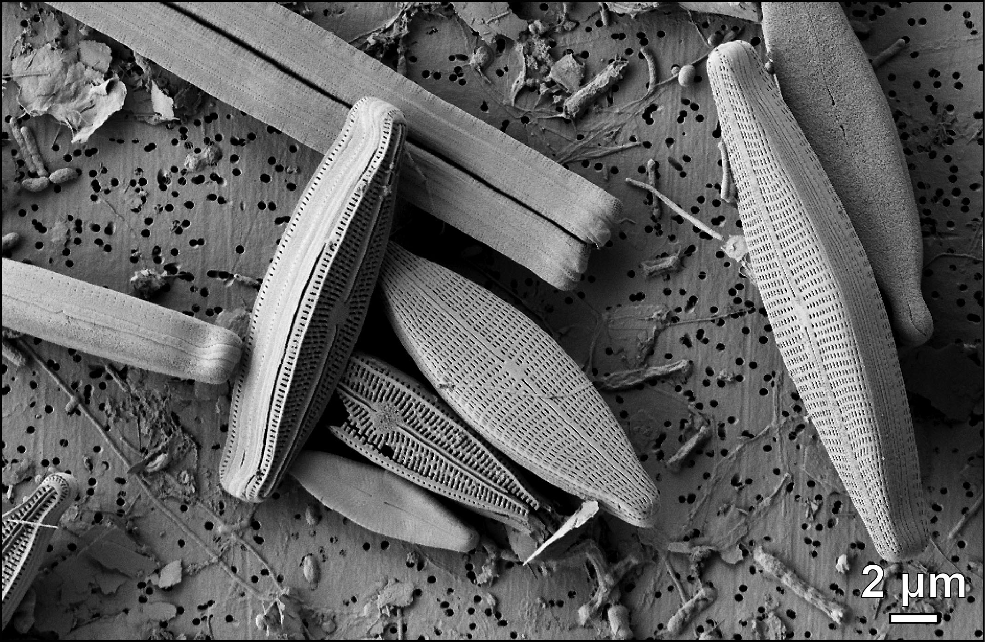

Fig.1 Diatoms from the mine pit lake of a former asbestos mine

In another widely cited paper it was claimed that olivine sand on beaches would take 700 to 2100 years to weather, unless it would be ground at high cost to micron-sized slivers. The authors apparently live in a world where water does not move, and mineral grains on a beach don’t move for many centuries, despite tides, surf, currents or storms. Experiments have shown that grains on the beach collide and abrade each other in the surf and are quickly losing micron-sized slivers that weather in a few days instead of 2100 years (figure). Our answer, therefore, would be that the surf is the largest ball-mill on Earth, and is free of charge.

Another objection in that paper was that the olivine grains would form a passivating reaction layer on their surface, which would stop the reaction. This objection is countered by the next wave, which removes such layers. For some reason people seem to prefer to raise silly objections, instead of embracing the best natural and cheap solution for our big problems, Olaf Schuiling

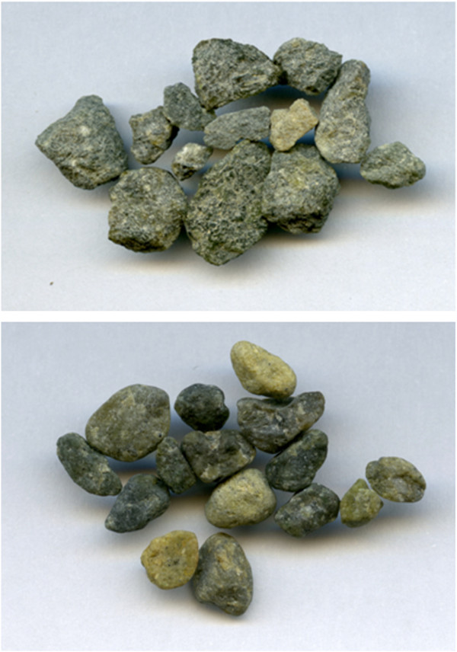

Olivine grit before and after ten days in the surf